SPACE

Section 1- DAY AND NIGHT
From Hands on Elementary School Science, Linda Poore 2003

Westminster College

Standards Addressed:
Students know the position of the Sun in the sky changes during the course of the day and from season to season.

Students will differentiate evidence from opinion and know that scientists do not rely on claims or conclusions unless they are backed by observations that can be confirmed.

PRETEST:

Draw and label the solar system and the universe. Explain why we have day and night. Explain why we have winter and summer. Pre-Test is at the end of this section. Give it again as a posttest after the students experiment.

KEY WORDS:
ROTATE: The Earth rotates on its axis once every 24 hours. AXIS: An imaginary line around which the Earth spins. (rotates) REVOLVE: The Earth revolves around the sun every 365 ¼ days.
TILT: The Earth tilts on its axis, thus sometimes North America is tilted away from the Sun, resulting in slanted Sun rays and cooler temperatures.
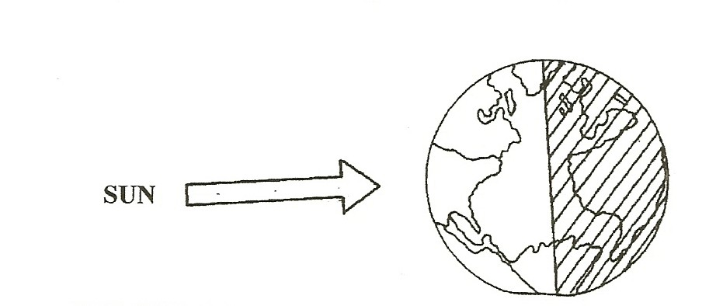

MATERIALS:
1 lamp with bulb
*extension cord (teacher to provide)
*globe (teacher to provide)
*book (teacher to provide)

IN ADVANCE: Arrange to do this activity in a dark room.

EXPLORE: [S, SUN-POSITION CHANGES] WHY DOES THE EARTH HAVE DAY AND NIGHT?
THE EARTH ROTATES EVERY 24 HOURS ON ITS AXIS.

Space-Day and Night

- Group the students on the floor around the lamp. Place the lamp on a desk.
Stand the lamp up by clamping it to a book.
If you need the ‘sun’ higher, place a clothes hanger through the clamp and hook it to a ceiling light fixture.
Place a clay ‘stick’ man on the globe where you live. Darken the room except for this ‘sun’.
Hold the globe high so everyone can see the globe and the man. Does the man on the globe see the ‘sun’? (yes)
What does the Earth do to make day and night? (rotate on its axis)
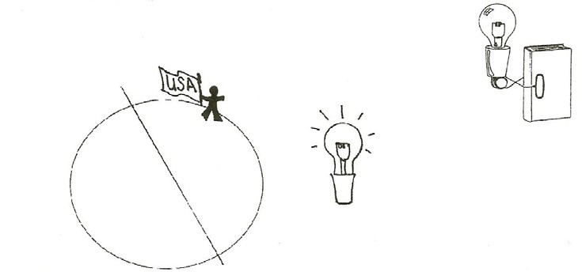

- Rotate the globe ½ turn to show the clay man on the other side, away from the ‘sun’. Does he see the ‘sun’ now? (no)
Discuss day and night.
How long does it take the Earth to rotate? (1 day=24 hours)

STUDENTS ROTATE IN PLACE TO SHOW DAY AND NIGHT
Have the students stand in a large circle, so they can see the ‘sun’ (lamp) in the center. Tell each student that they are the Earth. The Earth rotates toward the east, therefore the sun appears first in the east and seems to move across the sky to set in the west. Have students point to their left to know which direction they turn.

- Turn on the lamp and darken the room. Have students:
Stand so that their faces have day. (face lamp)
Students rotate slowly 3 times, raising their hand when they ‘have’ night. Observe students for understanding. Discuss. [S, Sun-position changes]

ASSESSMENT:

WHY DO WE HAVE DAY AND NIGHT?
Have students write the answer to this question.

[S, evidence-observations] [S, Sun-position changes]

Space-Day and Night

SPACE

Pre-Test or Post-Test (circle one)

Draw the solar system and label your drawing.

What makes up the universe? Draw the universe and label your drawing.

Explain why the Earth has day and night. Draw the Earth and Sun showing day and night.

Explain why the Earth has seasons. Draw the Earth and Sun to help explain the seasons.

