REFLECTION, DIFFRACTION, REFRACTION

SECTION 1: MEASURING ANGLES
HOW TO USE A PROTRACTOR

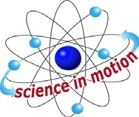
Westminster College

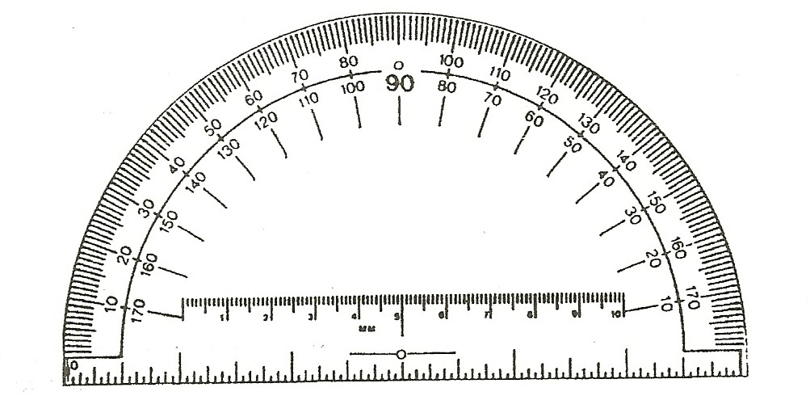

EXPERIMENT:
- Look carefully at the protractor in your kit, along the straight edge of the protractor there is a scale with a center point. Above the center point is a small hole with a short horizontal line extending from each side of the hole. This is the point of origin that you use whenever you measure an angle with the protractor. When measuring an angle, center the hole over the vertex of the angle that you want to measure.

If you extend the horizontal line of the point of origin, it becomes the zero degree and the 180 degree line. When you want to measure an angle, the vertex is placed in the center hole with one side of the angle directly under the horizontal lines at the point of origin. If aligned correctly, one side of the angle is directly under the zero degrees or 180 degrees mark on the protractor. When your protractor is positioned this way you can easily count the number of degrees between the two lines. This is the measure of your angle.

Look again at the horizontal line at the point of origin. When you measure angles, you need to place one angle line (axis) of the angle along this horizontal line, as described above. The other angle line (axis) will have to extend as far as the numbers around the curved side of the protractor. Because the numbers on the curved side go backwards and forwards, you can measure from either left to right or right to left.

- Use the protractor to measure the angles on the next page. The correct answer is given so that you can check your work.

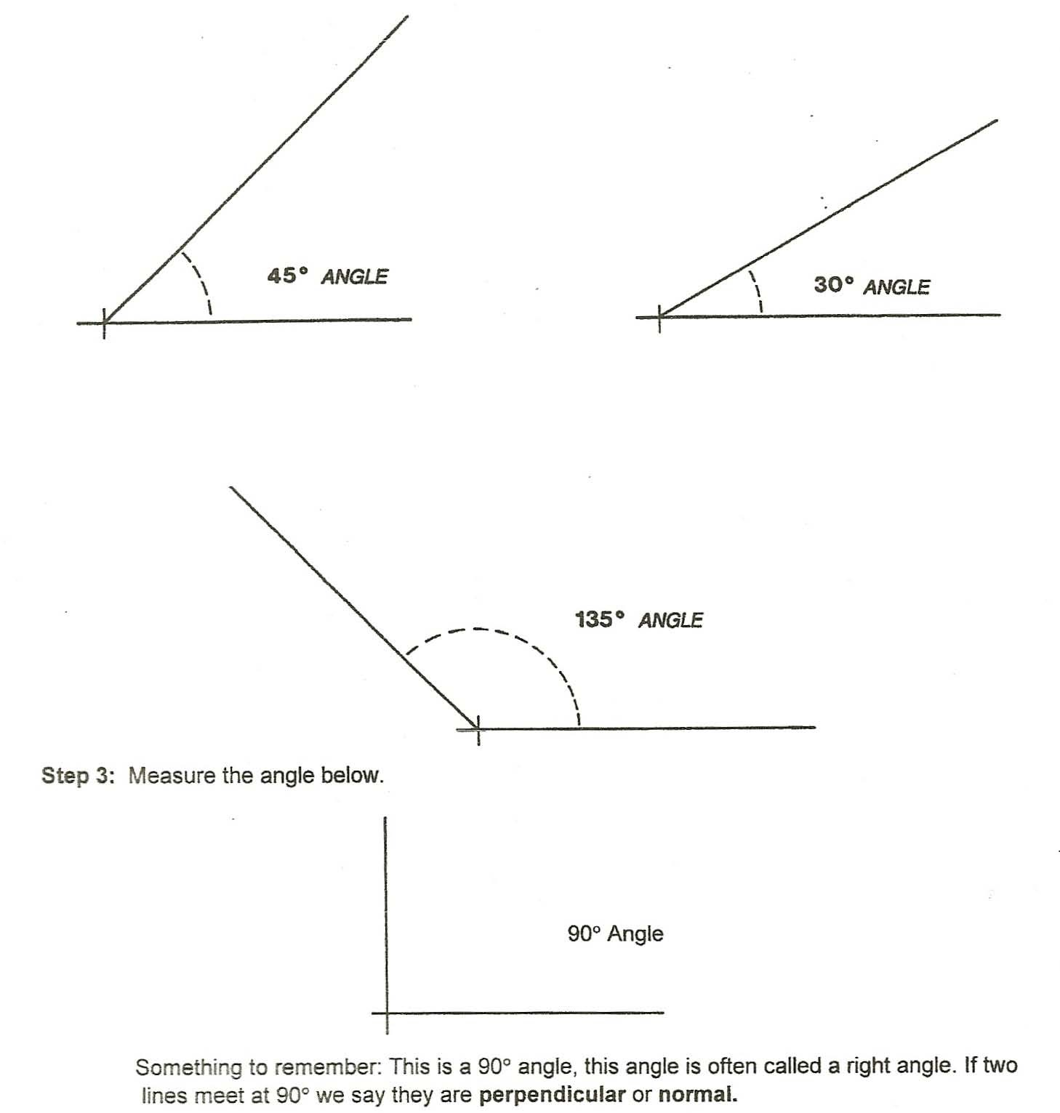

REFLECTION OF LIGHT

GOAL: To demonstrate the reflective properties of light and to study the virtual image formed by a plane mirror and to observe the law of reflection.

BACKGROUND:
Whenever a light wave strikes a surface and rebounds, we say that the wave has been reflected. A smooth surface, such as a plane mirror, reflects the light wave back at the same angle that the wave hits the surface. This is the law of reflection: the angle or incidence (incoming light wave) equals the angle reflection (reflecting light wave).
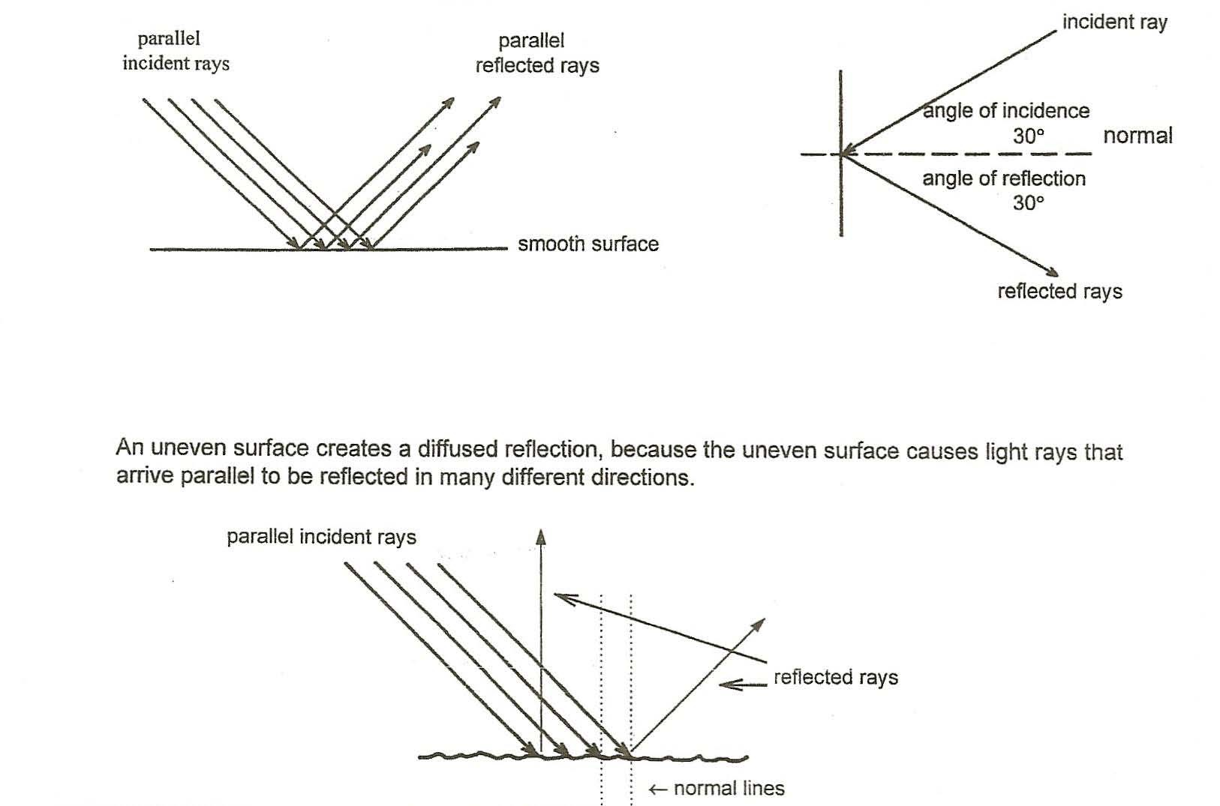

The light we normally see around us is a mixture of many different wavelengths. Each wavelength has its own color, but when the different wavelengths are combined, which light is created. When light strikes an object, some of the light is reflected and some is absorbed. We see color because of the reflected wavelengths. For example, a blue surface reflects blue light and absorbs other wavelengths.

MATERIALS:
Concave mirror black construction paper
Convex mirror loose leaf paper
flashlight scissors
flashlight slotted insert push pin or stick pins
mirror stands corrugated cardboard for a pin mat
flat plane mirrors magnifying glass

ASSEMBLY INSTRUCTIONS:
- Activities for this investigation are easier if students work as partners.

- The work area must be fairly dark for some of these activities. Turn off nearby lights, as needed.

- Remove the flashlight lens by unscrewing the cap. Place flashlight insert into the lens cap. Reassemble the flashlight.
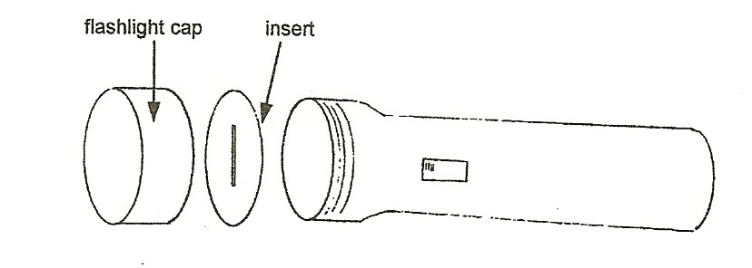

- Attach the cap to the flashlight. Keep the slit vertical.

- Keep mirrors clean. Hold mirrors by edges so as not to smudge with fingerprints.

- Magnets will hold mirrors to L-shaped metal brackets. Velcro dots hold the mirror to the magnet. One of the bracket legs should extend in front of the mirror.

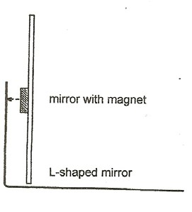
CAUTION: Mirrors are made of glass. Hold mirrors by edges and work over a newspaper-covered surface. Wrap mirrors carefully before storing in kit after activity.

