ELECTRICITY

SECTION 1: STATIC ELECTRICITY

STANDARDS:
Students know basic energy types, sources, and conversions.

Students describe the flow of energy through an object or system.
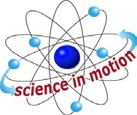
Westminster College

Students recognize or illustrate simple direct current series and parallel circuits composed of batteries, light bulbs, wire and on/off switches.

BACKGROUND:
In order to understand how electricity works, we must learn about atoms. Everything in the universe is made up of atoms. Inside an atom we find protons, neutrons and electrons. Protons are positively charged or positive, and electrons are negatively charged or negative. Inside the atom, most of the time there are the same number of protons and electrons. Sometimes the atom gets out of balance when it gains or loses electrons. If it gains electrons, the atom becomes negatively charged. If it loses electrons and has more protons, it is positively charged. The atom likes being in balance so when it gets the chance, it will get rid of the electrons or it will gain electrons by attaching itself to another atom.
Here is an example to help us understand:

(demonstrate using paper circles as electrons) When I walk across the floor rubbing my shoes on the carpet, I pick up electrons (bend over and pick up circles as you walk). So now the atoms that make up my body have extra electrons. I might touch something metal, like this door handle, and the electrons suddenly leave my body. I sometimes feel this happen. I get shocked. Who has ever been shocked like this before?

In our lesson, we are going to change the balance of electrons in atoms and create a special kind of electricity, static electricity.

MATERIALS:
construction paper circles saran wrap
paper towels salt
materials in the baggies: foil
plastic paper toothpick paper clip

STATIC ELECTRICITY

PROCEDURE:
- Pair students.
- Demonstrate how they will set up their Saran Wrap on the desk They will take one item out of the bag at a time and place it on the desk next to the Saran Wrap (if there are more than one of the same item they can put all on the desk, i.e., 3 pieces of plastic.) Then they rub the Saran Wrap with the paper towel, moving in ONE DIRECTION ONLY. Depending on the humidity, the students need to rub for 5 to 20 times. The more humid, the more times to rub. Then each partner will take opposite corners and lift the Saran Wrap off the desk. Next they will slowly lower the Saran Wrap close to the object t o see if there is any attraction from the static electricity.
- Give each pair a worksheet, one paper towel, one foot of Saran Wrap, and a baggie of materials.
- Using the handout, the students will make their predictions and then record their results as they experiment.
- Once they have concluded the experiment with items in the baggie, give each group a pinch of salt to test for attraction.
- Clean up salt by crumbling it inside the Saran Wrap and disposing of it in the trash can.
- Have students share their results. Discuss possible discrepancies.

Sometimes one student may have seen the attraction while others did not. This could be explained by the amount of static electricity. The more times the students rub the Saran Wrap, the more static electricity will build up (atoms that are electrically charged due to being unbalanced).

WHAT HAPPENS?
The electrons are transferred from the paper towel to the Saran Wrap. The Saran Wrap now has a charge, let’s say it is negative because it has more electrons. The items, let say they are positive, attract to the Saran Wrap because opposite charges ATTRACT each other. Other items don’t attract because there is not enough of a charge to overcome the weight of the object.

BALLOON AND HAIR DEMO:
Rub a balloon on a student’s hair. What happens?
The electrons transfer between the balloon and the hair. The hair has the same charge of the head but opposite charge of the balloon. Therefore, the hair sticks up away from the head and attracts to the balloon.

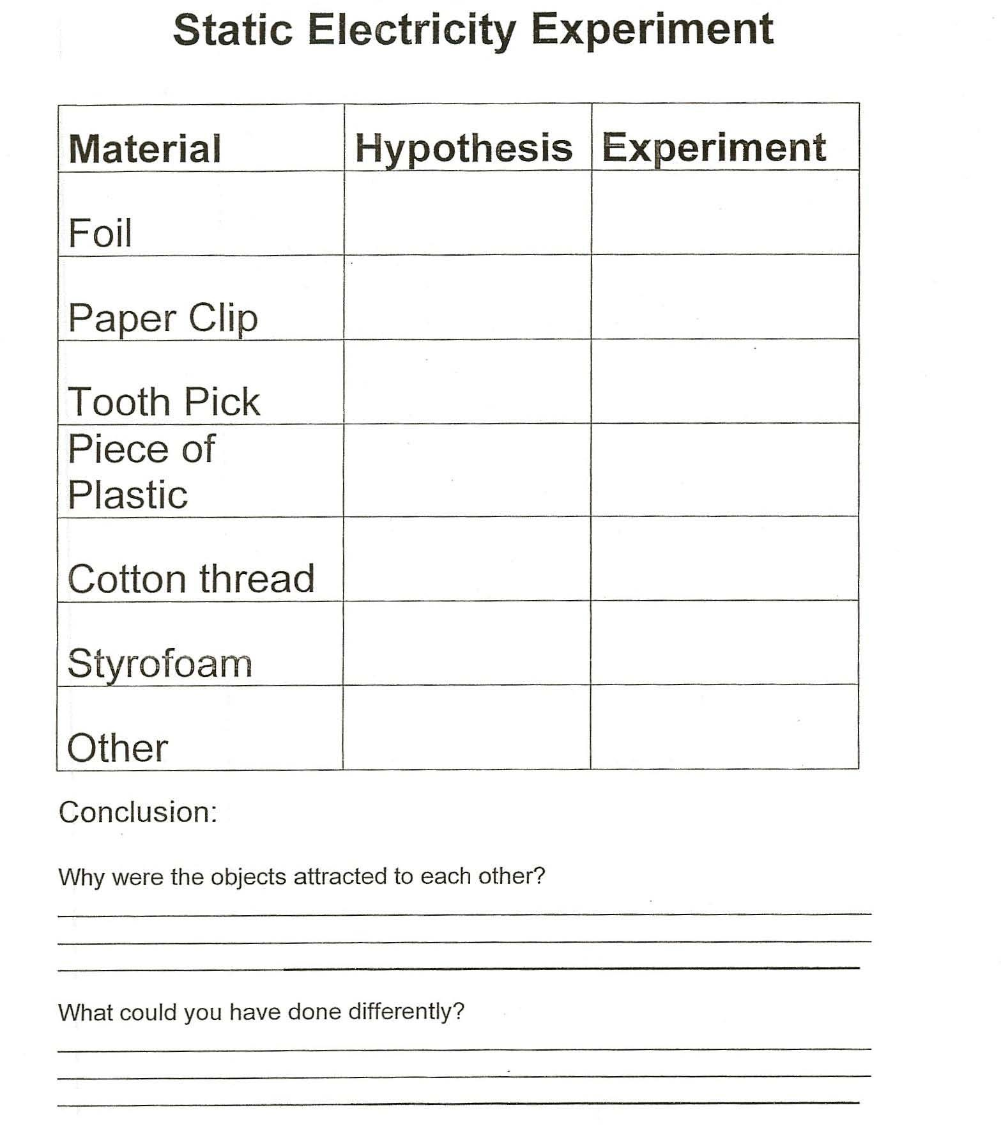
STATIC ELECTRICITY

