MACHINES AND MOTION

SECTION 1: USING FORCE TO DO WORK

STANDARDS:
Students will measure length, weight, temperature, and
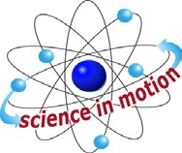
Westminster College

liquid volume with appropriate tools and express those measurements in standard metric system units.

Students will make predictions based on observed patterns and not random guessing.

PRETEST:
Describe or invent a machine that will help you lift the teacher with one finger. (Pretest worksheet at end of this section.)

IN ADVANCE:
You will need 1 brick and 1 long board (approximately 5’ to 6’ x 12” x 1”)

DISCUSS:

A FORCE IS A PUSH OR PULL
We can use force to move things.
Name things we push (bike, roller skates, desk). Name things we pull (door knob, drawer, wagon).
Which objects need more force before they will move? (heavier)

A FORCE CAN CHANGE THE SHAPE
Illustrate that a force can be used to change the shape of an object. (bend a paper clip, flatten ball of clay, stretch a spring, etc.)

NOTE:
WEIGHT is the pull of gravity on an object. Weight can be measured on a scale. The more mass an object has the more weight it has on Earth.
MASS is the amount of matter in an object. In space, objects have mass but no weight since there is no gravity. On the moon, the object weighs less as there is less gravity.

EXPLORE:

WHAT IS WORK?
WORK IS DONE WHEN A FORCE MOVES SOMETHING
- Have a TUG-OF-WAR on the playground with a long rope to illustrate that work uses energy and when forces are equal, no work is done. First have teams on cement. For the second tug-a-war have one team on grass.
How is friction useful? (prevents slipping) Why is it an unfair test?

- Have a student try to push a wall down. Did you exert a force? (yes)
Did you do work? (No, work is done only if you move something a distance according to the scientific definition of work.)

DISCUSS:

HOW MUCH DOES IT WEIGH IN GRAMS? HOW TO USE A SPRING SCALE:
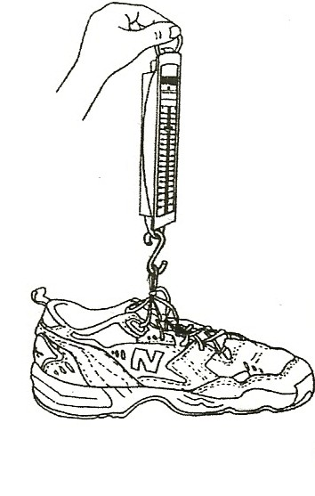
  - Show a spring scale and discuss the units it measures in and how to read it. The scale weighs in grams. Each mark is worth 10 grams (g). Make a transparency of the worksheet How many grams does it weigh? Have the students practice reading the scale on the overhead projector together.
  - Show the students how to hold the scale by the metal loop when weighing objects.
  - Check the scale to make sure it is set at 0 before each experiment. Show students how to adjust the scale by moving the metal piece at the top up or down so the scale reads 0 with no weight.
  - Never weigh any item heavier than 1000 g (1 kilogram or
2.2 pounds) with this scale as it may break. Heavy backpacks, chairs, etc. cannot be weighed using this scale.

MATERIALS:
1 spring scale
several objects to weigh (crayon box, scissors, your shoe) rubber bands (to hang objects from scale)
worksheet paper clip

EXPLORE:

ACTIVITY 1: USING FORCE TO DO WORK
- Attach each object to the spring scale using a rubber band and a paper clip.
- Write each objects’ weight on your work sheet. There are 2 worksheets:
How many grams does it weigh? shows a picture of the scale.
The students can draw a picture of the object or write the name of each object at the line showing how many grams it weighs.
They can write its weight in grams next to the picture.
Weighing Objects has a place for recording the weights of objects and estimating weight. This sheet challenges students to make predictions (estimate) the weight of objects.
This could be done individually or as a group activity at the end of this section as assessment.

DISCUSS:

COMPARING THE WEIGHT OF OBJECTS
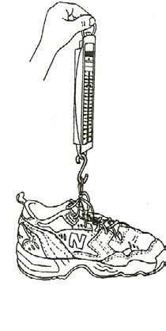
  - DISCUSS. Who has the heaviest shoe? Who has the lightest shoe? Do all the math books weigh the same?
  - What objects can’t you weigh on these scales?
(pencils, paper, paper clips, crayons-because they are too light.) To weigh small items, like paper clips, weigh a large quantity and divide to get the weight of one. (e.g., weight 100 paper clips in a bag) Two regular paper clips weigh about 1 g.
  - Hook 2 spring scales together and attach one to the wall, door knob, or overhead projector.
Predict the amount of grams of force on the second scale if the first measures 500 g when you pull on it.
How much force (in grams) was exerted on each scale? (the same)
(There is an equal force on each scale. See Newton’s law below.)
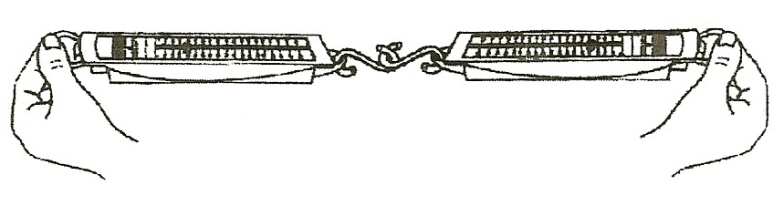

KEY WORDS:
NEWTON’S SECOND LAW OF MOTION: For every action, there is an equal and opposite reaction.
SIR ISSAC NEWTON (1642-1727) was a scientist who developed laws that explain the motion of objects and gravity.

MATH:
Using the spring scale, fill a 1-pound coffee can with sand until it weighs 1 kg (1000 g). Label the can: 1000 g = 1 kg. Pass it around for students to feel how much 1000 g is. Pass around 2 regular paper clips so students can feel 1 gram. How many paper clips would equal 1000 g? (about 2000). Since paper clips come in boxes of 100, this would be easy to check and good practice in counting by 100’s.

ASSESSMENT:
Evaluate the data on the students’ work sheets for accuracy and amount of objects weighed. Do hands on assessment during the activity, checking each child’s ability to accurately use the scale.

PREDICT: Have students predict the weight of objects on the work sheet,
Weighing Objects.

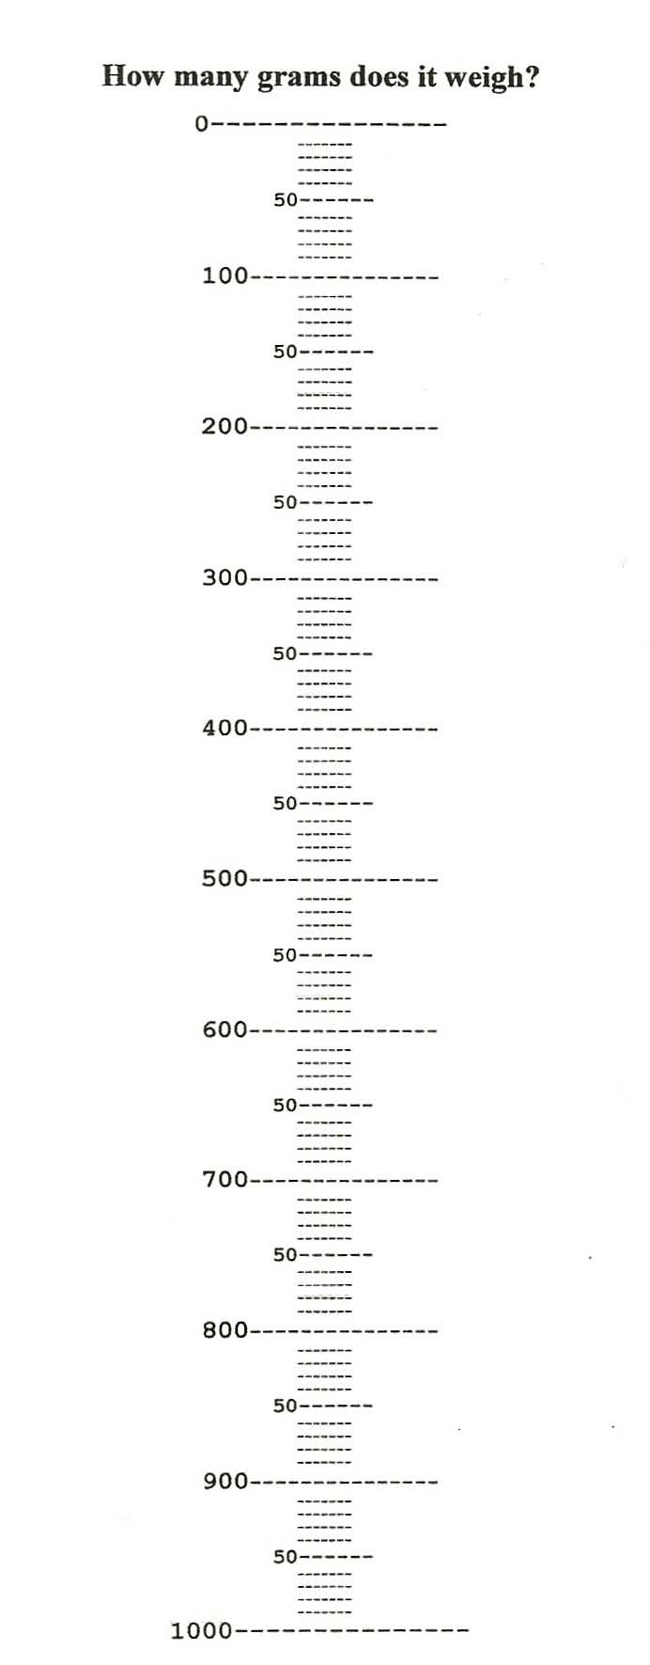

HOW DO MACHINES HELP US DO WORK?

Describe or draw how you could lift the teacher with one finger. What machine would you use? Explain why this machine works.

PRETEST DATE | POSTTEST DATE

Weighing Objects

Find the weight of your science book.
My science book weighs g. Now look at the objects below.

Estimate:
Circle the amount of grams you think each object would weigh.

Weigh each object and write its actual weight.

item | Estimate (circle one) | What did it weigh?
Pencil | 5g 25g 50g
Box of paperclips | 50g 250g 5 kg
Box of crayons | 25g 75g 200g
Teacher’s scissors | 50g 100g 250g
Hammer (in kit) | 100g 200g 300g
1 rock | 50g 100g 300g
Can opener (in kit) | 20g 50g 100g

