MAGNETS

SECTION 1-WHAT IS A MAGNET?
From Hands on Science by Linda Poore, 2003.

STANDARDS:
Students will differentiate observation from inference

Westminster College

(interpretation), and know scientists’ explanations about what happens in the world come partly from what they observe and partly from what they think about their observations.

Students will measure and estimate the weight, length, or volume of objects.

Students will conduct multiple trials to test a prediction and draw conclusions about the relationships between predictions and results.

Students will formulate and justify predictions based on cause-and-effect relationships.
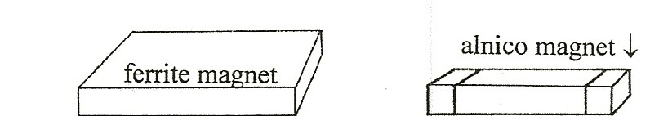

NOTE:
MAGNETS attract steel, iron, cobalt, and nickel. Nickel coins are not made of nickel. Alnico magnets in the kit are 1” long and have colored ends to mark the poles. Ferrite magnets are flat rectangles. Students will mark the ferrite poles with colored stickers to match the alnico, so like poles (green-green) repel. The cow magnet is a 3” cylinder. Do Not put magnets near tapes, diskettes, TV, VCR, computer, or other magnetic media.

PRETEST:
What do magnets attract? What happens when 2 magnets touch? Give the pretest to determine the students’ prior knowledge. (end of section)

IN ADVANCE:
Put different metals you provide in the plastic trays and put a label in each tray to show the type of metal. (e.g., copper penny, aluminum foil, etc.)

MATERIALS:
For Each Pair: For the Class:
2 ring magnets Trays of metals to test
1 alnico magnet copper penny, brass brad
1 ferrite magnet aluminum foil
1 magnetite rock lead or graphite pencil ‘leads’ 2 paper clips

DISCUSS:
What materials do you think the magnet will attract. (Many students may say metals. See note and standard above!)

EXPLORE:

WHAT MATERIALS INTERACT WITH MAGNETS:
Pass out materials. Have students:
Experiment. Move around the room, testing objects.
Fold a paper in half and label the top magnetic and nonmagnetic to record the results. [S, observe/interpret]

DISCUSS:
List metals that are not attracted to magnets. Discuss the magnetic rock! (see note below)

HOMEWORK:

MYSTERY QUESTION FOR PARENTS:
Have students tell their parents what magnets attract, including: ‘My magnet attracted a rock!’ This statement will give them a chance to teach their parents about magnetite.

ASSESSMENT:
Have students list materials that magnets attract. List metals that are nonmagnetic.

KEY WORDS:

MAGNETITE:
The rock, magnetite, is the lodestone used by early explorers as a compass. (Vikings, Chinese, Columbus) They kept a small piece of iron or steel (needle) with the magnetite in a box. They hung the ‘needle’ from a string to check direction because the same end always pointed north, toward the magnetic north pole of the Earth. Magnetite, a mineral that contains iron, is a very weak magnet and attracts iron filings. Magnets attract the magnetite rock. The Chinese were the first to use the compass in the twelfth century.

EXPLORE:

HOW DO 2 MAGNETS INTERACT? [S, observe/interpret]
- Tell the students that these are your ‘trick’ magnets and you have taught them how to jump, twirl, chase, flip, and hide. They are to be careful not to let them hide, as they must return the magnets to you.

ATTRACT AND REPEL
Give each student 2 matching magnets.
Put the magnets together in different ways. What happens? Discuss attract and repel.

- The best trick is to make a magnet wave.
This works well with the rectangular ferrite magnets.
Place one above the other so they are repelling (see picture) Tap the top one gently. Watch it wave.
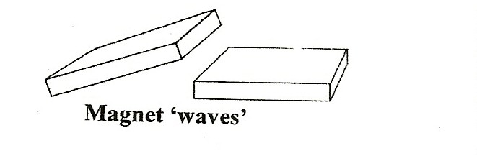
(Flip the top magnet, have patience and try again until it works.) Show this to the students and let them experiment.

ASSESSMENT:

UNDERSTANDING ATTRACT AND REPEL
Each student needs 2 matching magnets.
- Ask the students to hold 2 magnets that are attracting in their palm. Observe students for understanding.
- Have the students hold their 2 magnets on the middle of their desk while the magnets are repelling. At the count of three, everyone lets go.
(You can tell who does not understand repel as they are the students that are asking how others made the magnets jump!)

EXPLORE:

DOES THE MAGNETIC FORCE GO THROUGH OBJECTS?
- Will the magnet’s force go through paper?
Your finger? Your hand? The desk top? A book?
Put one magnet on each side of an object to see if the force will go through nonmagnetic objects.

HOW FAR DOES THE MAGNETIC FIELD EXTEND?
- How many pages in a book can the magnetic field go through?
Have students:
Put a paper clip on page 1 of a thick book with about 100 pages. Experiment by putting a magnet on page 2 and moving it.
Does the magnet interact with the paper clip on page 1?
Experiment to find out how many pages the magnetic force can go through. Record the number of pages the magnetic force field goes through.
Be sure students retrieve all magnets inside the books.

WHICH MAGNETS HAVE STRONGER MAGNETIC FIELDS
- Have students write a prediction.
Each student needs 2 matching magnets. Hold 2 magnets together so they repel.

Feel the magnetic field between them.
Hold the 2 repelling magnets together on a desk.
Remove your finger so the top magnet jumps. How far did it jump?
Trade magnets and repeat the experiment with pairs of each type of magnet (alnico, ferrite, ring)
Discuss which magnet has the strongest magnetic field. (alnico?)

[S, observe/interpret]

PERFORMANCE ASSESSMENT:
HOW STRONG IS THE MAGNETIC FIELD (WORKSHEET)
Students use a magnet/paper clip system to measure, in millimeters, the distance the magnetic field extends from each magnet.

[S, observe/interpret] [S, measure] [S, predict] [S, trials/conclusions].

POSTTEST: Same as pretest.

What do magnets attract?

MAGNET PRE TEST

What happens when you put 2 magnets together?

MAGNET POSTTEST

What do magnets attract?

What happens when you put 2 magnets together?

Describe the magnetic field of a magnet?

HOW STRONG IS THE MAGNETIC FIELD?
- How far does the magnetic force extend from 1 magnet?
Prediction: mm Use a ferrite magnet.
Place a paper clip on the ruler at ‘0’. Stand the ferrite magnet on the 5 cm mark, so its flat side is facing the paper clip.
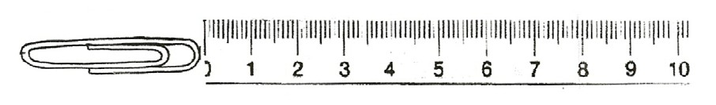
Slowly move the magnet toward the paper clip until they interact.
Observe how close they are. Repeat this experiment, but lay the magnet on the ruler so its edge faces the paper clip. Where is the force stronger, on the flat side or edge?
The strongest part of the magnet is called the pole.

- On the chart below, record the distance between the paper clip and ferrite magnet when they interact. Repeat 3 times and record the distances in millimeters.
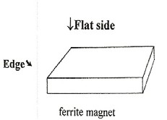
(1 cm = 10 mm) Find the average by adding the 3 answers and dividing by 3.

Ferrite Magnet Results:
1st try | 2nd try | 3rd try | Average
mm | mm | mm | mm

- Which magnet has the strongest magnetic field: alnico, ferrite, or ring?

Prediction

- Try the experiment again using the paper clip with the alnico and ring magnets. Write the distances you measured below on the charts and find the average.

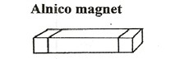
Alnico Magnet Results:
1st try | 2nd try | 3rd try | Average
mm | mm | mm | mm

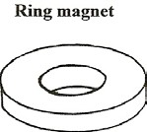
Ring Magnet Results:
1st try | 2nd try | 3rd try | Average
mm | mm | mm | mm

- The magnet with the strongest magnetic field is
- How high can you get a paper clip to jump? mm
Which magnet did you use? Did you use the magnet’s side, end or edge?

