ROCKS, EROSION AND WEATHERING

SECTION 1-WHAT IS A ROCK?
From Hands on Elementary School Science by Linda Poore, 2003.

STANDARDS:

Westminster College

Students will differentiate observation from inference (interpretation), and know that scientists’ explanations come partly from what they observe and partly from how they interpret their observations.

Students will measure and estimate weight, length, or volume of objects.

Students will construct and interpret graphs from measurements.

IN ADVANCE:
There are rocks provided of each type. The first time the lessons are taught, put 1 rock of each type in a small plastic bag labeled with the rock’s name and marked as the teacher’s sample. Keep these in a bag labeled ‘Teacher rock samples.” This helps the teacher identify the rocks during future lessons.

KEY WORDS:
ROCK: A rock is made of one or more minerals. Two varieties of the same rock may appear different because of the different proportions of the minerals.

MINERALS: Minerals are inorganic (neither plant or animal) substances from the Earth. A mineral consists of 1 substance only.

PRETEST:
What is a rock? How do rocks differ? With advanced learners use ‘The Rock Cycle’ assessment work sheet. (in Section 8)

MATERIALS:
1 Tray 1 pink granite
1 gray granite 1 magnifier

EXPLORE:

COMPARING ROCKS
1. HOW TO USE A MAGNIFIER
If this is the first time students use a magnifier this year, show them how to put the magnifier close to the rock and then pull back slowly until you see it clearly. Have the students determine which lens is the strongest (the smallest) Remind students to never touch the magnifier with the object.

OBSERVING ROCKS
Pass out materials.

Compare how these rocks are alike and different.
Describe properties of each rock. (e.g. speckled, hard, white) What is a rock? Discuss student ideas.

- Have students describe the different parts in granite? (shiny, glassy, dark) Rocks are made of 1 or more minerals.

MATERIALS:
For Each Pair
3 rocks(minerals) feldspar,
quartz
mica (muscovite)

EXPLORE:

1. OBSERVING MINERALS
Tell students you will give them the 3 minerals found in granite. Observe each mineral.
2. Discuss the properties of each mineral. (Feldspar can be white or pink. Quartz can be clear or milky. Mica is shiny, in thin layers, and may be black or clear.)

ASSESSMENT:

WHICH MINERAL IS MOST C OMMON IN GRANITE?
Give each pair of students one pink and one gray granite.
Have students find the 3 minerals in their granite sample and write answers to the following questions:
Which mineral is most common? Describe it. (feldspar, 60%) Which mineral is the least common? Describe it. (mica, 10%)
Trade rocks with your partner and see if your analysis is the same for the second rock. (Feldspar is most prevalent in granite. It is either pink or grayish-white in these samples.) [S, observe-interpret]

MATH: [S, observe-interpret]

PERCENT
- ESTIMATE
Put the following data on the board: 60%, 30%, 10%.
Ask the students to write the name of the mineral next to the number that shows how much is in their granite sample. (60%=feldspar, 30%=quartz, 10% =mica)

- Have students draw a pie chart showing the percent of each mineral in the rock. Label the minerals on the chart. [S, graph]

NOTE:
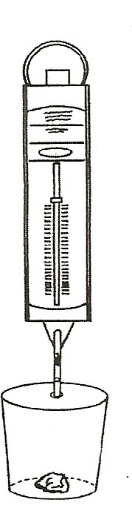
Show students how to use the 2 spring scales. Discuss what each mark is worth. (2 g on the 100 g scales and 10 g on the 500 g scale) Use the
100 g scales for heavier rocks. If the Newton calibrations on the scale confuse students, you can cover the Newton scale with a 1 cm wide sticky edge of a 3” Post-it™ sp the students have only one scale to look at.

HOMEWORK:
Ask students to bring 1 small rock from home. Have students: Use the My Rock work sheet to describe and measure their rock. Weight the rock in grams using a scale in the kit and a paper cup. Hang a paper cup from the hook. [S, measure-weight/length]

MATERIALS:
For the Class:
1 spring scale (0-100 g) 1 plastic cup
- spring scale (0-500g) 1 tray
- foam cups 1 ml vial

MATH:

FINDING THE VOLUME OF A ROCK

- SMALL ROCKS IN KIT
Fill the vial with 25 ml of water.

[S, measure/volume-ml]

Slowly lower the rock into the vial (tie a string around it). Read the number of milliliters of water on the vial now. Subtract this form 25 ml. (e.g., If it is at 34, then 34-25=9ml) The difference is the rock’s volume.
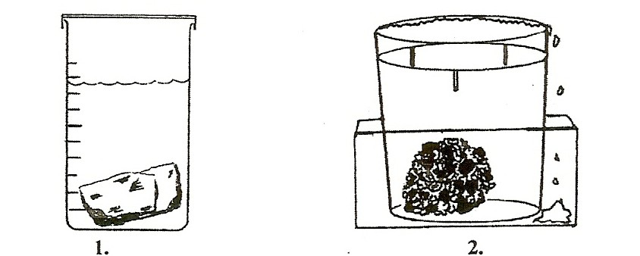

BIGGER ROCKS
To find a big rock’s volume, place a very full cup of water in a plastic tray from the kit. Add more water until a drop falls out. Tie a string around the rock and slowly lower the rock into the water. The rock takes up space, pushing the same amount, or volume, of water out of the cup. Measure the

amount of water that overflows in milliliters. The number of milliliters that overflows=the volume of the rock. (1 ml=1 cm3)

