POLLUTION

SECTION 10-GROWING PLANTS WITH ACID RAIN
From Hands on Science by Linda Poore, 2003.

OBJECTIVES
Students learn about the effects of acid rain on plant life.

Westminster College

Students will compare the rate of growth among plants that have been watered with tap water, acidic water and a mixture of both.

Students will infer the reason for the different growth rates.

Students will draw conclusions about the effects of acid rain on plant life.

MATERIAL
For Each Student For Each Team (4)
Activity Sheet 7 1 plastic beaker
3 fluted containers
1 marker
For the Class 1 metric ruler
- calibrated 1 oz cups 1 pkg grass seed
- plastic 9 oz cups
2 pitchers
6 bags soil
1 mixing spoon
1 roll masking tape 1 bottle vinegar tap water

PREPARATION

DAY 1
- Make a copy of Activity Sheet 7 (A & B) for each student.
- Prepare a quantity of acid water by filling a 2-qt pitcher ¾ full with tap water and adding half a bottle of vinegar. Stir well with a mixing spoon. Label this pitcher Acid Water.
- Place the pitcher of acid water, a 2-qt pitcher of tap water (labeled Tap Water), a roll of masking tape, the soil, and three plastic cups at a distribution station. Also have available for demonstration purposes two calibrated cups and a bottle of pH paper strips.
- Each team of four will need a beaker, a metric ruler, three fluted containers, a package of grass seed, about 6 cups of soil, three pieces of masking tape, a marker, 100 mL of tap water, 100 mL of acid water, and 100 mL of a half-and- half mixture of tap water and acid water. (hereafter referred to as ½ and ½).

Day 2
Each team will need three gardens from Day 1, their activity sheets and a metric ruler.

BACKGROUND INFORMATION
Acid rain is rarely acidic enough to kill trees and other plant life directly. Instead, the acid weakens the organisms, making them more vulnerable to insects, disease, and damage from storms. As the acidity of rain increases, so does its effect on living organisms both on land and in water. In fresh water, crustaceans, mollusks and snails begin to die when the pH drops to just slightly under 6.0. At 5.0, many fish begin to die. Although oceans may be big enough to disperse the acid rain, coastal areas are more susceptible to imbalances, and communities in these areas have been increasingly affected.

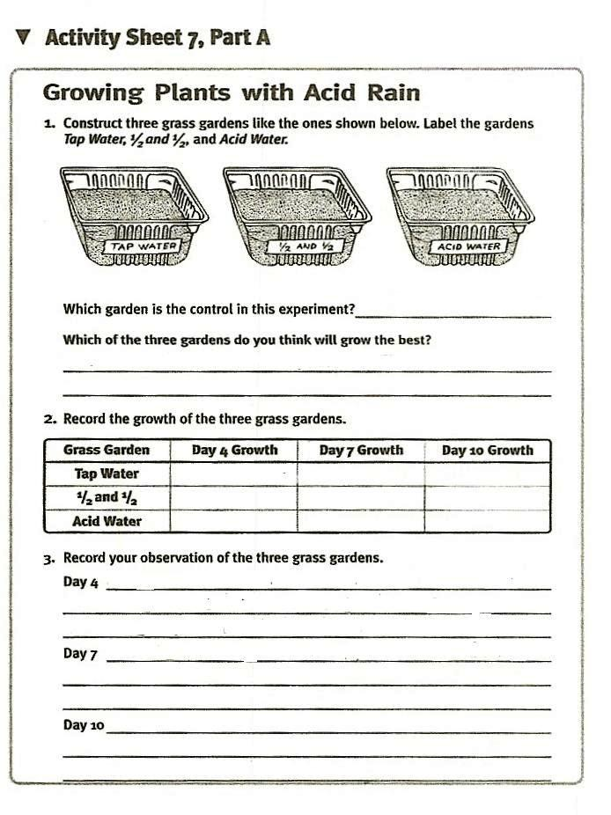

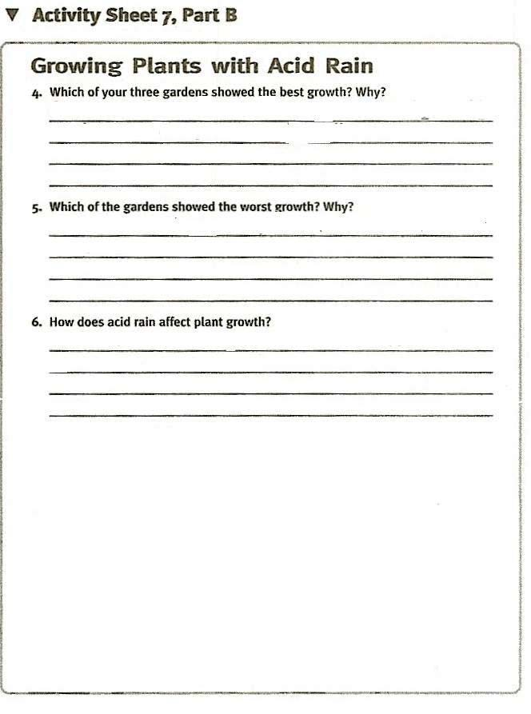

GUIDING THE ACTIVITY

DAY 1
- Initiate a class discussion by asking, How to you think acid rain affects plant life?
Students may have heard or read about the effects of acid rain on the region in which they live.

Explain that in this activity, students will see firsthand the effects of acid rain on plant growth.

- Perform a simple demonstration by pouring 10 mL of tap water into one calibrated cup and 10 mL of acid water into a second calibrated cup. Invite a student to test the pH of each water sample.
The tap water may be slightly acidic, but more likely it will be slightly alkaline. In either case, the difference should not affect your results. The grass should grow just fine with tap water.

- Distribute a copy of Activity Sheet 7 (A & B), to each student and three fluted containers and a metric ruler to each team. Tell them to examine the diagram on Activity Sheet 7A which shows the gardens they are about to make.

Have a member from each team bring a fluted container to the distribution station and add about three cups of sol to the container. Have teams fill the other two fluted containers so that each team has three cups of soil to the container. Have teams fill the other two fluted containers so that each team has three identical gardens ready for planting.
Tell students to leave a few handfuls of soil aside so that they can cover their seeds.

- Distribute a package of grass seed to each team and tell them to sprinkle about a third of the seeds on the top of each container. They should then cover the seeds with not more than 1 cm (about 3/8 in.) of soil and use masking tape and the marker to label the gardens Tap Water, ½ and ½ , and Acid Water.
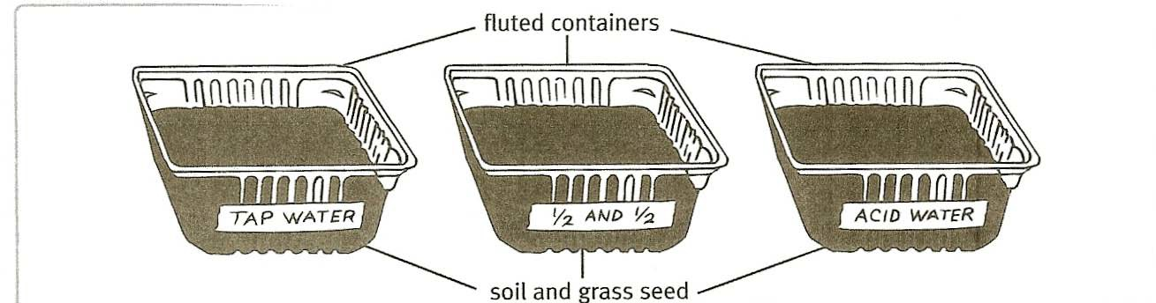

- Distribute one beaker to each team. Ask a member from each team to go to the distribution station, fill the beaker with 100 mL of tap water, and sprinkle the water on the garden labeled Tap Water. Next, have another member form each team bring the beaker back to the distribution station, fill it with 50 mL of tap water and 50 mL of acid water, and sprinkle the mixture on the garden labeled ½ and ½ . Repeat the procedure with 100 mL acid water and garden-labeled Acid Water.

Ask, What are we trying to test in this experiment?
Make sure students realize that the goal is to determine how acid rain affects the growth of plants.

Ask, Why do we have a garden watered with tap water?
To act as the control in the experiment.

In the space provided in Activity Sheet 7, A, have each student predict which of the three grass gardens will grow the best.
Invite several students to share their predictions with the class.

- Have students water their gardens again on the fourth and seventh days of the experiment. Keep in mind that you will need to make a new batch of acid water on both of these days. Mix and distribute as before.
In some classrooms, the air is so dry that students may need to water their gardens more often. In others, the frequency of watering may need to be reduced. Check the gardens during the first several days of the experiment to be sure that they are receiving the proper amount of water. The soil should be evenly moist but not soggy.

On watering days, have students use a ruler to measure the height of the grass in their grass gardens. Have them record their measurements, and any other observations they make about the conditions of their gardens, on their activity sheets.

- Rinse out and air dry pitchers, beakers, etc and return them to the kit.

- On the tenth day, divide the class back into teams of four and have them retrieve their gardens. Have students use a ruler to take a final height measurement. Invite the teams to compare the growth among their three grass gardens and to complete Activity Sheet 7, Part B. Ask, How did the acidity of the water affect the growth of grass in each garden?
The grass grown with acidic water looks sparser and shorter than the grass grown with tap water. The grass grown with a mixture of tap and acid water is somewhere in between.

Ask, How would you explain these results?
The acidity of the water impeded the growth of the grass. The more acidic the water, the fewer seeds that sprouted and the slower the rate of growth.

Ask, If rainwater were as acidic as the acid water you used for your garden, how do you think the fields and trees might be affected?
Students should realize that fields and trees that received acidic rainwater could also be damaged.

