SOUND VIBRATIONS

SECTION 10: RING MY CHIMES
From Science in a Nutshell

OBJECTIVE:

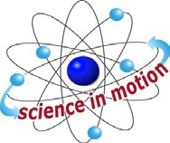
Westminster College

To observe how sounds can travel through different solid objects.

MATERIALS:
metal clothes hanger paper cups
Journal page for Activity 10 metal pan
paper clips ruler scissors Slinky string desk/table

BACKGROUND:
You already know that sound travels better through solid materials than through air. In this activity, you will experiment with various kinds of solid materials to discover how their sound waves are able to travel through strings.

EXPERIMENT:
- Cut a piece of string 2 m (about 6ft) long. Tie the center of the string to a metal hanger so that the two pieces of string dangling from the hanger are about equal in length.
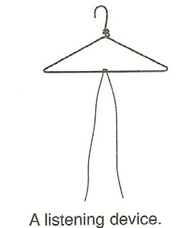
- Hold the ends of the string and swing the hanger gently against the side of a table and listen for the sound it makes.
- Wrap an end of a string around each index finger. Place an index finger against (not in) each ear. Ask your partner to swing the hanger against the table while you listen for the sound.

- Place a metal pan on the table and hit the hanger against it. Then try hitting the hanger against the metal pan while holding the ends of the strings against your ears.
- How are the sounds you hear through the string different from the sounds you hear through the air? Does sound travel better through air or through string? Record your observations on the journal page for Activity 10.
- Cut two pieces of string, each about 50 cm (19 in.) long. Attach a string to each end of the Slinky.
- What do you think you will hear if you hold the strings against your ears while your partner squeezes and releases the Slinky?
- Do you think that the sound will be different if the Slinky is hit against a table. Try it and find out.
- Unbend a paper clip and punch a small hole in the center of the bottom of each paper cup.
- Thread the end of a string from the hanger through the hole in a cup and tie it around an unbent paper clip. Pull on the string from outside the cup to flatten the paper clip against the inside bottom of the cup.
- Do the same for the other string and cup. The paper clips will keep the strings from pulling out of the cups.

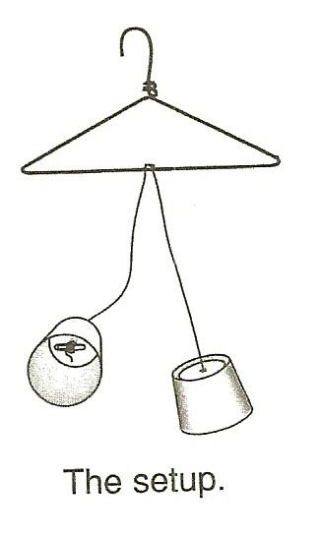

- Hold the open ends of the two cups over your ears. Have your partner hit the hanger against the table. Is the sound you hear the same as it was before the cups were added? Describe in your journal how the sound of the vibrating hanger is different.
- Why do you think that you hear a different sound after the cups are added to the ends of the strings?
- Add cups to the ends of the strings that are attached to the Slinky. Hold the cups against your ears and listen as your partner squeezes and releases the

Slinky. Record in your journal how the sound of the vibrating Slinky has changed.
- Save the cups from the activity to use again.

IN A NUTSHELL:
  - Many large clocks have chimes that ring when large suspended metal bells (like Big Ben in London, England) are struck and vibrate.
  - Because sound travels best through solids, sound waves that travel through a solid to our ears seem louder and clearer than sound waves that travel through the air.

CRACKING THE NUT:
  - Molecules are closer together in solid objects than in air. Why do you think that sound waves travel better through solids than through the air?

