SECTION 11: ACTION­REACTION IN ACTION

LAB

INTRODUCTION

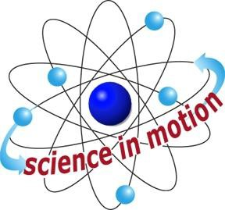
Westminster College

Most motion on the earth’s surface depends on Newton’s third law of motion: Forces always occur in pairs. For every action there is an equal and opposite reaction. You walk forward by pushing backward against the ground. You jump upward by pushing downward on the ground. You swim forward by pushing backward on the water. In each of these movements the force you exert is the action force. The force that you feel and that makes you move is the reaction force. Newton’s first and second laws of motion were introduced with the behavior of a ball. Our explanation of the Newton’s third law begins in the same way. Students then use spring jumpers to visualize action­reaction forces. The rubber disk of the spring jumper is very sticky, and the animal will stay in a compressed position for a long time if it is depressed with too much force. Make sure students press down very lightly when attaching the rubber disk to the plastic platform.

ASSESSMENT ANCHORS ADDRESSED
S4.A.2.1 Apply skills necessary to conduct an experiment or design a solution to solve a problem.

S4.C.1.1 Describe observable physical properties of matter.

S4.C.2.1 Recognize basic energy types and sources, or describe how energy can be changed from one form to another.

S4.C.3.1 Identify and describe different types of force and motion, or the effect of the interaction between force and motion.

PURPOSE
In this activity, students discover Newton’s third law of motion by observing the behavior of a bouncing ball, and then apply the law to the behavior of a spring jumper.

MATERIALS
For Each Group For the Class Table tennis ball Activity Sheet 11 Pennies*
Ruler* VCR
Spring Jumper Videotape, Toys in Space

Teacher provides items marked with *

Westminster College SIM Page 1

