SOUND VIBRATIONS

SECTION 11: STRING ALONG
From Science in a Nutshell

OBJECTIVES:

Westminster College

To explore how voices and other sounds can travel through string.

MATERIALS:
paper cups
Journal page for Activity 11 paper clips
wet paper towel ruler
scissors string

BACKGROUND:
You have already discovered that sounds can travel through strings. In this activity, you will build a string telephone in which your voice travels along a string. You will also build a device that makes strange sounds so you can surprise your friends.

EXPERIMENT:
- Remove the paper cups form the string and hanger set up that you made in Activity 10.
- Cut a piece of string about 2 m (6 ft) long. Thread one end of the string through the bottom of a cup. Tie the end of the string around an unbent paper clip as you did in Activity 10, Step 10.
- Do the same for the other end of the string and the second cup.
- Have your partner hold one cup while you hold the other cup. Gently pull the string straight and pull tight (taut).
- Have your partner hold the open end of the cup to one ear while speak softly into the open end of your cup. Can your partner hear you?
- Take turns talking and listening. Record your observations on the Journal page for Activity 11.
- Step closer to your partner so that the string hangs loosely. Talk through the string telephone again. Can you hear as well? Record your results.

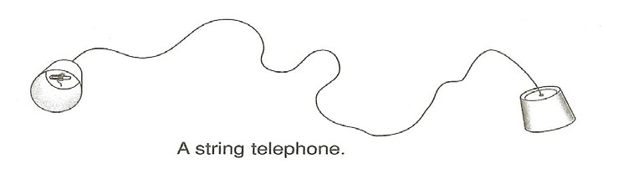

STRING ALONG

- Can you feel the vibrations in the string with your hand? Try it when the string is looser and when the string is loose and when it is taut. When does the string vibrate better, when it is taut or when it is loose? Explain your ideas in your journal.
- What are all the parts that must vibrate for your partner to hear you through the string telephone? List the parts in the journal.
- Now, build half a string telephone. Use a piece of string about 50 cm (18 in.) long, on paper cup, and one paper clip. Assemble them as you did in Activity 10, Step 10.
- Wet a small piece of paper towel. Hold the cup in one hand and use your other hand to slide the wet paper towel down the string. What do you hear? With practice you should be able to produce a sound similar to a rooster crowing.
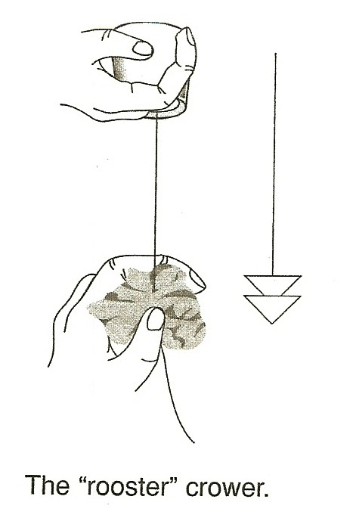
- Try wetting your fingers and not using the paper towel. How has the sound changed?
- Where did the loud rooster crowing sound from? What else is vibrating beside the string? The cup? The air inside the cup?
- Explain in your journal how the rooster crower is able to produce such strange sound.

SAFETY NUT:
Make sure all of the containers that you use for your string telephone are clean, dry and have no sharp edges!

IN A NUTSHELL:
The vibrations travel along the string to the cup, causing the air inside the cup to vibrate and produce the strings, loud sounds you hear.

CRACKING THE NUT:
How will the sound change if you use different materials for your telephone?
Try, for example, metal cans or milk cartons with different types of string or wire.

