REFLECTION, DIFFRACTION, REFRACTION

SECTION 11: DIFFRACTION OF LIGHT

Note: DO NOT look directly at the sun. A bright patch of sky will

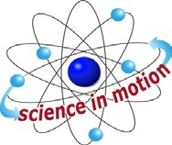
Westminster College

work just fine for this lab. DO NOT attempt to open up the small black box. This is your spectroscope and if opened the diffraction grating will become misaligned or lost.

PROCEDURE:
- The narrow end of the spectroscope has a small rectangular hole with a plastic sheet inside it. This piece of plastic contains the diffraction grating, to see the spectra you look through this piece of plastic into the spectroscope box. Aim the far end of the box so that the tiny slit on the far end is vertical and aimed at (or in the case of the sun near) the source of light you wish to observe.
- Shift the position and focus of your eyes slightly until the spectrum pattern appears projected beside the slit.
- Draw a sketch of what you observe from each light source. Try to be as accurate as possible.
Are you able to tell one light source from another by differences between the spectra of the different sources?
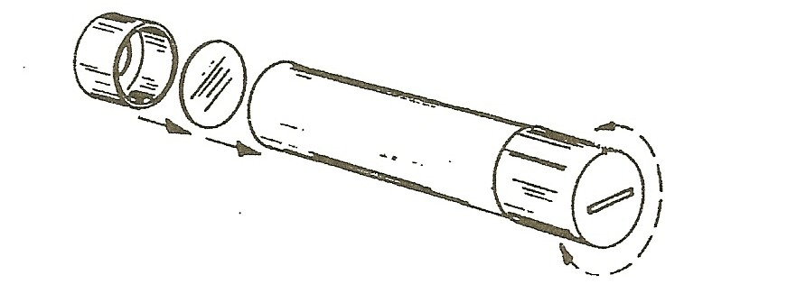

ADDITIONAL ACTIVITIES:
- CAUTION: Do this activity with adult supervision. If your school has a Bunsen burner and spectra salts, try burning small amount of the salts in the flame. While the salts change the color of the flame, study the flame through your spectroscope. Draw a chart showing the different patterns of spectra created by different materials.
- Instead of spectra salts your school may have a set of spectrum tubes and a power source to show them. If this is the case observe the spectra of each of the tube you have. Draw a sketch of each of the spectra you observe, are they different? These are called emission spectra, they are like a finger print for the material that is glowing.
- Find a chart that give the color spectra of different materials. How would the color pattern of a star tell an astronomer what material the star was made from?

Westminster College SIM Page 1

