REFLECTION, DIFFRACTION, REFRACTION

SECTION 12: REFRACTION OF LIGHT

GOAL: To demonstrate that light refracts, or bends, as it passes through different materials.
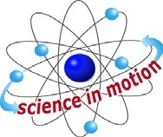
Westminster College

BACKGROUND:
Whenever a wave encounters a boundary between two different materials, its direction of movement is altered. This is known as refraction. The amount and direction of refraction depends on the materials that the wave if entering.

For example, a toy car is rolled across a corner of carpeting, with its right wheels on the carpet and the left wheels on a tile floor. The forward motion of the car will swing, or bend, towards the slower moving wheels on the carpeted surface.

The same effect is seen when a troop of soldiers marches across a field having a large muddy patch in its center. As each row of soldiers marches through the muddy section, the row will slow down, and alter direction slightly. Once the soldiers march out of the mud, the rows speed up again and return to their original direction.

The same thing happens to light waves as they move from air into a different material. Velocity is changed and the direction changes. In air, light travels at about 300,000 km/s, but as the light passes through glass its speed can drop as low as 197,000 km/s. As the light slows, it bends, or refracts.

This explains why white light refracts as it goes through a prism. The shorter wave-lengths (violet-blue) refract more than the longer (red) wavelengths. The separation of white light into the color spectrum is known as dispersion. In case of the light, shorter wavelengths such as blue refract more than a longer wavelength such as red. This allows up to separate light into the various colors in a different way than with diffraction.

The amount of refraction depends on the angle of the light as it enters the new material, and the change in speed of the light. Since it is somewhat difficult to measure the speed of light in the classroom we will focus our investigation on the angle at which the light enters the new medium. This is called the angle of incidence, it is measured form the normal line just as it was in our study of reflection.

MATERIALS:
Optics box colored pencils or crayons
Prism water
Flashlight with batteries graph paper
Flashlight cap/slotted ruler and pencil
black construction paper

Westminster College SIM Page 1

ASSEMBLY INSTRUCTIONS:
- Activities for this investigation are easier if students work as partners.
- The work area must be fairly dark to observe the light beams. Turn off nearby lights.
- Place slotted cap on flashlight.

PROCEDURE:
- Cover your work surface with newspaper to absorb any spilled water.
- Place a sheet of graph paper on top of the newspaper. Align the edge of the graph paper with the edge of the work surface.
- Half fill the semi-circular optics box with water. Place lid on box.
- Place the optics box on the graph paper, straight edge of box near the edge of the work surface and parallel to the horizontal lines of the graph paper.

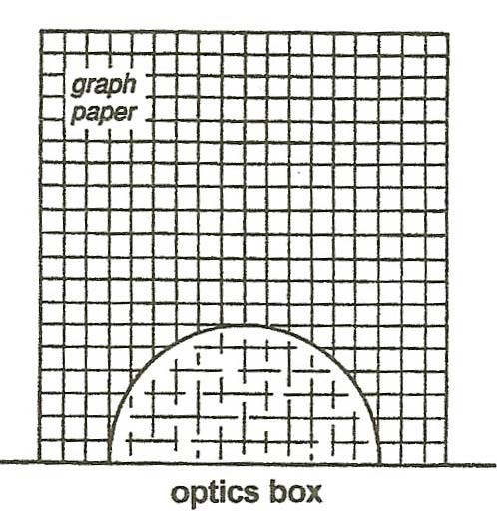
- Hold the flashlight just below the work surface, so a narrow beam of light enters the optics box. Keep the flashlight perpendicular to the straight edge of the optics box. The slit will be vertical. Practice until you have narrow beam of light enters the optics box.

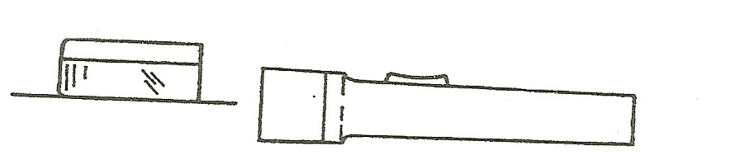

- Slowly move the flashlight along the straight edge of the optics box, from left to right. Keep the flashlight perpendicular to the optics box. Observe the beam of light as it enters the optics box. Place an X on the graph paper where the light beam enters the optics box.

- Trace the optics box on the graph paper.
- Move the flashlight back to the left side of the optics box and shine the light beam through the box at the first X. (Keep the flashlight perpendicular to the box.) Watch as the beam of light exits the optics box. Use your pencil to trace the path of the light beam as it exits the box.
- Point the flashlight at the optics box where the center X and right X are located. (keep the flashlight perpendicular to the box.) Trace the path of the light beam as it exits the box.) Observe the refraction of the light beam at each location. Sketch your results.
- Try shining the light into the optic box at different angles through the center
X. Does changing the incident angle change the angle the light refracts to?
- Turn the optics box around, so that the curved side is facing you. Try shining the light beam through the box on the curved side. Does it make a difference as to whether the flashlight is perpendicular to the curved surface or at an angle? Can you get the light beam to refract as much as before?

ADDITIONAL ACTIVITY
Add one or two drops of milk to the water in the optics box. Try shining the light beam through the cloudy liquid. Record your results. With what you know about reflection and refraction, make a hypothesis as to what is happening to the light beam.

