SECTION 12: THE GRASSHOPPER GAME

LAB

INTRODUCTION
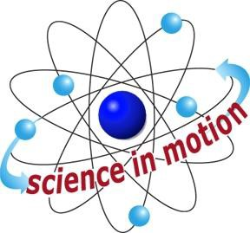
Westminster College

The grasshopper illustrates Newton’s third law of motion as it flips. When you push down on the grasshopper’s nose, the force is transferred to the table on which the grasshopper sits. As the grasshopper pushes down on the table, the table pushes upward on the grasshopper. In this activity, students experiment with two grasshoppers of unequal mass. The action and reaction forces are the same for each grasshopper but because one is less massive it will accelerate faster, and therefore jump higher and farther, than the more massive grasshopper.

ASSESSMENT ANCHORS ADDRESSED
S4.A.2.1 Apply skills necessary to conduct an experiment or design a solution to solve a problem.

S4.C.1.1 Describe observable physical properties of matter.

S4.C.2.1 Recognize basic energy types and sources, or describe how energy can be changed from one form to another.

S4.C.3.1 Identify and describe different types of force and motion, or the effect of the interaction between force and motion.

PURPOSE
In this activity, students construct action reaction flipping toys of different masses and then compare their performances.

MATERIALS
For Each Student Activity sheet 12 Grasshopper instructions Grasshopper patterns Scissors*

Teacher provides items marked with *

Westminster College SIM Page 1

