SECTION 13: CLACKER CONSERVATION

LAB

INTRODUCTION
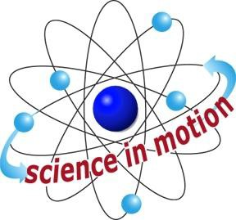
Westminster College

In this activity, students observe behaviors that confirm Newton’s third law of motion. That law states that for every action there is an equal and opposite reaction. Momentum is a property that a moving object has due to its mass and velocity: momentum (p) = mass (m) x velocity (v). The law of conservation of momentum states that the total amount of momentum of a group of objects does not change unless outside forces act on the objects. With Newton’s third law and conservation of momentum, you can explain all sorts of motion that may seem complicated at first. Examples include bouncing on a trampoline, knocking down bowling pins with a ball, and tackling a football player.

ASSESSMENT ANCHORS ADDRESSED
S4.A.2.1 Apply skills necessary to conduct an experiment or design a solution to solve a problem.

S4.C.1.1 Describe observable physical properties of matter.

S4.C.2.1 Recognize basic energy types and sources, or describe how energy can be changed from one form to another.

S4.C.3.1 Identify and describe different types of force and motion, or the effect of the interaction between force and motion.

PURPOSE
In this activity, students apply Newton’s third law of motion to the behavior of a popular toy­ the clacker, or clacking balls.

MATERIALS

For Each Group For the Class
clacker Activity Sheet 13 VCR
Videotape, Toys in Space

Teacher provides items marked with *

Westminster College SIM Page 1

