REFLECTION, DIFFRACTION, REFRACTION

SECTION 13: REFRACTION OF LIGHT

ROY G BIV is an acronym for the colors of the rainbow. White light is separated into a color spectrum according to its various wavelengths.
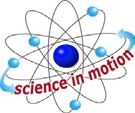
Westminster College

In order, the colors are: red, orange, yellow, green, blue, indigo (blue-violet) and violet. Red light has the longest waves that are visible to the human eye and violet light has the shortest.

PROCEDURE:
- This activity works better in a darkened room.
- Stand the prism vertically on the work surface.
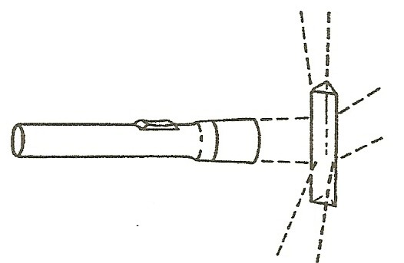

- Hold the flashlight about 15 cm from the prism and shine the light beam directly at the prism. Move the flashlight so the light first strikes one of the flat surfaces of the prism. Then move the flashlight so that the light beam strikes one of the sharp edges of the prism. What happens when the light beam strikes different parts of the prism?
- Aim the light beam at the sharp edge of the prism. Place a sheet of white paper underneath one of the refracted light rays.
- Use a set of colors to shade in the paper where the spectrum appears. How many colors of the rainbow can you detect? Is the entire spectrum for white light visible?
- Move the white paper under each refracted light beam. Is there a spectrum visible for each refracted beam?

Westminster College SIM Page 1

