REFLECTION, DIFFRACTION, REFRACTION

SECTION 14: CONVEX AND CONCAVE LENSES

BACKGROUND:
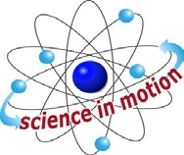
Westminster College

A lens is any transparent material with at least one curved surface that either magnifies or reduces an image. Your eye has a lens that focuses images on the retina. Light passes through a lens is refracted (bent) at the curved surface.

A lens can create either a real or virtual image. A real image can be focuses on a screen. A virtual image cannot be focused on a screen. The focal length is the distance from the center of the lens or mirror to the point where the light rays converge.

A convex lens, sometimes called a converging lens, brings light rays together. If an object is more than one focal length from the lens, a real image is formed. The real image will be upside down.

A convex lens will form a virtual image if the object is less than one focal length from the lens. This virtual image will be right side up and magnified to a larger size than the actual object. This is why a convex lens is used in magnifying glasses.

A concave lens, sometimes called a diverging lens, spreads light rays apart. This virtual image will always be right side up and smaller than the actual object.

The lenses in this kit are double convex and double concave lenses. This virtual image will always be right side up and smaller than the actual object.

The lenses in this kit are double convex and double concave lenses. That is, the lenses have two curved surfaces.

MATERIALS:
double concave lens pencil
double convex lens chalk dust flashlight
protractor chalk

PROCEDURE:
- Find the convex lens in the kit. The convex lens bulges outward on both sides. It is thicker in the middle than at the edges.
- Hold the convex lens in front of your eye, about 30 cm from your face. Look around the room. Describe the way distant objects look through the convex lens.

CONVEX AND CONCAVE LENSES

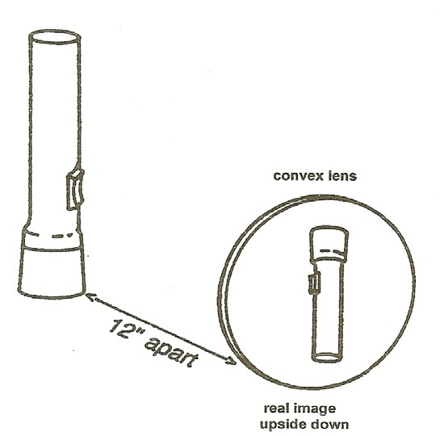

- Slowly move the convex lens up and down over the printed page. What do you observe as the letters move into and out of your field of view?

- Now slowly move the lens closer to and farther from the printed page. What happens to the image?

