SPACE CAMP

SECTION 2: COORDINATION STATION

OBJECTIVE:

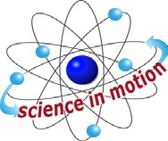
Westminster College

Astronauts train for weightlessness by carrying out operations in a gigantic water tank.

MATERIALS:
Stop watch
2 containers of water
2 nuts and bolts for each container paper towels

PREPARATION:
- Fill containers with water.
- Remove nuts from the bolts. Place 5 pair in each container.

PROCEDURE:
- Explain that students will be timed to match 2 nuts with its corresponding bolt using ONE HAND ONLY.
- Have students roll up their sleeves. Have 1 student at each container.
- Time students. When they have finished, they will say STOP. Tell them the time. Have them record their time on their worksheet.

Westminster College SIM Page 1

