ROCKS, FOSSILS AND SOILS

SECTION 2: EDIBLE ROCKS
From Hands on Science by Linda Poore, 2003

STANDARDS:

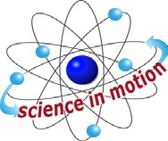
Westminster College

Students know how to compare the physical properties of different kinds of rocks and that rock is composed of different combinations of minerals.

Students will measure weight and length with appropriate tools and express measurements in standard metric units.

MATERIALS:
For Each Student For the Teacher
1 granite rock 10 spring scales (grams)
1 cookie 10 paper cups (clean)
1 toothpick
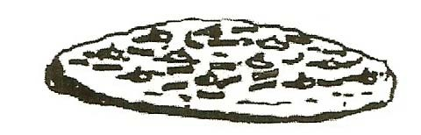
1 paper towel
worksheet My Cookie Rock

KEY WORDS:
ROCK: One or more minerals. The Earth mixes the minerals together by melting them using heat and pressure. As the materials cool, the mixture becomes rock made up of distinct minerals. The amount and type of minerals determine the type of rock. Geologists examine rocks and classify them according to their minerals.

SAFETY:
Remind students that toothpicks are sharp. Keep toothpicks away from eyes.

IN ADVANCE:

MAKING COOKIES
Have students or parents make cookies at home, adding many of the following ingredients to a standard cookie mix: chocolate chips, raisins, butterscotch chips, M & M’s, nuts, etc. Students not making cookies could bring in one ingredient. Quick Cookies: Mix 3 cups of Krusteaz® cookie dough mix with water, following package instructions.
Add the extra ingredients listed above.
For each student, place a heaping tablespoon of dough onto a piece of foil. Bake according to package directions.

EDIBLE ROCKS

EXPLORE:

DISSECTING COOKIE ROCKS AND COUNTING MINERALS
- STORY LINE:
Read the following to the students and write a list of the ‘mineral’ ingredients you used on the board:
“Dear Fellow Scientists: These edible rocks were discovered near the mouth of an abandoned mineshaft in Millard Canyon. The old miner, named Dusty, who first showed them to me told me that if you take the rocks apart very carefully, you may find some precious minerals. Can you find copper (*gold raisins), feldspar (*cranberries), mica (*raisins), quartz (*white chocolate chips), fool’s gold (*butterscotch morsels)?”
(*Substitute ingredients that you actually used in the cookies.)

REVIEW AND REINFORCE:
Review: Give each student 1 granite rock.
Have them describe the different parts that make up the rock.
These are the minerals that make up granite rock. (The shiny, black flakes are mica, the clear or cloudy white chunks are quartz, the pink is feldspar.)

EXPERIMENT:
Give each child a cookie on a paper towel. DO NOT EAT THE COOKIE
List on the board all the parts that make up the cookie.
Tell Students: Pretend the cookie is a rock. What would you call each part? (minerals)
You are going to measure the cookie and then carefully take the cookie apart and put its ‘minerals’ in separate piles.

- MEASURING IN CENTIMETERS AND GRAMS Give each student the worksheet My Cookie Rock. Predict which mineral you think your cookie has more of.
Use the spring scale and a clean paper cup to weigh each cookie.
Measure the cookies length. Thickness can be measured by placing the cookie on its side or sticking a toothpick in a cookie and measuring how far it went in.
Pass out the toothpicks and let students dissect the cookie rocks. No eating until after the discussion.

ANALYZING
Which mineral was found to be the most common in your cookie ‘rock’? Which mineral was the least common? Name your rock and eat it.

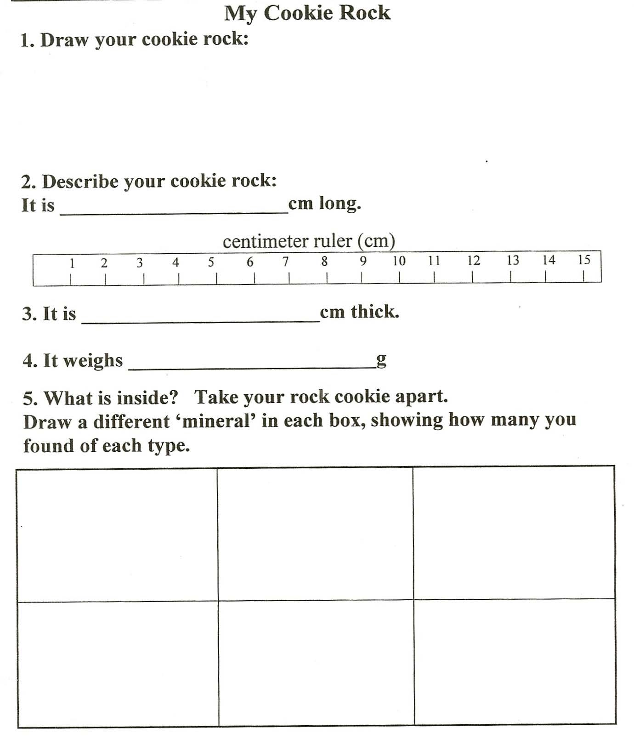
EDIBLE ROCKS

