SECTION 2: GRAVITY AND BALANCE

LAB

INTRODUCTION
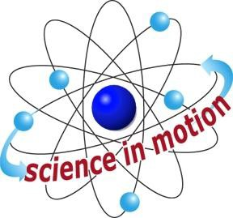
Westminster College

This review activity introduces the concepts of gravity and weight. In the activity, we assume that students are familiar with the term gravity and know that it is the force pulling objects toward the center of the earth.

If an object is not moving, all forces on it must be balanced. The gravity force is pulling down on all objects on earth’s surface. If an object is not falling, an upward force must be supporting the object against the downward pull of gravity. This gravity support force is equal in strength to gravity’s downward pull. This is the important and perhaps unfamiliar force that students identify in this activity.

To measure gravity force, we measure the gravity support force required to keep an object from falling. A spring scale is used for this measurement. The spring stretches more when the object pulling down on it is heavier. The spring scale is calibrated in grams and also in Newtons, a metric unit named after Sir Isaac Newton.

Weight is the strength of the gravity force pulling down on an object. The unit of weight is the Newton (N) in the metric system the pound (lb) in the English system. This activity references the pound because it is so familiar in the US. The gram is not a unit of weight. The gram measures mass, or the amount of matter that an object contains. To increase familiarity with the Newton, students convert their own weight from pounds to Newtons.

ASSESSMENT ANCHORS ADDRESSED
S4.A.2.1 Apply skills necessary to conduct an experiment or design a solution to solve a problem.

S4.C.1.1 Describe observable physical properties of matter.

S4.C.2.1 Recognize basic energy types and sources, or describe how energy can be changed from one form to another.

S4.C.3.1 Identify and describe different types of force and motion, or the effect of the interaction between force and motion.

Gravity and Balance

PURPOSE
In this activity, students are introduced to gravity as the force that pulls objects toward the earth’s center. They learn how to measure the magnitude of this force and recognize that there must be a gravity support force whenever an object is not falling.

MATERIALS

For Each Group For the Class
Activity Sheet 2 Calculator*
Bag for spring scale Bathroom Scale* Wooden ball
Spring scale
Teacher provides items marked with *

