MACHINES AND MOTION

SECTION 2: INCLINED PLANES HELP US DO WORK

STANDARDS:

Westminster College

Students know tools and machines are used to apply pushes and pulls (forces) to make things move.

Students will measure length, weight, temperature, and liquid volume with appropriate tools and express those measurements in standard metric system units.

Students will make predictions based on observed patterns and not random guessing.

IN ADVANCE:
Ask a student to bring in a brick and a long board (at least 12” x 5’ x 1”)

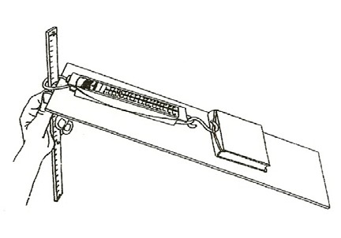
MATERIALS:
1 spring scale rubber band
1 ramp (masonite board) Machine Lab Work Sheet
*objects to weigh (scissors, shoe, etc.)

EXPLORE:

MEASURING IN GRAMS
- Fold a paper in thirds and label the columns:
Object It weighs The force I use to lift it up a steep ramp Lift each object with the scale. Record the weight in grams.
- Make the ramp steep. Pull each object up the ramp with the scale and record the amount of force needed to pull the object up the ramp.

- The ramp is an inclined plane.
Write one sentence telling what you learned about inclined planes. It may take less force to lift an object up the ramp. (friction) Which objects do not slide easily? (objects with friction)
How does friction affect the results? (harder to pull =more force needed)

ASSESSMENT:
List the variables that causes some items to need more force than others to pull them up the ramp. (weight, friction from object rubbing—shoe had lots of friction compared to book, angle or ramp, etc.)

NOTE:
Place a rubber band inside the cover of each book so it can be pulled using the spring scale. This method prevents the rubber band from rubbing on the ramp, producing friction. The book should weigh between 500 and 700 g, and all teams should use the same book (e.g., reading book) to control the variable of weight.

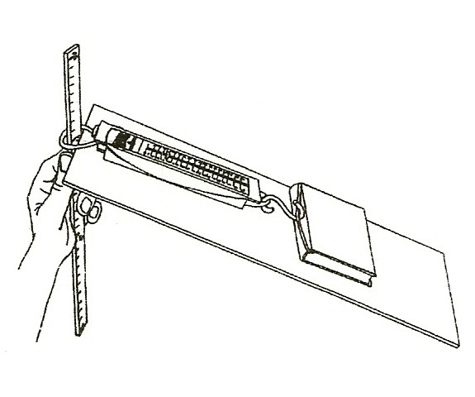
COMPARING INCLINED PLANES MATERIALS:
1 ruler
1 book with rubber band 1 ramp
worksheet
1 spring scale

EXPLORE:
EXPERIMENTING WITH RAMP ANGLE
- Pass out the worksheet for Activity 3. Weigh the book.

- Have students: Pull the book up the ramp 3 times, changing the ramp angle each time.
Try the ramp at a height of 10 cm, 20 cm, and 30 cm. Record your results on the worksheet.
What variable did you change in these experiments? (ramp angle)

- Write a sentence to tell how an inclined plane (ramp) helps do work. (When the ramp angle is small, less forced is needed. A longer ramp will result in a smaller ramp angle.)

MATERIALS:
1 long board
1 short wood board 2 spring scales

ASSESSMENT:

COMPARTIN LONG AND SHORT RAMPS
- Set up a long ramp and a short ramp to a height of 20 cm. Both ramps lift the object to a height of 20 cm.

- Have students:
Predict which ramp will require the most force to lift the book. Lift the book 20 cm and record its weight.
Write an estimate of the amount of force needed in grams to lift the object using each board.

DEMONSTRATE:
Have one student lift the book 20 cm by pulling it up each ramp.
Record the amount of force it took to lift the book up the long and short ramp. Have all students write a conclusion on the worksheet for Activity 3 comparing the short and long ramps, using the words force, ramp, distance.

HOW DOES RAMP ANGLE AFFECT THE AMOUNT OF FORCE NEEDED?
Which ramp is steeper for lifting the object the same height, short or long ramp? (short)
Which ramp requires the most force to lift a book 20cm? (short) The long ramp ‘spreads’ the work over more distance.

ASSESSMENT:
Photocopy the following or write on the chalkboard:
- You need to put a very heavy box onto a truck. Which board would help the most? I would choose a board that is: (circle one)
6’ long 12’ long 20’ long

- Draw a picture to show how you could use the board to help you lift the box onto the truck. Draw the box, board, truck, and you.

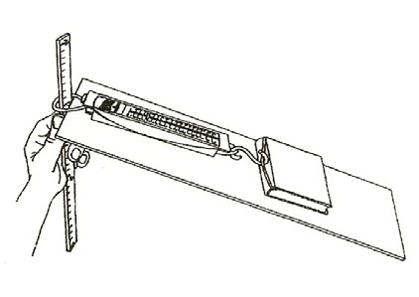
How does ramp angle affect the amount of force needed?

The book weighs g.

Pull the book up each ramp. How much force do you need?

 | Force I used to pull the book up the ramp
Ramp is 10 cm high | g
Ramp is 20 cm high | g
Ramp is 30 cm high | g

Finish this sentence:
The steeper the ramp

Would you use a long or a short ramp to help you lift a heavy box into a truck?

Which would make the work easier? Explain:

