MAGNETS

SECTION 2-MAKING A MAGNET?
From Hands on Science by Linda Poore, 2003.

STANDARDS:
Students will conduct multiple trials to test a prediction and

Westminster College

draw conclusions about the relationships between predictions and results.

Students will follow a set of written instructions for a scientific investigation.

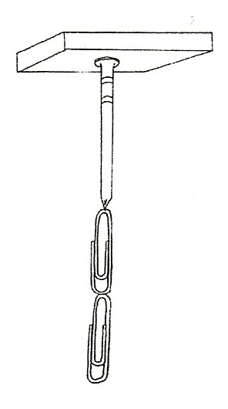
NOTE:
Steel objects left next to a magnet will become a magnet. Keep nails, staples, and pins separated from all magnets before this activity.

IN ADVANCE:
Have a student use a staples to eject 10 staples into each plastic tray. Do Not put the magnets in the trays. Keep the staples separate from all magnets until ready to experiment. If you do not have staples, use the pins in the kit.

MATERIALS:
For Each Student:
5 nails
10 staples in a plastic tray 1 magnet

EXPLORE:

1. CAN A NAIL BECOME A MAGNET?
[S, instruction] [ S, trials/conclusions]
Pass out the student worksheet: Making a nail a magnet.
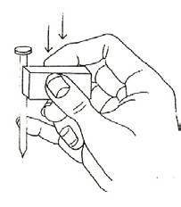
Discuss the work sheet.
Ask the students to make the nail a magnet so it can pick up staples. Students first place a magnet on top of the nail.
Will the nail pick up staples if you remove the magnet? How many? (The nail remains a magnet for a few minutes.)

- The students stroke a nail in one direction with a magnet to make the nail a magnet and test the stroked nail to see how many staples it will pick up.
- HOW DOES THE NUMBER OF STROKES AFFECT THE NAIL’S MAGNETIC FORCE? (Record on the work sheet.)

The students compare nails stroked with the same magnet different amounts of times.
How many staples does each one pick up? How can you make a stronger ‘nail magnet’?
Put 2 stroked nails together to see if they attract or repel. (Staples left near a magnet will become a magnet.)

- Make a transparency of the chart, What Makes a Magnet Work,
Introduce the words atoms and domains and discuss.

MAKING A NAIL A MAGNET

Place the magnet on top of the nail.
How many staples do you pick up? How many nails do you pick up?

Place 2 magnets on top of the nail.
How many nails do you pick up?

Remove the magnets. Is the nail still a magnet? How many staples will it pick up without the magnet?

Rub the magnet on the nail in one direction.
How many staples will it pick up after 30 strokes? Complete the chart below. Use a different nail for each experiment.
Try each experiment 3 times.

Number of Staples Picked Up:

Number of Strokes | 1st try | 2nd try | 3rd try
30
50
75
100
150

Describe how to make this nail magnet stronger.

How long will the nail magnet pick up staples?

How could you find out?

