**WEATHER**

# SECTION 2: MAKING A THERMOMETER

From *Hands on Science by Linda Poore 2003.*

# STANDARDS:

**Westminster College**

*Students will* record observations and data with pictures, numbers, or written statements.

# MATERIALS:

*For Students For Teacher*

12 vials (50 ml) red food coloring

12 plastic tubes with stoppers ice chest with ice

ruler hot pot

small rubber bands water

worksheet tall, slim jars

# IN ADVANCE:

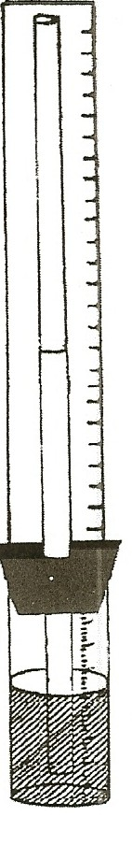Till the 12 vials half-full with pink water. Put the stopper-tube in the vial firmly. The water should fill about one-third of the tube. (You can gently shake out water if there is too much in the tube.) Attach a ruler to each vial with 2 rubber bands: one around the vial and ruler and one around the top of the tube and the ruler.

**WORK SHEET:** Before Xeroxing the worksheet, write numbers along the ruler. The ruler reads 1-30 or 1-12, on the reverse side, for students who have trouble with numbers. The ruler on the vial must match the picture on the worksheet.

# EXPLORE:

## MAKING A THERMOMETER

**HOW DOES A THERMOMETER WORK?**

1. Have students draw a picture of their ‘vial’ thermometer at room temperature. How high up the ruler is the water? Write the number to show where the water is at room temperature. Color in the thermometer on the worksheet for room temperature.
2. Have students predict what will happen if they make the vial warm. Students should rub their hands together quickly to warm them. Have students hold the ‘vial thermometer’ on their desk in warm hands. (don’t shake it) What happens? (The liquid goes up.)
3. Pass out 1 jar with 2” of hot water and 1 jar with 2” of ice water to each team of 4 students. Let them place their ‘vial thermometer’ in hot water. At what number on the ruler did the water stop? Color the hot thermometer on the worksheet and write the number on the ruler it went up to.

## Westminster College SIM Page 1

*MAKING A THERMOMETER*

1. Place it in the cold water and record the number on the worksheet.
2. **WHY?** The liquid in a thermometer expands when it gets warm, moving up the plastic tube. The liquid contracts when it gets cold. (In the student ‘vial thermometers’ it is actually the air in the vial that is expanding and pushing the water up the tube, therefore the vials are half full of water to allow enough air for it to work.)

# NOTE:

## HOW DO *REAL* THERMOMETERS WORK?

Alcohol or mercury expands readily when warmed, moving up the very thin thermometer tube. Water expands and contracts very little. The hand-made thermometer works because the air in the vial expands pushing the water up.

## Westminster College SIM Page 2

*MAKING A THERMOMETER*

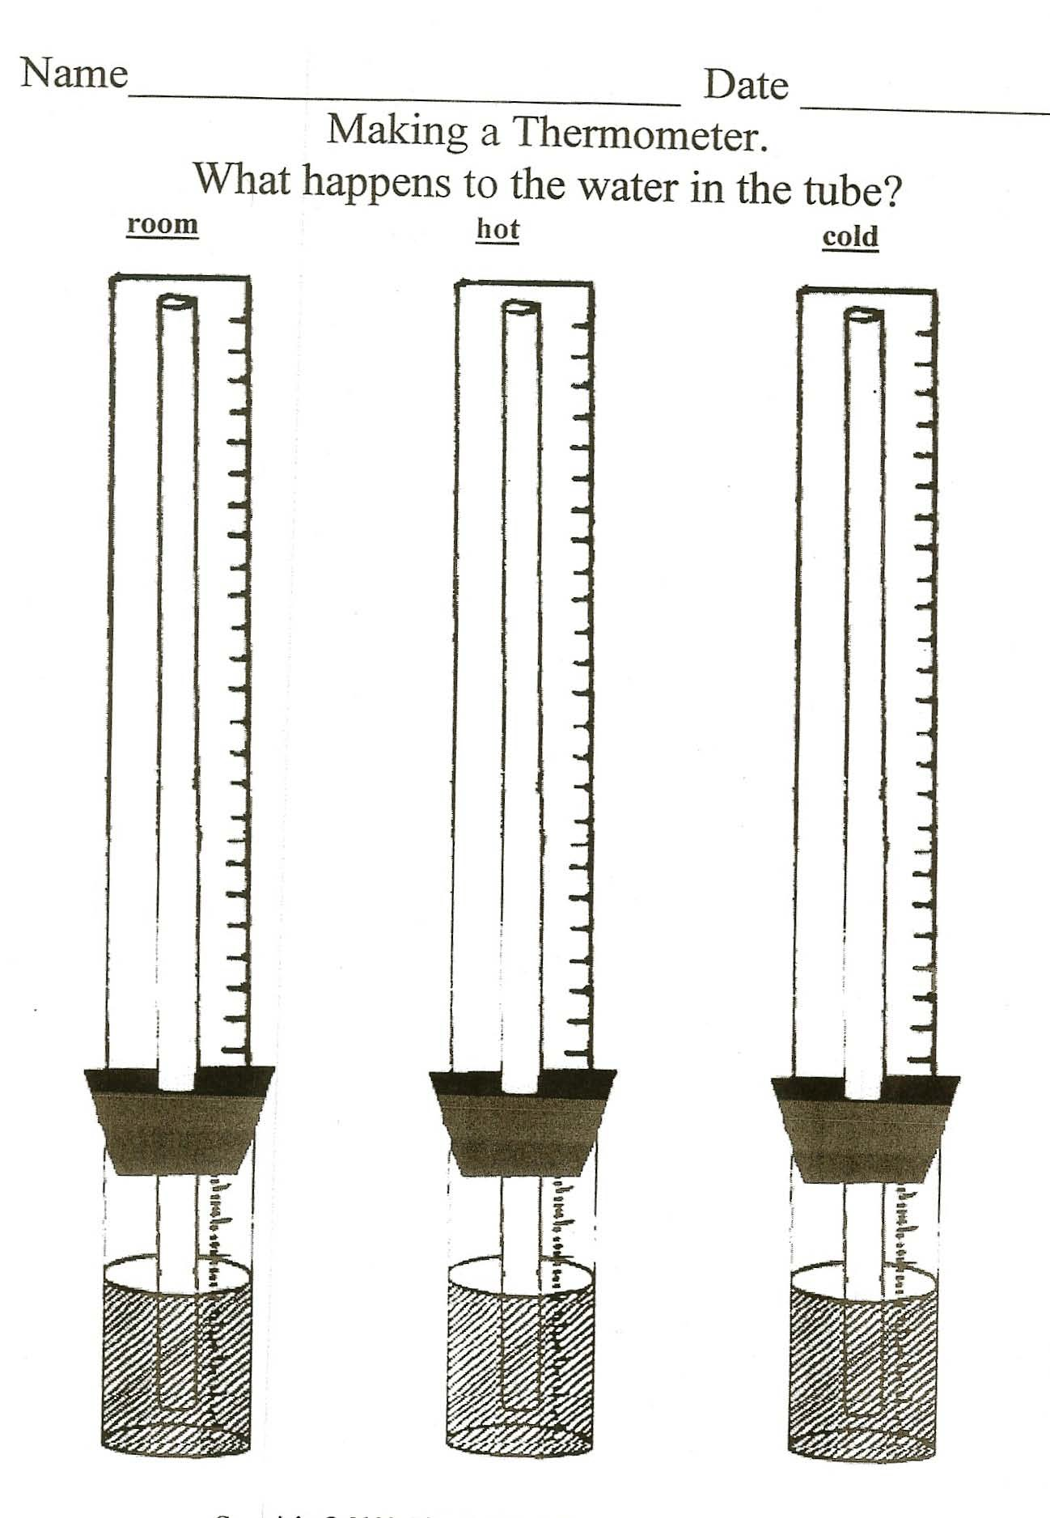

**Westminster College SIM** Page 3