SOUND VIBRATIONS

ACTIVITY 2: MAKING SOUNDS
From Science in a Nutshell

OBJECTIVE:
To investigate how sounds are produced.

MATERIALS:
balloon
journal page for Activity 2 metal strip
rubber band, thick table or desk tuning fork

Westminster College

BACKGROUND:
If an object is making a sounds, that object is vibrating, or moving back and forth rapidly. Many objects around you will vibrate and make sounds.

Look in the kit and find the tuning fork. When a tuning fork is struck against an object, its vibrations make the same sound every time. Always strike a tuning fork against a rubber-soled shoe, not against a desk or a table. Hard surfaces can damage the tuning fork and the tuning fork can damage the furniture.

In this activity, you will explore way to produce sounds using some of the objects in your kit.

EXPERIMENT:
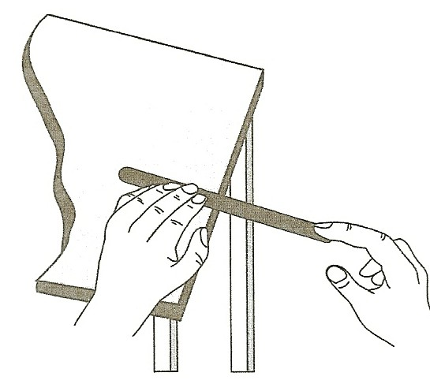
- Examine a rubber band, a metal strip, a balloon, and a tuning fork. Try to get each object to make a sound.
- On your journal page, record the different ways you were able to get each item to make a sound.
- Stretch a thick rubber band between your fingers. Pluck it using a finger on your other hand. Observe what is happening to the rubber band while it is making sound.
- Position the metal strip on the desk or table so that most of the metal strip sticks out beyond the edge. Hold the metal strip firmly against the surface of the desk by pressing on it with one hand.
- With a finger on your other hand, press down gently on the free end. Let your finger slide off.
Observe what happens while the metal strip is making noise.

MAKING SOUNDS

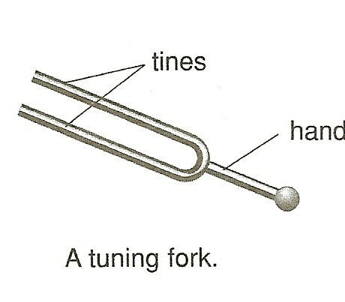
- Blow up a balloon. Stretch the neck of the balloon and let some air escape. Did you hear a sound? Observe the neck of the balloon when it is producing a sound.
- Hold the handle of the tuning fork in your hand with the two tines facing up. Strike one tine against the heel of your shoe or sneaker and hold it near your ear. What happens?
- How can you stop the tuning fork from producing a sound? Record your observations in your journal.
- In your journal, record how the actions of the rubber band, metal strip, balloon, and tuning fork are alike when they make sounds.

IN A NUTSHELL:
Sound is produced when an object moves back and forth rapidly (vibrates).

CRACKING THE NUT:
Hold your fingers against your throat. Start to talk, sing, or hum. What do you feel? What is it that vibrates when you speak?

SAFETY NUT:
Everyone should have his or her own balloon. Share observations, not germs.

