LIGHT

SECTION 2-SHADOWS AND LIGHT
From Hands on Science by Linda Poore, 2003.

STANDARDS:
Students know sunlight can be blacked to create shadows.

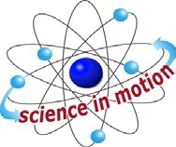
Westminster College

Students know an object is seen when light traveling from an object enters our eye.

Students know the color of light striking an object affects the way the object is seen.

Students will repeat observations to improve accuracy, and know that the results of similar scientific investigations seldom turn out exactly the same because of differences in the things being investigated, methods being used, or uncertainty in the observation.

Students will differentiate evidence from opinion, and know that scientists do not rely on claims or conclusions unless they are backed by observations that can be confirmed.

PRETEST:
Give students the Light and Shadows Pretest at the end of this section.

TEACHING TIP:
Use a dark room or have students do these experiments under their section.

MATERIALS:
For Each Pair: For The Teacher:
flashlight with batteries wax paper
pencil overhead projector
ruler masking tape
white paper plastic bag

EXPLORE:

HOW DO YOU MAKE SHADOWS BIG?
Tell students to stand up to make shadows of their pencil on their desk.
Challenge students to:
Try to make the shadow bigger than your desk. Make the pencil shadow small.
Make it fuzzy. Make it sharp (focused)
Pass out materials. Turn the lights off. Experiment.

CAN YOU MAKE A CURVED OBJECT LOOK STRAIGHT?
(Use paper circles, round math blocks, or a roll of masking tape. Turn the circle’s side or edge to the light to make its shadow a straight line.)
Can you make a straight object look curved? (The shadow of a ‘straight’ pencil may appear to curve near the middle of the pencil.)

[S, observations-evidence]
- How does a lamp shade affect shadows? Predict.
Place white paper over the flashlight to make a lampshade. (Light is diffused-not as bright.)

MAKING SHADOW ANIMALS
Pass out the worksheet, Making Shadow Animals.
This can be done in class or as a homework activity.
Students can practice at home, creating new animal shadow forms. Use an overhead projector as light source. Let students practice.
Students can also place a flashlight and hand behind photocopy paper to make shadow shapes that can be seen from the other side of the paper by their partner.
The hand should be closer to the paper than the light.

ART:

MAKE SHADOWS PUPPETS.
Shine light on the puppets behind a white paper. Put on a play.

ASSESSMENT:

PHOTOCOPY THE FOLLOWING CHART FOR EACH STUDENT:
Have students copy this chart and write predictions:

I predict I found out
1. If a hand is close to the light will its shadow be big or little?
2. If a hand is close to the light will its shadow be fuzzy or clear?
3. Will a plastic bag make a shadow?

Next, use an overhead projector and show the students the experiments. Have them record what they observe under “I found out.”
Answers: 1.(big) 2.(fuzzy-unfocused)? 3.(bag makes a light shadow)

[S, conclusions-evidence] [S, shadows]

KEY WORDS:
TRANSLUCENT:
Transmits light but the light is scattered inside the material so you cannot see through it. (Only light passes through it.)

TRANSPARENT:
Material that lets most of the light pass through it. You can see objects through transparent materials.

OPAQUE:
Materials that do not transmit light. (Cannot see through it.)

EXPLORE:
- WHAT OBJECTS ARE TRANSPARENT? [S, light-see] Introduce the word transparent by holding up a plastic bag to show it is ‘see through.’ If you can see the object through it, it is transparent. Look for transparent objects in the room. (Clock cover, window)
Compare wax paper and clear tape. Which is more transparent? Hold an object behind the wax paper so it is 1” from it, touching it, and 1’ behind the wax paper. When can you see the object?
Some items like wax paper are ‘semitransparent’ as you can see the object through it if the object is touching the wax paper, but not if it is further behind it. If it only lets light through, it is translucent.

TRANSLUCENT OBJECTS LET ONLY LIGHT THROUGH?
[S, observations-evidence] [S, predict]
PREDICT:
Can you see an object through white paper? (No)
Hold your hand behind the paper and have a student shine a flashlight behind your hand, toward the paper. [You can see your hand’s shape (shadow) if it is touching the photocopy paper.] Translucent objects let light through.
List translucent objects in the room (light fixtures?).
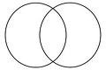
Make a Venn diagram to classify objects s transparent and translucent, with semi-transparent objects in the center circle.

Venn Diagram

OPAQUE:
Introduce opaque. (You cannot see objects or light through anything opaque.) List opaque objects in the room. [S, light-see]

COMPARING SHADOWS:
Compare the shadows made by transparent, translucent, and opaque objects. Darken the room and use an overhead projector.
PREDICT: Which objects make dark shadows? (opaque)

Which objects make light shadows? Experiment. Discuss.

MATERIALS:
For Each Pair:
1 flashlight with batteries
bag of objects to test from Section 1

EXPLORE:

CLASSIFYING OBJECTS, TRANSPARENT, TRANSLUCENT, OPAQUE
Keep the classroom lights on. Have students:
Place a flashlight on their desks so it shines on the ceiling and hold each object above the light.
Put all objects into one of 3 groups: transparent, translucent, or opaque. Try any other objects at your desk. (book, your shirt sleeve, hand)

[S, see-light]
- Compare student results. Discuss. Retest any items students disagree on.

[S, repeat-accuracy]

ASSESSMENT:
HOMEWORK:
Use the homework worksheet. Tell students that objects that are sometimes transparent can be drawn covering both the translucent and transparent lines. Students are to bring at least one example of each to school. Ask students to test a glass of milk, a dollar bill, their hand, and other objects. [S, repeat-accuracy]

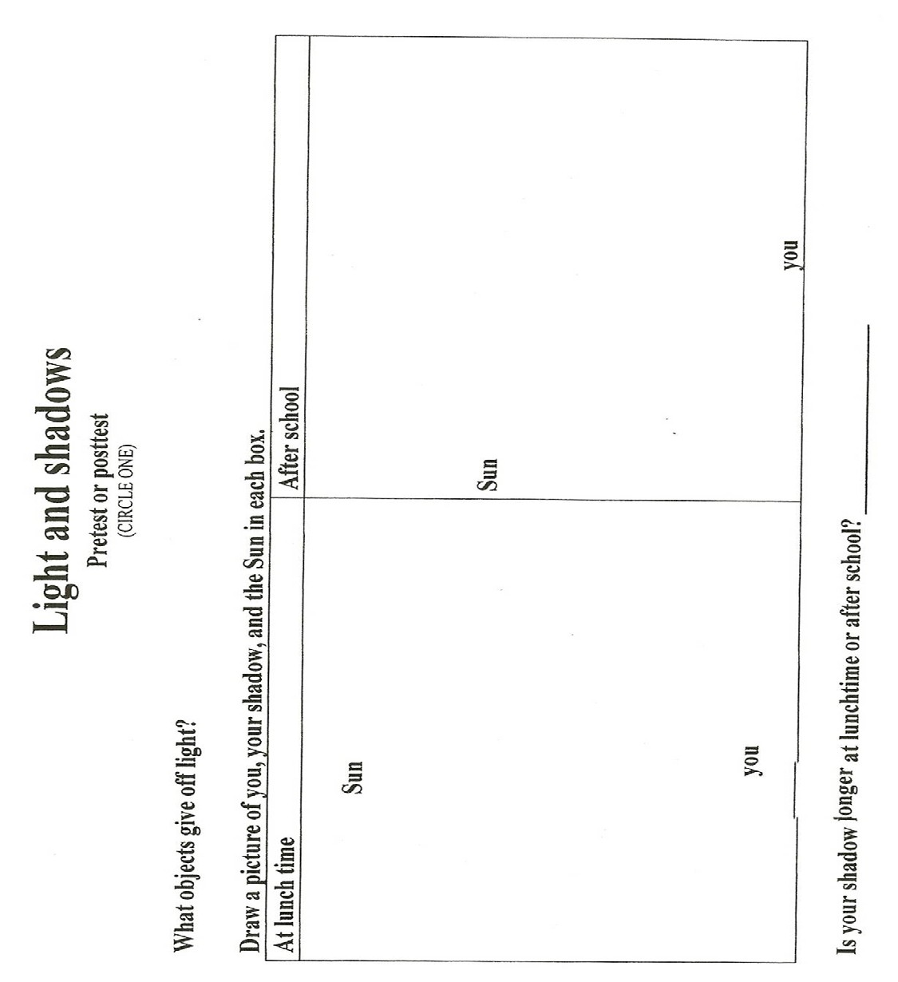

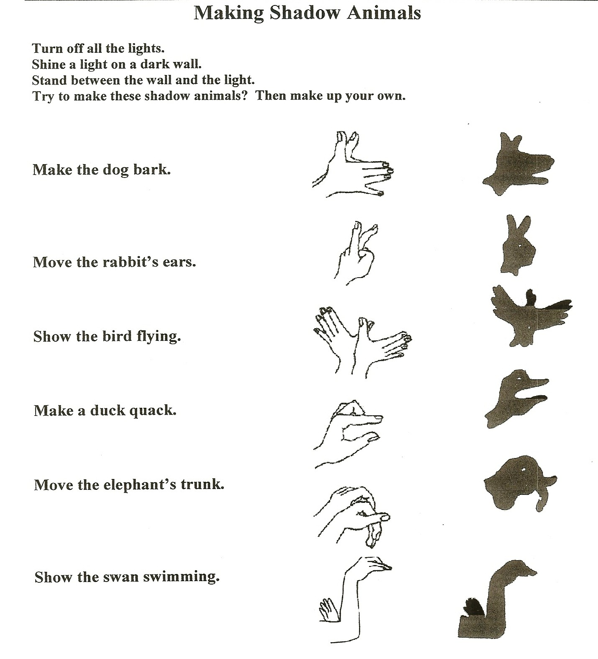

TRANSPARENT, TRANSLUCENT, OR OPAQUE

FIND OBJECTS THAT ARE TRANSPARENT, TRANSLUCENT, AND OPAQUE.

Draw and label the items below.
(If it is barely transparent, draw it on the line between transparent and translucent.)
TRANSPARENT MEANS | TRANSLUCENT MEANS | OPAQUE MEANS

