ROCKS, EROSION AND WEATHERING

SECTION 2-TESTING ROCKS FOR HARDNESS THE SCRATCH TEST
From Hands on Elementary School Science by Linda Poore, 2003.

Westminster College

STANDARDS:
Students will formulate and justify predictions based on cause-and-effect relationships.

Students will follow a set of written instructions for a scientific investigation.

MATERIALS:
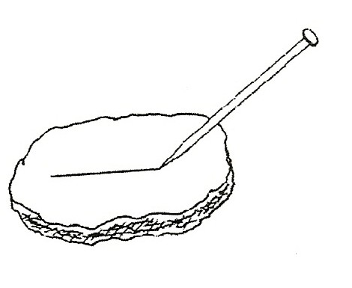
For Each Pair:
tray with rocks:
1 quartz 1 limestone
1 shale rock 1 rock salt
1 granite 1 sandstone
1 feldspar 1 nail
chalk from chalkboard 1 penny glass jar
rocks students bring from home student work sheet

NOTE:

MINERAL HARDNESS SCALE:
- rubs off on fingers talc
- can be scratched by fingernail gypsum
- can be scratched by a penny calcite
- can be scratched by a steel nail fluorite
- can be scratched by a steel nail apatite
- scratches glass feldspar
- scratches steel or glass quartz
- scratches quartz topaz
- scratches topaz corundum
- scratches all materials diamond

You can copy this scale on a transparency to use during the class discussion. Harder minerals scratch softer ones. The scale goes from one to ten. (soft to hard)
Do Not test a diamond as it may crack on a flaw.
Tiny diamonds imbedded in steel are used in industry to cut other materials.

Testing Rocks for Harness-The Scratch Test

EXPLORE:

WHICH ROCKS ARE SOFT? [S, instructions]
- Use the work sheet at the end of this section to test rocks and record results. Pass out trays of rocks.
Place all the rocks on the desk.
List the names of all the rocks on the board. Have students identify each rock they recognize.
Name each rock. Write a description on the board for each rock. Record descriptions on the work sheet, Testing Rock Hardness.

MAKING PREDICTIONS: [S, predict]
- Have students: Observe rocks. Predict which are harder. Sort rocks into 2 groups: harder/softer.
Compare student ideas and discuss.

FINGERNAIL TEST:
- First try to scratch each rock with your fingernail. (chalk, shale)
Hardness scale: 1 or 2 – The scratch mark does not rub off.) Record these rocks on your chart. Return these rocks to the tray. Only experiment on the remaining rocks, which are harder. Emphasize for students to try each rock only once, so rocks are not destroyed.

PENNY TEST:
- Which rocks will a penny scratch?
Record answers on work sheet. (rock salt-hardness is 2.5)

NAIL TEST:
- Test the remaining rocks to see if a nail scratches them. Rocks that were not scratched by the nail are the hardest.

GLASS TEST:
- Test the hardest rocks only. Turn a jar upside down on your desk. Try scratching the bottom of the jar. Remember, if the rock scratches the jar, the scratch won’t rub off. (Hardness scale: 6 or 7-feldspar, quartz)
Safety: Do not break the jar. Hold the jar with one hand when testing a rock.

- Compare results and discuss. Identify the rocks by name. Compare predictions with results. Collect all rocks. [S, predict]

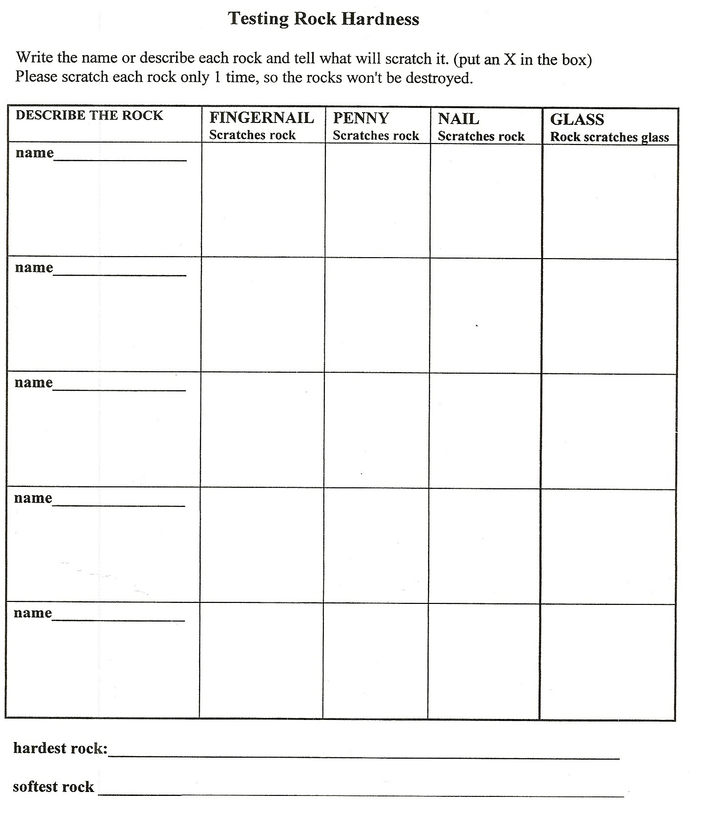
Testing Rocks for Harness-The Scratch Test

