SPACE

Section 2-THE MOON ORBITS THE EARTH
From Hands on Elementary School Science, Linda Poore 2003

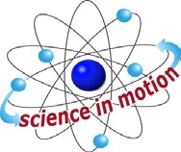
Westminster College

Standards Addressed:
Students know how the moon’s appearance changes during the four-week lunar cycle.

Students know that the Earth is one of several planets that orbit the Sun and that the Moon orbits Earth.

Students will differentiate evidence from opinion and know that scientists do not rely on claims or conclusions unless they are backed by observations that can be confirmed.

IN ADVANCE:
Hang the lamp in the middle of the room, from the ceiling, by putting a clothes hanger through the handle. If this is not possible, have the students sit on the floor for this activity so the lamp can be placed on a desk, above their heads. These activities works best in a dark room.
If you cannot make the room dark, have the students stand closer to the lamp. The students will notice that the side of the Styrofoam ball that is lighted sparkles as it reflects light.

PRETEST:
Ask students to draw what the moon looks like. Tell them they can make more than one drawing.

MATERIALS:
FOR EACH PAIR: FOR THE CLASS:
1 Styrofoam ball 1 Lamp with bulb attached to a book
1 Toothpick 1 Moon poster
Extension cord (provided by teacher)

NOTE:
ROLE PLAYING: Students can take turns being the Earth while their partner makes the moon ‘revolve around them.’

EXPLORE:

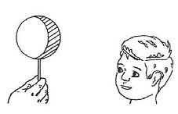
THE PHASES OF THE MOON [S, moon orbits]

THE MOON REVOLVES AROUND THE EARTH
- Show students the moon chart in the kit.
Ask them why the moon changes during the month. The revolves around the Earth once every 27.32 days.

THE MOON REVOLVES AROUND THE EARTH
To see why the moon changes during the month, give each teach of 2 students 1 moon (ball) on a toothpick.
One student holds the ‘moon’ and walks around the other student one time. The second student is the ‘Earth.’

THE MOON REFLECTS THE SUN’S LIGHT [S, evidence-observation]
How does the ball get light? (from the lamp)
The moon gets its light from the Sun. When the Sun shines on the moon, its light reflects off the moon and we see the light.
Have the students stand in a circle with their backs to the lamp. Turn on the lamp. Darken the room.
Have students:
Hold the Styrofoam ‘moon’ up above their heads. The ‘moon’ is lighted. This shows the ‘full moon.’
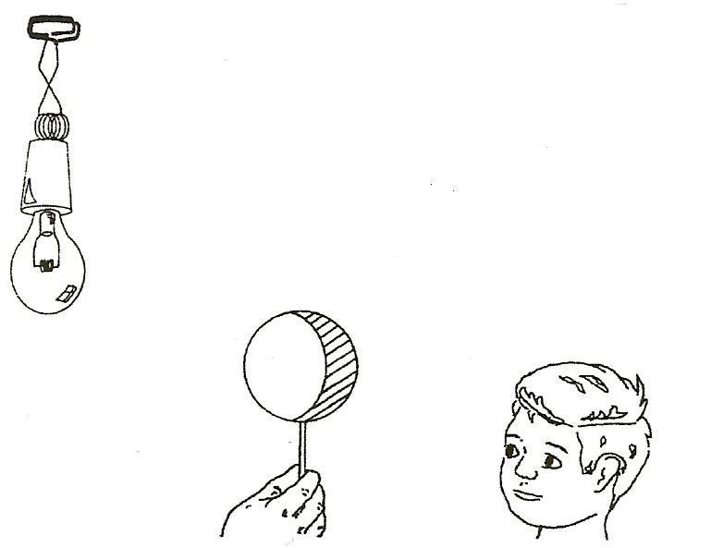
The Styrofoam sparkles where the lamp’s light is reflected.

WHY DOES THE MOON CHANGE DURING THE MONTH?
[S, moon-changes]
One side of the moon always faces the Sun, reflecting the Sun’s light. We see part of this lighted surface depending on where the moon is on its journey around the Earth.
During a full moon, we see the moon’s entire lighted surface. During a new moon this lighted surface is not facing the Earth.

VIEWING THE MOON’S PHASES: [S, evidence-observations]
[S, moon-changes] FULL-GIBBOUS-HALF-QUARTER-CRESCENT-NEW
All pairs of students are to face the ‘sun’ lamp that is hanging in the center of the room. Darken the room.
Have one partner hold the moon above their heads, and in front of the second student’s face. The other student is the Earth. The student observes how the light on the moon changes as the moon slowly moves around him [The ‘Earth’ student turns with the moon to see its lighted surface (the Earth rotates).]
This way you can see the moon at each phase.
When is it Full? (back is to the lamp) When is it New (all dark? When is it a half moon? (shoulder to light)
A gibbous moon is almost full. (between half and full) The students switch places and repeat the activity.

DEMONSTRATE:

WE ALWAYS SEE THE SAME SIDE OF THE MOON
(Practice this demonstration before doing it with students.)
- We see only one side of the moon because the moon rotates on its axis every
27.32 days and also revolves around the Earth every 27.32 days. Pin the numbers 1, 2, 3, 4 on the 4 sides of a Styrofoam ball.
- Hold the #1 side facing the globe. Write on the board which wall of your room the #1 is facing. Move one-quarter of the distance around the globe and also turn the moon one-fourth. What side is facing the Earth? (still #1)
- Move again one quarter so you are now half way around the globe, again turning the moon one-quarter. The moon still has side #1 facing the Earth. Write on the board which wall in your room the #1 is facing now. (opposite wall compared to the beginning) The moon is rotating. Complete the one lunar orbit. Discuss

MOON POSTER [S, moon-changes]
Review the phases of the moon using the moon poster from the kit.

ASSESSMENT:
Hang the light but do not turn it on.
Have students stand in a circle around the lamp and hold the ball.
Have students:
- Stand so their moon would be a full moon if the light were on.
- Stand so their moon is a new moon.
- Draw a picture showing the locations of the Earth, moon and Sun when the moon is a full moon.
- Show the moon’s phases poster.
Point to a New Moon. Ask the students to write its name on their paper.
- Tell why the moon looks different during the month. (The moon is in a different position relative to the Earth and Sun.)

HOMEWORK:

CHARTING THE MOON’S PHASES
Use the work sheet, The Moon, to keep a chart for a month.
Hint: Tell the students what time to go out to see the moon.
Worksheet answers: The moon rises because the Earth turns, so it is higher in the sky later at night. The moon is in a different location because it rises later each night and it revolves in a tilted orbit around the Earth.

WHEN THE MOON IS FULL:
Draw a circle. Observe the moon and draw the patterns you see on the moon. Look again another night and add more to your picture. From Earth we always see the same side of the moon. If you have binoculars, look at the moon at night with them. Never look at the Sun.

