REFLECTION, DIFFRACTION, REFRACTION

SECTION 2: THE VIRTUAL IMAGE

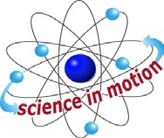
Westminster College

EXPERIMENT:
- Attach a sheet of blank or loose-leaf paper to your pin mat. Draw a line in the center of your sheet about 5 cm long.
- Attach one of the plane mirrors to an L-shaped bracket (see illustration on previous page).
- Place the mirror and the stand on the center of your paper so that the surface of the mirror is aligned with the line you drew in step 1.
- Mark a point on your paper 5-10 cm in front of the mirror, label this point A. At point A stick your stick pin through point A so that the pin stands up from the pin mat.
- Bend over so that you are at eye level with the mirror and somewhat off to one side of the pin. Lay your ruler on the paper, then close one eye and adjust the ruler until sighting down the ruler leads to the image of the pin your see in the mirror. When you can sight down the ruler to the image of pin, draw a line along the ruler so that the line points at the image. This is called a sight line.
- Move your point of view about 8-12 cm to the other side of point A so that you can still see the image in the mirror but from a much different position. Repeat Step 5 drawing a new line toward the image from a different direction. (Be careful not to move the mirror through this process.)
- Remove the mirror from the line and set it aside. Extend the two sight lines you drew, that pointed at the image of the pin, to the point where they meet behind the mirror’s position. Label the point where the lines meet point B. Point B is the location of the virtual image, in other words it is the place where a second pin appears to be within the mirror.
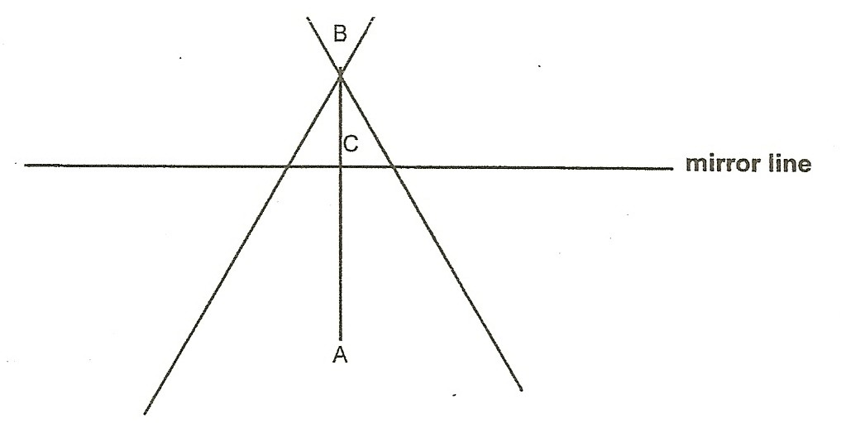

THE VIRTUAL IMAGE

- Draw a faint line from point A to point B. Mark the point where this faint line crosses the mirror point C. Now measure segments AC and BC. Are they about the same length?

QUESTIONS:
- Usually even the most careful students will have a slight difference between AC and BC, check with those around you. Why does this happen?

- After you have completed the activities on refraction come back to this question and see if you could answer them differently.

