DETECTIVE LAB

SECTION 2: RECORDING FINGERPRINTS
From Science in a Nutshell

OBJECTIVE:
To make and examine a permanent record of fingerprints.

MATERIALS:
hand lens
Identification Sheets (prepared in Activity 1)
Journal Page for Activity 2 tape (transparent)
scrap paper
moist paper towel
#2 pencil scissors

Westminster College

BACKGROUND:
Have you ever closely examined your fingertips? A fingerprint is the mark made by the pattern of ridges on the skin of the ends of our fingers. The pattern of every fingerprint remains the same throughout a person’s lifetime. The same pattern even grows back after the skin is injured or removed!

Sweat pores, located along the ridges, gives off oils that stick to the ridges. Whenever the ends of your fingers touch something, these oils leave an outline of the pattern of the ridges.

In this activity, you will learn how to make a permanent record of your fingerprint patterns.

EXPERIMENT:
- Use a hand lens to examine the tips of your fingers. Find the special patterns of ridges on each finger. Do any of the patterns have the same shapes? On the Journal page for Activity 2, describe the patterns you see.

- 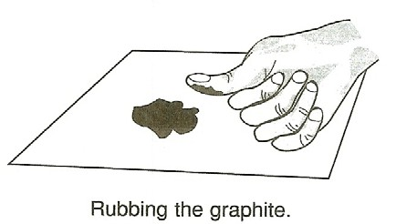Make a permanent record of your fingerprints, so that they may be examined easily. Begin by rubbing the sharpened end of a #2 pencil onto a piece of scrap paper to make a dark smudge.

- Press the end of your right thumb into the center of the smudge and rub it side to side and up and down until this part of your thumb is covered with graphite.

- Tear off a piece of tape that is about 5 cm long. Touch the sticky side of one end of the tape to the part of your thumb that is coated with graphite. Peel the tape off your thumb. Examine the pattern of the fingerprint on the tape.

- If the print is not clearly visible, try the procedure again with another piece of tape. When you get a fingerprint that is clearly visible, place the tape on your Fingerprint Card, found on the back of your Identification Sheet.
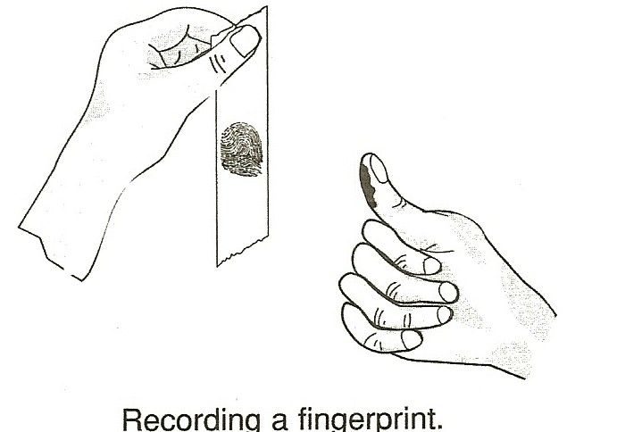

- Clean your thumb with a moist paper towel. Repeat steps 2-5 for all your fingers and the other thumb. Put each print in the correct place on the Fingerprint Card.

- Examine your fingerprints with a hand lens. Are the patterns the same or different? Do any of the patterns match exactly?

- On the back of your partner’s Identification Sheet is a Fingerprint Card. Use the same procedure in steps 2-6 to record your partner’s fingerprints on his or her card.

- Then, work with your partner to record the fingerprints to the other people for whom you made Identification Sheets.

- Use the hand lens to compare your fingerprints with those of the other people. Can you find a fingerprint that matches one of yours? Can you find any two prints that are the same? Record your answer in the journal.

- Why do you think fingerprints are so helpful to police? Record your answer in your journal.

IN A NUTSHELL:
Because no two sets of fingerprints are alike, fingerprints are used to identify people.

CRACKING THE NUT:
Do you think that identical twins have identical fingerprints? If possible, obtain fingerprints from a set of identical twins.

