SPACE CAMP

SECTION 3: LITE FOOD

OBJECTIVE:

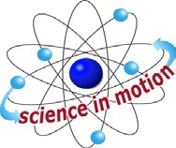
Westminster College

Have you ever imagined eating food as it floats around due to weightlessness from having no gravity? Here’s your chance.

MATERIALS:
Plates
mini marshmallows (10 each student) Trash can

PROCEDURE:
- Give each student a plate and have them count out 10 marshmallows.

- Instruct them to toss one marshmallow at a time in the air above their head and try to catch it in their mouth. If it hits floor, do not eat.

- Count how many you catch. Record on worksheet.

Westminster College SIM Page 1

