POLLUTION

SECTION 3 – RECYCLING PAPER
From Hands on Science by Linda Poore, 2003.

OBJECTIVES

Westminster College

Students investigate one method of recycling paper and then brainstorm additional uses for recycled-paper products.

Students will recycle old newspaper into papier-mâché bowls.
Students will examine the properties of paper to determine its suitability for other uses.
Student will brainstorm ideas for other recycled-paper products.

MATERIALS
For Each Group For the Class
Activity Sheet 1 ladle or cup
1 balloon 1 bottle oil, cooking
1 ½ gallon fluted container 1 pail
1 cotton ball 1 pkg wallpaper paste
1 stack newspaper tap water
1 plastic tray

PREPARATION
- Make a copy of the Activity Sheet for each student.
- One week before the activity, ask students to begin saving old newspapers. A day or two before the activity, have students bring them to class.
- In a large pail, slowly combine the package of wallpaper paste with 1 gallon plus 2 cups of water. Add the paste a few spoonfuls at a time, stirring continuously to prevent lumps. The mixture should be the consistency of cream.
- Establish a materials distribution center for the following items: the pail of paste, a ladle(or cup) for ladling paste, ½ gallon fluted containers, trays, balloons, cotton balls, the bottle of cooking oil, and a large pile of old newspapers.
- Each team of four students will need one tray, one fluted container into which 3 cups of paste have been ladled, one balloon, one cotton ball saturated with about half a teaspoon of oil, and a small stack of newspapers.
- You will also need to clear an area where the students’ papier-mâché bowls can dry. A warm, sunny spot will speed drying. Cover the area with newspaper to protect from drips.

BACKGROUND INFORMATION
In the last two activities, students learn firsthand how quickly trash is generated, trash that eventually ends up in landfills – or worse yet- as litter. Subsequently, many students will be eager to examine ways to reduce the amount of waste they produce.

Recycling is one of the most effect ways to reduce waste. It not only saves landfill space but also conserves natural resources, such as trees. Unfortunately, hundreds of recycling programs in this country have had to reduce the amount of materials they collect, or exclude some recyclable materials altogether, simply because there is no one to see them to. Recycling works only if there is a market for the recycled materials.

In this activity students “manufacture” a product from recycled newspaper: a papier-mâché bowl. Then they examine the properties of newspaper that make it suitable for other uses, and brainstorm ideas for additional products that can be made from recycled newspaper.

GUIDING THE ACTIVITY
- Remind the students of the ideas they came up with for reducing the amount of waste paper the class generates. W rite the term recycle on the board and tell students that recycle means o use a material again in the same or in a new way.” Explain that the material may retain its original form or be changed in some way to make something totally new.

Point out that recycle is an excellent way to reduce waste, but that recycling only works if there is someone who will buy those products made from recycled materials. In other words, the new product must be useful and affordable, and there must be a demand for it.

Ask, What is one product that is made from recycled paper?
Most students will know that used paper can be recycled into new paper products, such as grocery bags. Encourage the class to come up with additional uses for paper waste.

Tell the students that they will investigate one method of recycling old newspaper and that after they have experimented with this method, they will have the opportunity to come up with some ideas for additional recycled-paper products.

- Divide the class into teams of four and invite one member from each team to come up to the distribution station and get a tray, a fluted container filled with three cups of paste, a balloon, a cotton ball saturated with oil, and stacks of newspapers.
Although students can work on trays, you may wish to have them cover their work areas with newspaper to keep them clean.

- Distribute the ACTIVITY SHEET and review the instructions with students, reminding them to share tasks throughout the activity.

ACTIVITY SHEET
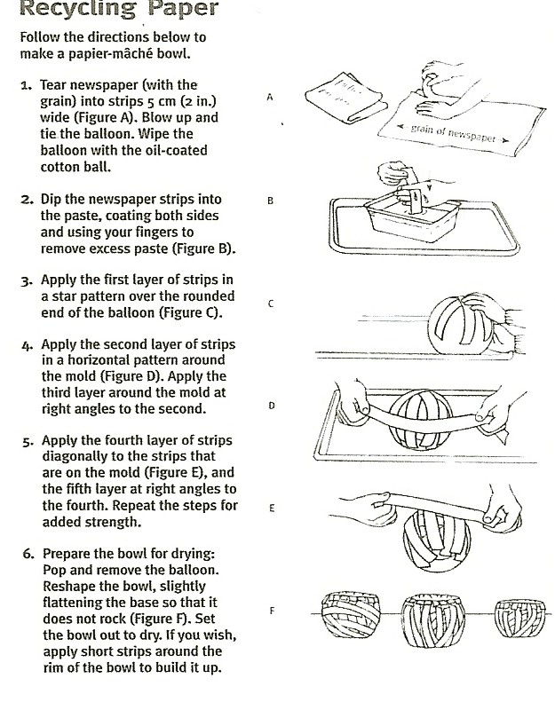

- While some team member tear the newspaper into strips about 5cm (2in) wide, have the others blow up the balloon, tie it off, and wipe the rounded end with the oil-soaked cotton ball.
Tell students that their products will be stronger if they tear their paper strips “with the grain.” To determine which direction this is, have them tear one sheet of newspaper vertically, then horizontally. The straightest, cleanest tear is the one made “with the grain.”

The balloon is the mold for the papier-mâché bowl. Coating it with oil will make it easier to separate the bowl from the balloon later on.

- Have the students take turns holding and turning the balloon mold and dipping strips into the paste and applying them to the mold, as shown on the activity sheet.

- After the students have applied at least five layers of paper strips to the mold, the bowls are ready to dry. Have them pop the balloon with their pencil, remove it, reshape the wet papier-mâché shell if needed, flatten the bottom so that it will stand up by itself, and set it out to dry.
This drying method may result in some odd-shaped bowls, depending on the thickness of the papier-mâché, but the bowls will dry faster and ultimately be more stable if they had been left to dry on the balloon.

Also note that drying times will vary from one bowl to the next. Most bowls should be dry in about one day. If a bowl feels cool to the touch, it is not yet dry.
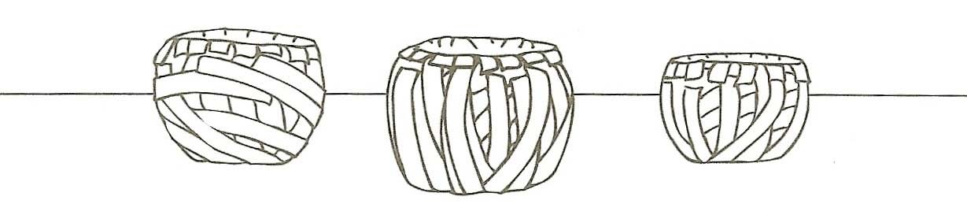
- Once the bowls have been set out to dry, begin a class discussion by asking, What are some properties of newspaper that made it easy to form into bowls?
Students should realize that they were able to form bowls because wet paper conforms to any shape.

Ask, What are some other properties of newspaper that might make it a good material for making things?
Most students know that newspaper is absorbent, can take on color, is a good insulator, burns when exposed to heat and flame, and dissolves when wet.

Encourage students to brainstorm by asking, Based on these properties and the recycling technique that you used today, what are some additional products that could be made from recycled newspaper?
Write all student responses, no matter how outlandish, on the board. If students have trouble coming up with ideas, offer a few suggestions to get them started. Building blocks, furniture, trays, storage boxes, shoes, aprons, and toys could all be made from old newspaper.

Next, engage students in a discussion of the feasibility of each proposed product. For each item ask, Is this product something that a lot of people would need or want? What would be involved in making the product? Would it take a long time to make? Would it require a lot of extra materials? How much would the product cost to make? How much would you sell it for?
By going through this process, students should realize that some of the products that have been suggested are more practical than others.

Have students try to come to a consensus regarding which recycled-paper products are the most and least practical. Then ask, Which recycling program is more likely to succeed: one that collects newspapers to turn into shipping insulation, or one that collects newspapers to turning into clothing?
Students should acknowledge that the program that turns recycled materials into useful, affordable products is the one most likely to succeed.

