SPACE

Section 3-SOLAR AND LUNAR ECLIPSES
From Hands on Elementary School Science, Linda Poore 2003

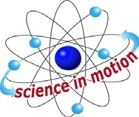
Westminster College

Standards Addressed:
Students know that the Earth is one of several planets that orbit the Sun, and that the Moon orbits Earth.

Students know the position of the Sun in the sky changes during the course of the day and from season to season.

Students will differentiate evidence from opinion, and know that scientists do not rely on claims or conclusions unless they are backed by observations that can be confirmed.

KEY WORDS:
ECLIPSES are caused when something blocks the Sun’s light and causes a shadow.
SOLAR ECLIPSE: A partial or total darkening of the Sun occurring when the moon moves between the Earth and the Sun.
LUNAR ECLIPSE: A partial or total darkening of the moon occurring when the Earth’s shadow falls on the moon.

MATERIALS:
FOR EACH PAIR: FOR THE CLASS:
1 Styrofoam ball 1 lamp with bulb
1 toothpick globe (teacher will provide) extension cord (teacher will provide) book (teacher will provide)

TEACHING TIP:
Instructions on eclipses can be Xeroxed and given to students. Hang the lamp from the center of the room. Darken the room.

EXPLORE:

WHAT CAUSES ECLIPSES OF THE SUN OR MOON? [S, moon orbits]
- ECLIPSE OF THE MOON
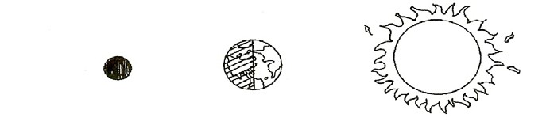
Hold your moon in front of you. Your head is the Earth. Turn your back to the Sun and hold the moon so that it is a full moon. Now, adjust the position of the moon so that your head blocks the Sun’s light, making the moon dark.

Space-Solar and Lunar Eclipses

THE EARTH BLOCKS THE SUN’S LIGHT CASTING A SHADOW ON THE MOON.
The moon’s orbit around the Earth is at a tilt, allowing the Earth’s shadow to fall on it occasionally, resulting in an eclipse. [S, moon-orbits Earth]

ECLIPSE OF THE SUN: THE MOON SHADES THE EARTH
Face the sun and hold the moon in front of you and above you. Have your partner adjust the moon so that its shadow falls on one of your eyes. During an eclipse of the Sun, only a small part of the Earth receives no sun and is in total darkness.
As the Earth rotates, this area of darkness, created by the moon’s shadow, changes position.
Slowly rotate your head and have your partner describe where the shadow falls.
(Remember your head is the Earth rotating on its axis.)

[S, evidence-observations] [S, Sun’s-position]

ECLIPSE OF THE SUN:
THE MOON’S SHADOW FALLS ON PART OF THE EARTH

