REFLECTION, DIFFRACTION, REFRACTION

SECTION 3: THE LAW OF REFLECTION

Using the diagram you drew in part 1 we are going to try to demonstrate the law of reflection which says the angle of incidence is equal to the angle of reflection.
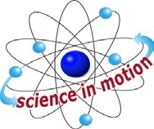
Westminster College

PROCEDURE:
- Label the outer end of your first sight as point D, mark the point where this sight line meets the mirror line as point E. (Line DE should now be your original sight line from Activity 1, Step 5. ) Line DE is the path the light had to follow from the mirror to your eye.

- Draw line AE from the point where the pin was originally placed to the mirror. This is the path the incident light had to follow to get from the pin to the mirror.

- From the point E on the mirror line draw a line EF that is at a right angle to the mirror line. This is the normal line that we use to measure our incident and reflected angles.
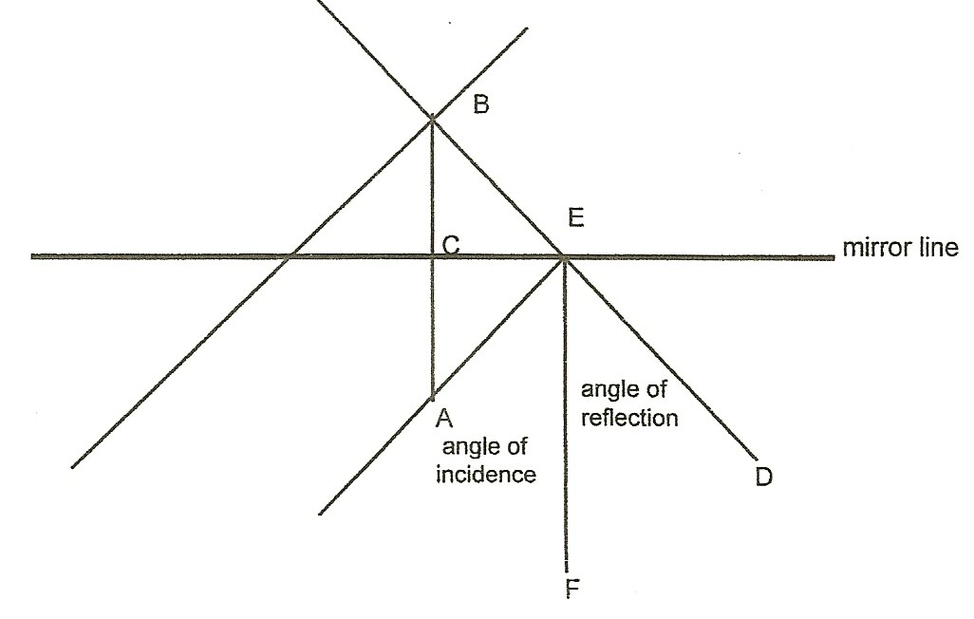

- Measure the incident angle AEF and record your results. Measure angle DEF, this is your angle of reflection. Are the two the same?

- Repeat Steps 1-4 for your other sight line, change the letters for points D, E, and F to some other letters to help you keep things straight.

THE LAW OF REFLECTION

QUESTIONS:
- Did the angle of incidence equal the angle of reflection?

- If the two angles were not equal what factors could explain the difference?

