MAGNETS

SECTION 3-THE MAGNET POLES AND THE COMPASS
From Hands on Science by Linda Poore, 2003.

STANDARDS:

Westminster College

Students know how to build a simple compass and use it to detect magnetic effects, including Earth’s magnetic field.

Students know that magnets have two poles (north and south) and that like poles repel each other while unlike poles attract each other.

Students will follow a set of written instructions for a scientific investigation.

Students will measure and estimate the weight, length, or volume of objects.

Students will conduct multiple trials to test a prediction and draw conclusions about the relationships between predictions and results.

Students will formulate and justify predictions based on cause-and-effect relationships.

MATERIALS:
For Each Pair: For The Teacher:
1 ferrite magnet pencil
- alnico magnet colored dot stickers
- ring magnets 8 ring magnets

EXPLORE:

FINDING THE MAGNET’S POLES
2 bar magnets (N-S poles)

[S, instructions] [S, poles]

- WHERE IS THE MAGNETIC FORCE STRONGEST? Give each student 2 magnets. Review attract and repel. Pass out the work sheet: Find the Magnet’s Poles.
Have students:
Put two magnets of the same type together in different ways to find the strongest magnetic force (the two poles).
Put the two edges together and then the 2 sides. Measure and record answers on the work sheet. Where is the strongest force on each magnet? (alnico-ends, ferrite-sides, ring-sides)

MAGNETIC POLES:
Show the teacher’s bar magnet with N and S poles marked. (north and south poles)
Predict which poles will attract. Which will repel? (n-n and s-s repel, s-n attract)
You can hang one from a string so students can see the interaction. Put the magnets’ poles together so they attract and repel. Discuss.

OPPOSITE POLES ATTRACT [S, poles]
Alnico magnets have different colored poles. Give 2 alnico magnets to groups of 4 students.
Have them demonstrate the interaction of the poles to their group. (opposites attract-green attracts yellow)

WHICH ENDS OF ALNICO MAGNET REPEL EACH OTHER?
(same color: green-green and yellow-yellow)

MARKING THE POLES [S, poles]
Have students:
Make the alnico yellow end attract the ferrite magnet. What color would the ferrite be? (green-opposites attract) Pass out green stickers to place on this side.
Yellow stickers can be put on the opposite side of the ferrite magnate. Mark the circle magnets in the same way.
Students trade magnets with their partner and to test to make sure opposites (green-yellow) attract and all magnets are marked correctly.

ASSESSMENT: [S, poles] [S, predict]
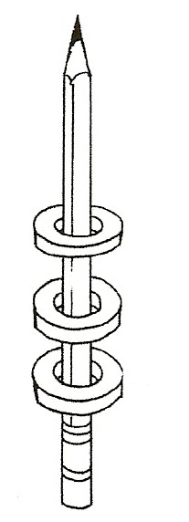
Teacher places one ring magnet on a pencil. What will happen if you add one more magnet? Have students:
Write on their paper: 1., 2., 3., 4. Predict, and 5.
For numbers 1., 2., and 3.: Write attract or repel after you add each magnet. Add a magnet 3 times.
Predict what will happen if you turn over the top magnet. Write your prediction on number 4. Try it.
Record the results on number 5 for the prediction on number 4.

PERFORMANC ASSESSMENT:
COMPARING MAGNETIC FIELDS (work sheet)
Is the magnetic field stronger when magnets attract or repel? Give each student a work sheet, Comparing Magnetic Fields. Students design experiments to test their hypothesis.

Then, they experiment, collect data, and draw conclusions.

[S, measure] [S, poles] [S, predict] [S, trials/conclusions]

MATERIALS:
For each pair:
1 compass 1 paper clip
1 cup water 1 ferrite magnet
1 magnet boat 1 alnico magnet

EXPLORE:

WHY DOE THE COMPASS NEEDLE POINT NORTH?
[S, compass/Earth]
1. EXPERIMENTING WITH COMPASSES
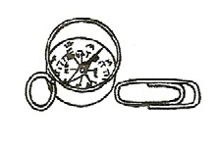
Pass out compasses and paper clips only.
How does the compass pointer interact with a paper clip?
Have students:
Make the paper clip interact with the compass needle to make it spin. What happens? (attracts) What is the compass pointer? (a magnet) Predict how the pointer would interact with a magnet? (attract-repel)

- Put a magnet on the table next to the compass needle. Observe. Turn the magnet so the opposite pole is near the needle.
(The magnet attracts 1 end of the pointer, repels the other.)
DO NOT PLACE A MAGNET ON TOP OF COMPASS as the compass
needle may lift off.

WILL THE MAGNETIC FORCE GO THROUGH WATER? MAKING A COMPASS
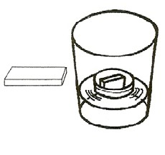
Pass out the magnet boats, cups of water, alnico and ferrite magnets. Collect the compasses.
Put the alnico magnet in the boat and place the boat in the cup of water. Experiment by placing the ferrite magnet near the cup.
Does the magnetic field go through water? (yes)
How far from the cup will the ferrite magnet interact with alnico? Make the 2 magnets attract and repel.
Discuss the interaction of the magnets’ poles (attract and repel).

- Compass needles are floating magnets attracted to the Earth’s magnetic field. Take the cup/boat/magnet systems outside, placing them at least 3 feet apart, with no other magnets or steel nearby, they will point to magnetic North. Have the students rotate the boats several times to see if they will return to pointing North. Draw an arrow in chalk on the ground pointing to magnetic North. Which color of the alnico magnet points North?

- FINDING MAGNETIC NORTH [S, compass/Earth] Take the real compasses outside, away from steel or magnets. Place them on the round, at least 3 feet apart to prevent interaction with each other, and have the students point to show the direction of the needle. Rotate each compass case so that the N is under the pointer.

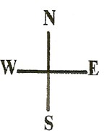
- Have students point to the direction: North, West, East, and South, using their compass.
←Draw a chalk ‘compass’ on the cement. Write N, E, S, W.

NOTE:

THE EARTH IS A GIANT MAGNET [S, compass/Earth]
Make an overhead transparency of the map at the end of this section. The compass needle is a magnet and is attracted to the poles of the Earth.
(North and South poles). The magnetic North pole is near the Prince of Wales Island in Northern Canada, 1200 miles from the geographic North Pole!
Compasses point to this spot and not true north. Using the map, discuss where you would actually ‘end up’ if you went north using the compass. (The needle points to the right of true north if you are in California and to the left of true north if you are in Florida.) The Earth’s North magnetic pole attracts the South pole of the compass needle. (opposite poles attract)

NORTH SEEKING POLE
If you hang the teacher’s marked N-S magnet from a string (away from other magnets) it will point north. The N on the teacher’s magnet means “north-seeking pole” and thus the N should point ‘north’ towards the magnetic pole. This marked N will attract the south on other magnets.

EXTENSION:
WHICH POLE IS NORTH? [S, compass/Earth] Have a ring magnet by a string away from other magnets. When it stops moving, the side facing the magnetic North pole is the North-seeking pole of the magnet. You can mark an N on the colored sticker on this side.

ANIMAL MIGRATION AND NAVIGATION
Birds, whales, and even some bacteria have tiny magnets inside them for assisting in navigation, migration, feeding, etc.

COW MAGNETS
Cows have 4 stomachs. They accidentally eat small pieces of wire cut from bales of hay. Farmers have a device that sends a 3-inch magnet down the cow’s throat to their first stomach. The magnet catches the wires so the wire doesn’t cut the 4 stomachs.

