ROCKS, EROSION AND WEATHERING

SECTION 3-USING THE STREAK TEST TO IDENTIFY ROCKS
From Hands on Elementary School Science by Linda Poore, 2003

STANDARDS:
Students will conduct multiple trials to test a prediction and draw conclusions about the relationships between predictions and results.

Students know how to identify common rock-forming minerals (including quartz, calcite, feldspar, mica, and hornblende) and ore minerals by using a table of diagnostic properties.

MATERIALS:
For Each Pair: Rocks:
tray galena
1 glazed tile hematite
magnifier pyrite
chalk sulfur
pencil(graphite) shale
student work sheet feldspar

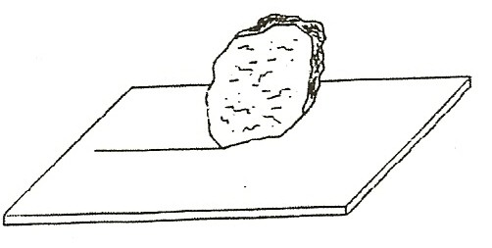
Westminster College

EXPLORE:

ROCKS CAN BE IDENTIFIED BY THEIR STREAK!
- Have students rub their pencil and the chalk across the tile. Why do they leave a mark? (They are soft rocks. A pencil is usually graphite, a form of carbon.)

SORTING ROCKS: LUSTER AND CLEAVAGE
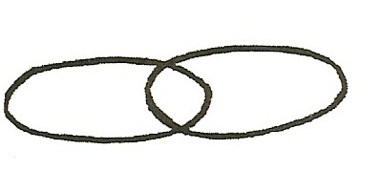
- Pass out trays with materials.
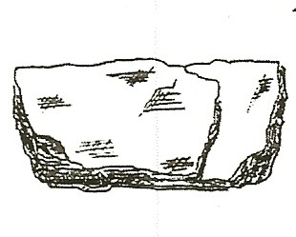
Sort rocks into 2 groups by one property using a Venn diagram. → → → →
Ask students what property they sorted by. (Example: shiny/not shiny)
Introduce the words luster (Shiny) and cleavage
(layered, flat planes with smooth surfaces). Ask all students to sort rocks into shiny and not shiny and then sort each group (shiny/not shiny) again into 2 sets: cleavage/no cleavage. Discuss and compare groups.

MAKING PREDICTIONS
- Have students: Predict what color streak each rock will make. Write down their predictions on a piece of paper.

TESTING FOR STREAKS
- Have the students rub each rock across the tile to make a streak.

Compare the color of the streak to the color of the rock.
Make several different streaks next to each other to compare the colors. Make a streak with your pencil (graphite).
Compare it’s color to other streaks.
Decide on a name for each color. Which streak is greener? redder? brownish? grayish?

Identifying Rocks by the Streak they Make worksheet.
- Pass out the student worksheet (at the end of section) Have students:
Match rock streaks to streak colors on the work sheet. Complete the work sheet except for the rock name.
Place the rock on the name square.
There is no space of the work sheet for feldspar.
(Work Sheet answers: Streak colors for rocks: Galena: lead/gray, Sulfur, yellow, Pyrite: greenish/black, Hematite: reddish, Shale: gray/brown, Feldspar: pink/white streak)

NAMING THE ROCKS:
- Tell the name of each rock by saying, “Hold up the rock that makes the
streak.” (e.g., yellow) Is it shiny or dull?
Name another property of this rock. (rough) Its name is . (e.g., sulfur)
Which rock was the softest? (streak made with little effort.)
Which rock was the hardest? (Force used to make a streak or does not make a streak.)

- Allow students to test for streak color with other minerals in the kit or rocks they bring from home.
Hard rocks will not leave a streak.
Students can rub the tile with a finger to erase all the streaks after the lesson.

IDENTIFYING ROCKS BY THE STREAK THEY MAKE

ROCK | SHINY OR DULL | DESCRIPTION | STREAK COLOR
Name |  |  | Lead/gray
Name |  |  | Yellow
Name |  |  | Greenish/black
Name |  |  | Reddish
Name |  |  | Gray/Brown

What type of rocks make a streak?

Which rocks are too hard to leave a streak?

Why do scientists use the streak test?

PROPERTIES OF MINERALS

MINERAL | COLOR | LUSTER | STREAK | HARDNESS | PROPERTIES
Calcite | White/clear | Glassy | White | 3 | Fizzes with acid
Feldspar | White/pink | Glassy | White/pink | 6 | Cleavage
Galena | Lead gray | Metallic | Lead gray | 2.5 | Cleavage, an ore
Gold | Bright Yellow | Metallic | Yellow | 2.5-3 | Conducts electricity, an ore
Graphite | Black | Shiny | Gray black | 1-2 | In pencils, an ore
Halite (rock salt) | Colorless | Glassy | White | 2.5 | Salty taste
Hematite | Gray/red | Dull | Dark red | 6 | Found in lava
Hornblende | Green/black | Glassy | Pale gray | 5.5 | Cleavage
Magnetite | Iron black | Metallic | Black | 6 | Magnetic, an ore
Malachite | Bright Green | Dull | Pale green | 3.5 | Cleavage
Mica | Silvery black | Glassy | White | 2.5 | Flaky
Olivine | Olive green | Glassy | White gray | 6.5 | Stubby crystals
Pyrite | Gold | Metallic | Green black | 6.5 | Looks like gold, an ore
Quartz | Milky White | Glassy | White | 7 | Looks like glass
Sulfur | Yellow | Shiny | Yellow | 2 | Deposits in hot springs

- You have a mineral with no luster. Using the chart, list the minerals it could be.

- Name two minerals on the chart that look glassy and have a hardness of 2.5.

- Name the 3 green rocks on the chart:

Describe 2 things you would do to find out the name of a green rock you found. 1.
2.
- You are given a chunk of ‘gold’. How will you tell that it is not pyrite?

- Which rock on the chart is the hardest?
- Which rock on the chart is the softest?

