ROCKS, FOSSILS AND SOILS

SECTION 3: WHAT IS A SOIL?
From Hands on Science by Linda Poore, 2003

STANDARDS:

Westminster College

Students know soil is made partly from weathered rock and partly from organic materials, and that soils differ in their color, texture, capacity to retain water, and ability to support the growth of many kinds of plants.

Students will compare and sort common objects based on two or more physical attributes (including color, shape, texture, size, weight.)

Students will write or draw descriptions of a sequence of steps, events, and observations, and include the use of magnifiers or microscopes to extend senses.

Students will follow verbal instructions for a scientific investigation.

IN ADVANCE:
Have each student bring soil from home in a plastic bag or dig up a cup of soil from under a bush on the playground. Try to include small insects, leaves, and sticks in the sample.
REUSE: Have students bring in plastic 2-liter bottles for making composts.

PRETEST:
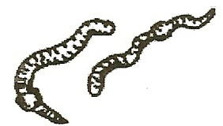
Fold paper in half. Write soil on one side and rock on the other. Tell everything you know about each one. Pretend you are looking at soil. What is in it? How can you tell a rock from soil?

KEY WORDS:
SOIL: The layer of organic (living) and inorganic (nonliving) materials on the surface of the Earth.
The texture of soil depends on the particle size and the materials present.
CLAY: Inorganic and may feel soft due to the tiny particles.
LOAM: Soil rich in organic (living) materials, sand, and clay.
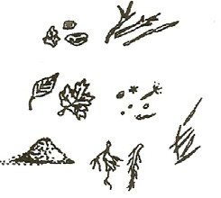
HUMUS: Consists of decaying organic material, is loosely packed and therefore holds more air and water.

MATERIALS:
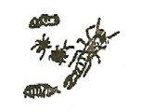
5 trays of rich potting soil (1 tablespoon each) 5 trays of clay (1 tablespoon each)
5 trays of humus (1 tablespoon each) 1 slim plastic jar
magnifiers for each student paper towels
worksheet How to Make Soil

EXPLORE:

OBSERVING SOIL WITH MAGNIFIERS
Group students in cooperative groups of 4. Pass out one type of soil at a time to keep students from mixing soils.
First, pass out potting soil (loam) trays.
Have students: Put rich soil (loam) on a paper towel. Examine the soil with magnifiers to find out what is in it.
Draw pictures of each item in the soil. (rocks, sticks, leaves, roots) Draw these items on the top of the worksheet, How to Make Soil. What else might be in the soil? (insects, pine needles, sees, worms) Put all soil back on the trays. Collect soil trays and paper towels.

COMPARING CLAY AND HUUS TO RICH SOIL
Pass out trays of clay to each group of 4 students.
Have students: Feel the material. Describe how it feels. Compare these materials to the rich soil.
After a few minutes, collect these trays and give the students the humus to observe. Discuss with the class what materials they found in each soil.

DEMONSTRATE:

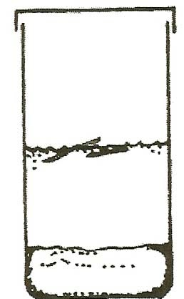
SOIL CONTAINS DIFFERENT MATERIALS AND AIR
Add 2 inches of rich loam soil to the slim plastic jar. Ask students, “What is in soil?”
Have students observe as you slowly pour 1 cup of water into the jar. What comes out of the soil when water is added? (bubbles=air) Predict what will happen if we shake the jar.
Put the lid on the jar and shake. (part of the soil floats) Discuss: Why do some things settle first? (heavier) Why do some float? (less dense than water)
Leave soil in the jar for the next year.
Pour off the excess water and leave the lid off until the soil dries.

DISCUSS:
What is soil made of? What color is soil? Compare how different soils feel?

ASSESSMENT:
Fold a paper in thirds.
Have students: Title the paper, What is soil made of? Write living, once living, and nonliving on the paper. Discuss what the terms mean.
Draw or write what they found in the soils.

HOMEWORK:
Challenge students to bring in materials to make soil
Discuss materials needed: sticks, sand, leaves, bark, roots, etc. If possible, get a decaying log from the forest or a woodpile.

MATERIALS:
Items brought in by students decaying log from forest
4’ x 4’ butcher paper ( 1 piece per team of 4 students)

EXPLORE:

MAKING SOIL
- Today you are going to help the forest make soil
You are the tiny insects, wind, rain and frozen water that will break up materials into soil. (*water expands as it freezes, breaking rock)

- Group students outdoors in teams of four around each piece of paper. Make sure each group has materials (from home) to make soil.
Use rocks to break materials, grind up leaves, break up sticks. Decaying pieces of a tree from the forest work the best.

- Have each team group their smallest pieces of soil together. Collect these tiny pieces in a jar or cup.
How much soil did the class make?
Save this soil we made for the plant-growing race. (Section 4)

- DISCUSS: What changes these materials into soil in the forest? (wind, rain, insects burrowing, rivers, frozen water, mold, bacteria, mushrooms, and other fungi)

ASSESSMENT:
Have students complete the worksheet How to Make Soil.

HOW TO MAKE SOIL

We looked at soil with a . This is what we found in the soil. (Draw and write a word in each box.)
sticks

To make soil we started with:

This is what I did to make soil:

A stick in the forest will become soil. What causes it to become soil?

