SOUND VIBRATIONS

ACTIVITY 3: WHAT’S THE FREQUENCY?
From Science in a Nutshell

OBJECTIVE:

Westminster College

To investigate how the speed of vibration determines the sound we hear.

MATERIALS:
journal page for Activity 3 metal strip
radio, small portable table or desk
ruler

BACKGROUND:
You already know that the very quick, back and forth movement of an object is called a vibration. Did you know that the number of times an object vibrates each second is called frequency?

Most people can hear sounds that have frequencies between 20 and 20,000 vibrations per second. Some animals can hear sounds that have frequencies with different ranges.

In this activity, you will lengthen and shorten the vibrating section of a metal strip. Do you think that the frequency (speed) of vibration will change? Will a change in frequency change the sound you hear? Let’s find out!

EXPERIMENT:
- Position the metal strip so that about half (12cm) of it extends beyond the edge of a table or desk. Hold the metal strip firmly against the table with one hand.
- With a finger of the other hand, press down gently on the free end of the strip. Let your finger slide off. Observe what happens to the metal strip.
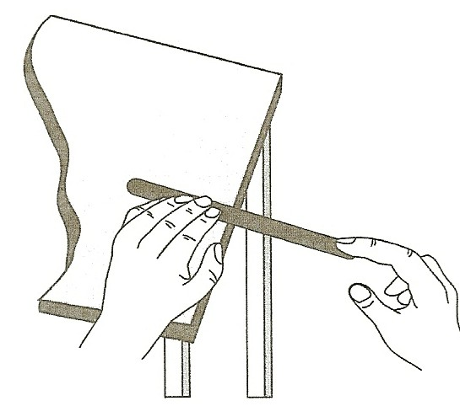
- Reposition the metal strip so that only 3 cm (about 1 in.) of it extends over the edge of the table. Press down on the free end again and let go. What happens?
- How did the frequency change when you changed the length of the section that was vibrating? How did the sound change?
- How do you think the frequency and sound will change if you reposition the metal strip again so that about 22 cm (about 9 inc.) extends over the edge? Try

WHAT’S THE FREQUENCY?

it. Press down on the free end and let go. What happens?
- How did the frequency of the vibration change? How did the sound change?
- In your journal for Activity 3, compare the frequencies and sounds for all three lengths. Repeat any parts of Steps 1-6 if necessary.
- As the length of the vibrating section of the metal strip gets shorter, does the frequency get higher or lower?
- How does the pitch of the sound change when the frequency of the vibration changes? Record your answers on your journal page.
- Position the metal strip so that half of it extends over the edge. Hit the free end hard. Then, hit it lightly. Which produced the louder sound? When did the metal strip move the greatest distance up and down?

IN A NUTSHELL:
  - The number of times the metal strip vibrates back and forth is called its frequency. Low frequencies have a low pitch or low, deep sounds. High frequencies have high pitch or “squealy” sound.
  - The loudness of a sound is called volume.

CRACKING THE NUT:
Some animals can hear sounds with frequencies that are much higher or lower than those that people can hear. Why do you think a dog can hear the sound made by a dog whistle, but people cannot?

