MACHINES AND MOTION

SECTION 3: FRICTION AND LUBRICANTS

STANDARDS:

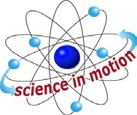
Westminster College

Students know objects fall to the ground unless something holds them up.

Students will measure length, weight, temperature, and liquid volume with appropriate tools and express those measurements in standard metric system units.

Students will construct bar graphs to record data using approximately labeled axes.

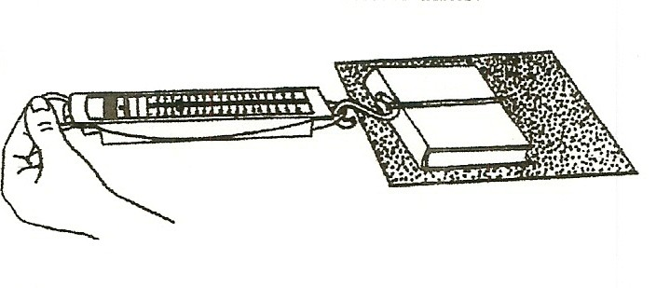
COMPARING THE AMOU MATERIALS:
crayons
scale
wax paper sandpaper
reading book with rubber band for pulling

KEY WORD: FRICTION: The slowing of motion between two objects. The friction causes the energy of motion to become heat energy.

EXPLORE:

WHICH SURFACE CAUSES THE MOST FRICTION?
- Pass out the worksheet, Friction and Lubricants
Have Students: Pull the book across each surface and record the amount of forced needed (as shown on the scale).
Hold the sandpaper so it doesn’t move, but the book moves over it. Record the amount of force necessary to start the object moving.
This will be the highest number of grams indicted on the scale. (It is hard to get an object to start moving.)

- Place crayons or pencils under the book for wheels and pull, measuring the force. Record your answers on the work sheet.

- Which surface causes the most friction?
Make a bar graph to compare the results (graph at end of section)

DISCUSS:

Westminster College SIM Page 1

WHEN IS FRICTION USEFUL?
- Which things are made rough to produce friction? (mat in tub, streets are rough, tires, etc.)

- Have students put 1 foot on their desk and look at the shoe sole. Which shoes are made to create more friction? (bumps on sole)
Have students make a crayon rubbing of the bottom of their shoe and write whether it has a lot of friction or very little.
When do we want shoes with little friction? (dancing, bowling)

AIR CREATES FRICTION:
Drop 2 pieces of paper at the same time. (fall slowly)
Crumple one and try again. (Crumple paper had less surface area.)
Which paper hits first? (ball) Why? (Both weigh the same. More air pushes on the flat paper, slowing its fall.)
Drop a quarter and paper at the same time while standing on a desk. Which hit first? Drop crumpled paper and quarter together.
Discuss air friction (air resistance). Relate to parachutes
(Air causes more friction on larger light objects because they have more surface area.)

- GRAVITY: Gravity causes objects to fall unless something holds them up. What affects the rate of falling objects? (air friction) Without air, all objects fall at the same rate. The astronauts proved this on the moon by dropping a hammer and feather together. Since there was no air, they hit the ground at the same time.

KEY WORDS:
GRAVITY: A force between all objects. Large objects, like the Sun, Earth and moon, have enough force to pull objects toward them.
LUBRICANT: Any substance that reduces friction. (oil, wax, graphite)

ACTIVITY 5:
HOW DO LUBRICANTS HELP MACHINES?

MATERIALS:
cornstartch
baby powder in a shake bottle

EXPLORE:

FRICTION CONVERTS MOTION ENERGY TO HEAT ENERGY
- Have students: Rub their hands together.
How do your hands feel? (hot) Friction causes heat energy.

ADDING A LUBRICANT

The teacher pours ¼ tsp. of baby powder or corn starch on everyone’s hands. Students rub hands together again.
Discuss. (hands slide-less friction) Machines have less friction with lubricants.

WHAT OTHER LUBRICANTS REDUCE FRICTION?
Discuss. (oil in pan so food doesn’t stick, oil on bike’s moving parts and car engine, wax on ski bottoms to make them slide, soap on finger to remove a ring, wax on drawers to make them slide, etc.)

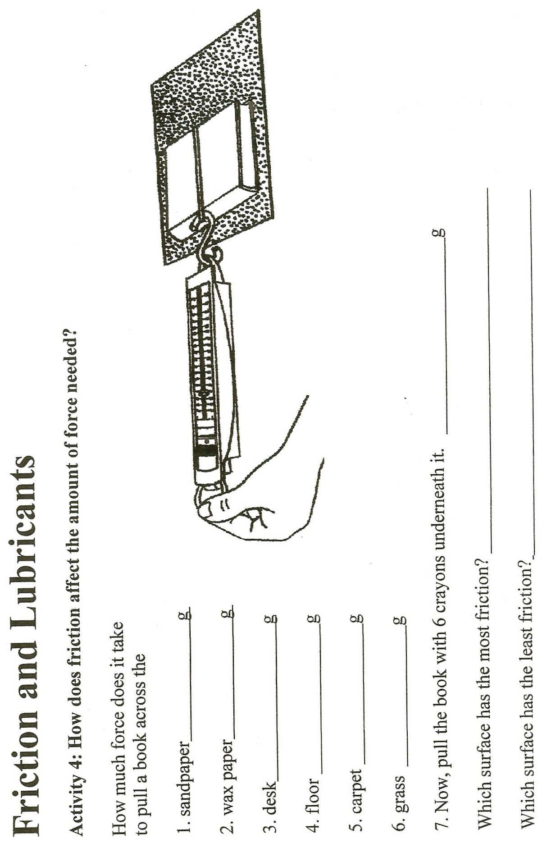

1 2 3 4 5 6

KEY: 1. sandpaper, 2. 3. 4.

5. 6.

Which surface has the most friction?

