DETECTIVE LAB

SECTION 4: DUST AND LIFT
From Science in a Nutshell

OBJECTIVE:
To dust and lift fingerprints.

MATERIALS:
body powder
brush, soft long bristles colored chalk
Fingerprint Card (prepared in Activity 2) hand lens
white index cards
Journal page for Activity 4 plastic knife
lid, Nutshell box
black construction paper scrap paper
#2 pencil microscope slide transparent tape

Westminster College

BACKGROUND:
Whenever your fingers touch something, the oils from your skin leave a fingerprint—some are visible and some are invisible. When the fingerprint is difficult to see or invisible, it is called a latent fingerprint.

Latent fingerprints at crime scenes often prove to be important clues. Police use a variety of different powders to make latent fingerprints visible. First, they brush powder on an object that they think may contain fingerprints. Then they place tape on the dusted fingerprint. When the tape is removed, the fingerprint sticks to the tape, and the fingerprint is lifted.

This process is called dusting for fingerprints. Dark powders are used on light colored surfaces and light colored powders on dark colored surfaces.

In this activity, you will develop the skill of dusting surfaces to make latent fingerprints visible. Then you will lift these prints and preserve them for futher study at your lab.

DUST AND LIFT

EXPERIMENT:
- To make a clear latent print, rub the end of your right index paper on the side of your nose or through your hair to coat the fingertip with additional oil.

- Press your right index finger onto the lid of the Nutshell box. Then lift your finger straight off the lid, being careful not to rub or smudge the print. Carefully examine the fingerprint in bright light.

- Lightly sprinkle some body powder onto the lid, near but not on the print. Gently, brush the powder onto the print with the soft brush.

- Very carefully, brush the powder off the fingerprint until the pattern is completely visible. If parts of the pattern are missing, you may need to add more powder.
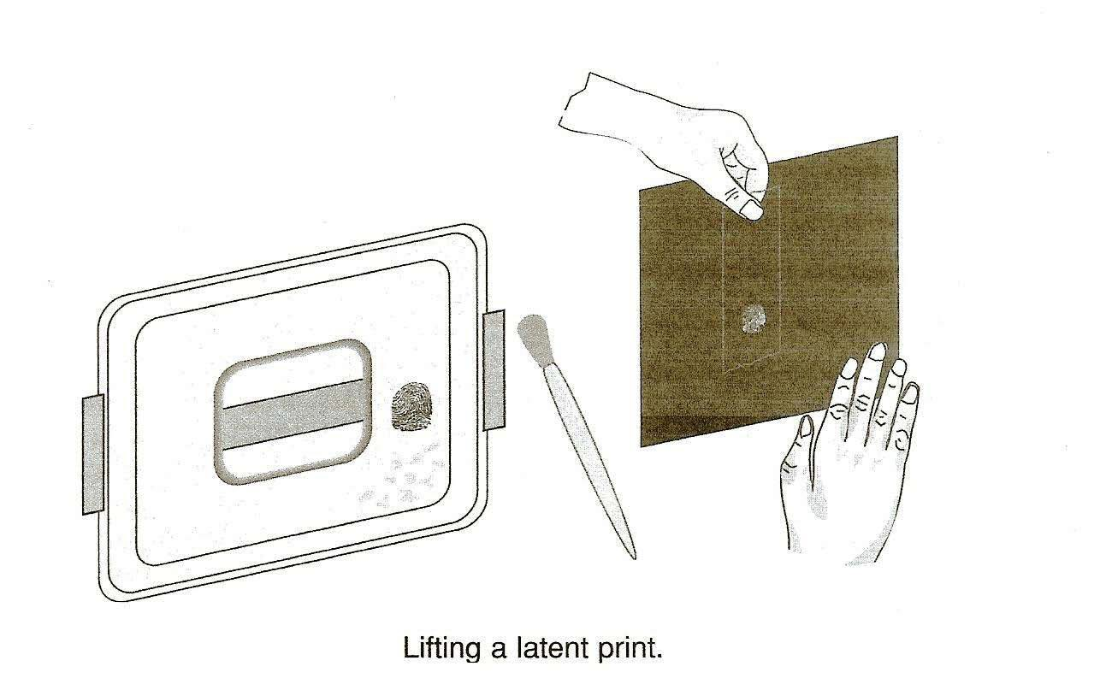

- When the detail of the print on the box lid is visible, tear off a piece of tape about 5 cm long. Place the tape over the print. Try not to trap any air under the tape. Use a fingertip to lightly rub over the tape.

- Remove the tape with the attached print and carefully stick the tape onto a piece of black construction paper. Label the other end of the tape with your name and which finger was used to make the fingerprint.

DUST AND LIFT

- Compare your lifted print with the print of your right index finger on your Fingerprint Card. Do they match? Record your observations on the Journal page for Activity 4. Clean the lid of the Nutshell box.

- Ask one of the people who have made a Fingerprint Card to leave one latent print on the microscope slide while you look away.

- Hold a piece of colored chalk over a piece of scrap paper. Scrape the side of the chalk with the blade of the plastic knife. Carefully dust the latent print with the dust from the colored chalk. Lift the print from the slide.

- Place the lifted latent print on an index card and compare it with the prints on the Fingerprint Card. Which finger touched the slide? Use the hand lens, if necessary. Record on the journal page which finger you think was used.
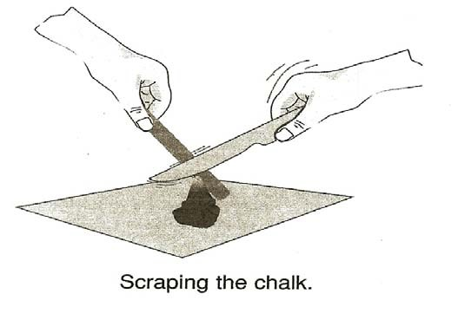
- Try making fingerprints on different kinds of surfaces. Try plastic, wood, tile, metal, paper, cloth, and others. Which surfaces are best for dusting and lifting clear fingerprints? Record your ideas in your journal.

- Try using dust from the colored chalk to dust and lift latent fingerprints from surfaces that are light in color. After the print is lifted, place the tape on a white index card for further study.

IN A NUTSHELL:
  - Fingerprint powders stick to the oily patterns left behind whenever we touch something with our fingertips.
  - The color of the powder used depends upon the color of the surface being dusted.

CRACKING THE NUT:
How many latent fingerprints can you find around your home or school? Examine light switches, telephones, doorknobs, appliances, and other smooth or hard surfaces. Try to identify who made them.

