WEATHER

SECTION 4: EVAPORATION AND CONDENSATION
From Hands on Science by Linda Poore, 2003.

STANDARDS:

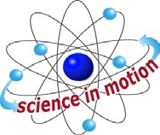
Westminster College

Students know the properties of substances can change when the substances are mixed, cooled, or heated.

Students know solids, liquids and gases have different properties.

Students will record observations and data with pictures, numbers, or written statements.

Students will make new observations when discrepancies exist between two descriptions of the same object or phenomenon.

KEY WORDS:
EVAPORATION: The change from a liquid to a gas that occurs at the surface of all liquids. Warmer temperatures increase the rate of evaporation.

BOILING: The hottest temperature that a liquid can get and remain a liquid; the liquid rapidly changes to a gas at its boiling point.

CONDENSATION: When a gas cools and becomes a liquid. Clouds form due to condensation. When you take a shower, condensation occurs on the cold mirror because the steam becomes too cold to be a vapor.

HUMIDITY: The percent of water vapor in the air. The higher the humidity (amount of water in the air), the warmer the temperature is when dew forms. With low humidity, dew forms at cooler temperatures.

MATERIALS:
For the Teacher
chalk
- pie tin
- tall slim plastic jars 1 jar lid
1 sponge
1 plastic bag

EXPLORE 1:

WHERE DO PUDDLES GO AFTER THE RAIN STOPS? EVAPORATION:
- On the playground make several puddles or use existing puddles after a rain. Mark the circumference of each puddle with chalk and have students predict

what will happen in 1 hour. Visit the puddles several times during the day, making the shrinking circumferences each time with chalk. Where did the water go? (into the air) Have students say the Big E word-evaporation.

HOW CAN WE MAKE WATER EVAPORATE?
Use a sponge to make a wet spot on the desk in front of each student. Ask students how they can make the water evaporate quickly without touching it. Discuss the students’ idea. (fan it, blow on it, heat it with a light)
Let students try their ideas. Leave 1 sponge spot on the chalkboard to compare the students’ evaporation experiments to the normal rate of evaporation in the room. (It is fun for students to do their evaporation experiments on the chalkboard, if space is available.)
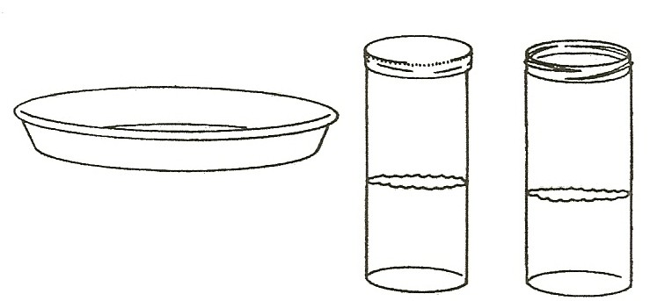

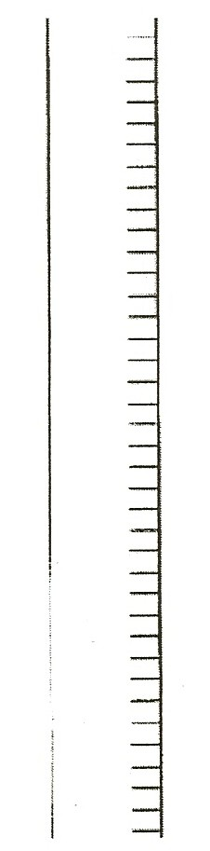
LIQUIDS TAKE THE SHAPE OF THEIR CONTAINER
Have students observe the jar with 4 inches of water. (half full) Will the water fit in the pie tin? Predict. Pour water into the pie tin. What shape is the water now? (fat, round)
Pour this water into a clear bag and containers with different shapes. Observe. The same volume or amount of water takes the new shape.

EVAPORATION RACE
Show the students the pie tin and the 2 jars. Put 1 half jar of water in each container.
Predict what will happen to the water in each container.
Tell the students to all say the BIG E word-evaporation. Discuss Put a lid on one jar.
Ask students to predict what will happen to the water if you put all 3 experiments in a sunny spot.
←Tape a strip of paper to each cup to measure the water level each
day. (Strip for measuring is also on the student work sheet.) Mark the beginning level and date on each cup.
Since evaporation occurs only on the water’s surface, the pie tie has more surface area and the water evaporates more quickly. Water in the jar with the lid will evaporate and condense, remaining in the air.

HOMEWORK:
Assign this activity as homework, by passing out the homework sheet, My Evaporation Race, at the end of this section.

MATERIALS:
For Each Pair
1 thermometer
1 gallon bag
1 cup with water, half full
worksheet, Where does the water go?

EXPLORE 2:

OBSERVING EVAPOARTION AND CONDENSATION
- COLLECTING SOLAR ENERGY
Give each pair of students a thermometer in one half cup of water.
Have students: Touch the water. How does it feel? (cool) Read the temperature of the water.
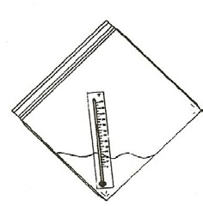
Color a red line on your overheat thermometer transparency to show the temperature, and have the students record the beginning water temperature by coloring the thermometer on their worksheet, Where does the water go? (Mark the temperature and then color down.)

HEAT CAUSES EVAPORATION
Have students: Place their thermometer in a 1-gallon plastic bag, add the water from their cup, and seal the zip-lock.
Tape the bag in a sunny window at an angle so 1 corner is down. If your room does not receive direct sunlight, pick other sunny windows at the school and tape the bags to the outside of the windows.
Make sure the tape is secure so the thermometers do not brake.

CONDENSATION
Check the experiments after 20 minutes in the sunlight. What happened to the bag? (water drops on the inside of the bag)
Draw drops on the worksheet picture.
Watch the drops ‘rain’ down the bag into the water. Where did the water come from? (the bag)
Look at the thermometer and draw a red line on the second thermometer picture to match it. Did it go up or down? (up)
What is the temperature? How does the water feel? (warmer) Discuss where the water from puddles goes. (into the sky) Feel inside the top of the bag. (wet)
Use the big E word-evaporation. The water changes to a gas as it heats. The gas floats in the bag. The bag is cooler than the water vapor, and the water vapor condenses on the bag. The water drops in the bag are condensation.

- When you get out of the swimming pool on a hot day, how do you feel? (cold, shiver)
The water needs heat energy to evaporate and it takes it from your body. The reason you sweat is to cool your body.

- Dogs pant in the summer because it causes evaporation of the liquid in their mouth, cooling blood vessels under the tongue. The cooler blood circulates, cooling the dog’s body.

- YOUR SHOWER PRODUCES CONDENSATION When you take a shower, what happens on the mirror? Where does the water come from?
(The steam gets too cold to be a gas and changes back to a liquid.) In your car where do you see condensation?
(On the inside of the windows when it is cold outside. The water vapor is from your warm breath.)

