ROCKS, FOSSILS AND SOILS

SECTION 4: GROWING SEEDS IN DIFFERENT SOILS
From Hands on Science by Linda Poore, 2003

STANDARDS:

Westminster College

Students know soil is made partly form weathered rock and partly from organic materials, and that soils differ in their color, texture, capacity to retain water, and ability to support the growth of many kinds of plants.

Students know both plants and animals need water, animals need food and plants need light.

Students will make predictions based on patterns of observation rather than random guessing.

Students will construct bar graphs to record data using appropriately labeled axes.

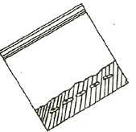
MATERIALS:
For Each Pair For The Teacher
1 plastic sandwich bag seeds
1 cup of water several types of soil:
clay, loam, and humus in kit,
soil they ‘made’ and sand from the schoolyard

DEMONSTRATE:

WHICH SOIL IS BEST FOR GROWING SEEDS?
- DESIGN A FAIR EXPERIMENT CONTROL VARIABLES
Have students work in cooperative groups to decide how to make a fair experiment to compare seed growth in different soils. Make sure each group discusses the location, water, seeds, and amount of soil. Discuss all student ideas and decide on a class experiment design that controls the variables.
(e.g., same amount of soil, water, seeds, light)
Encourage students to bring soils from home in plastic bags to test.

EXPERIMENT:
Have a seed race! Compare plant growth in different soils. Use samples of each soil type in the kit, sand form the schoolyard and the soil the students made in Section 3. Put one cup of each soil in separate plastic bags. Plant 4 seeds in each zip-lock plastic bag and water with the same amount of water. (To prevent mold, soak seeds in 12 oz. of water and 1 tsp. bleach, 3 hours, and handle seeds with

GROWING SEEDS IN DIFFERENT SOILS

clean hands.) Each group can try a different soil. Label the bags with permanent marker to indicate the type of soil.

- PREDICT which soil will be best for growth. (The best medium may be sand/soil)

WHICH SOIL GREW THE HEALTHIEST PLANTS?
Compare the plants in each soil.
Compare the height, color, number of leaves, and thickness of stems to determine the best soil for growing healthy plants. (Darker green plants are healthier.)
Why do you think one soil was best? Which soil absorbed the water best? Did seeds drown in one soil type?
What do plants need? (nutrients, water, adequate drainage, light, etc.)

- Have students: Fold a paper in fourths and draw the plants growing in each soil. Label each picture with the soil type. Continue the plant race for 3 weeks.

MATH:

GRAPHING
The plant height can be measured and graphed after two weeks. Use the graph Seed Growth in Different Soils. (end of section) Have students decide together how to number and label the graph axes. It may work best to remove the plants carefully from the bags to measure them.

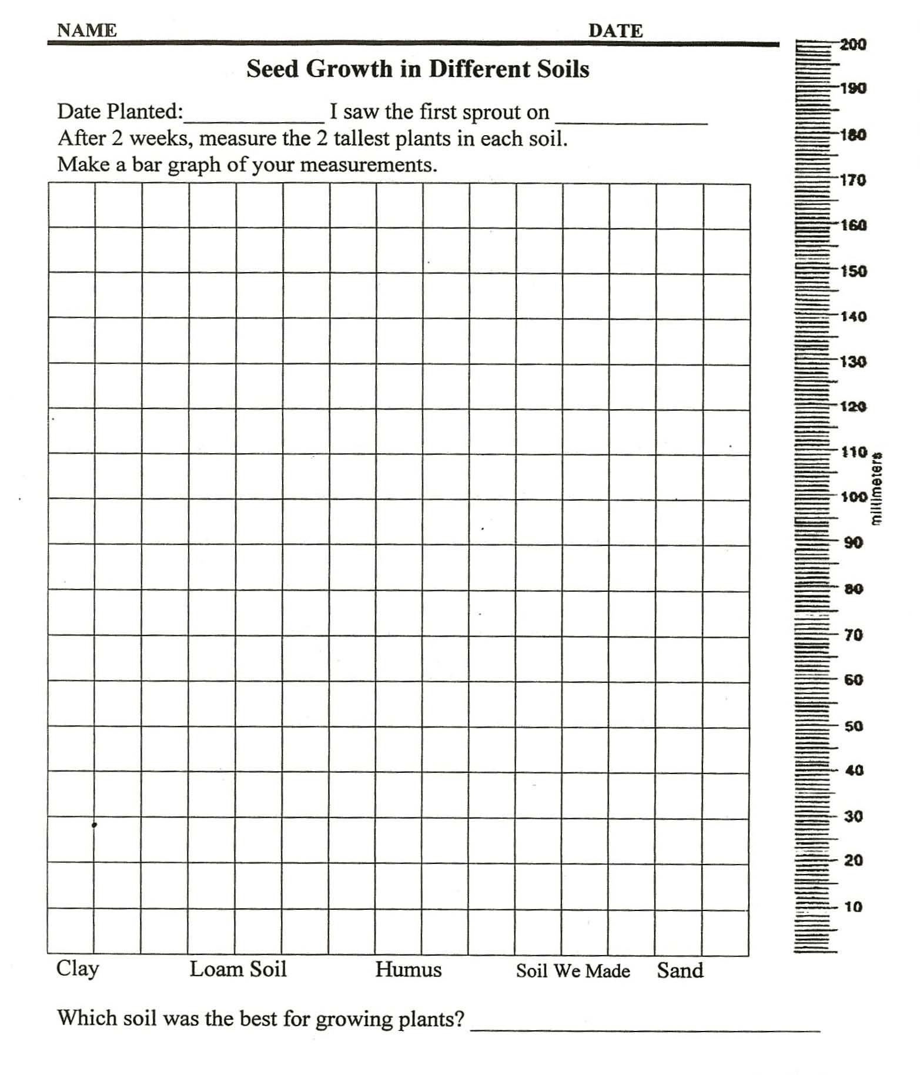
GROWING SEEDS IN DIFFERENT SOILS

