MAGNETS

SECTION 4-TESTING MAGNET STRENGTH
From Hands on Science by Linda Poore, 2003.

STANDARDS:
Students know that magnets have two poles (north and south)

Westminster College

and that like poles repel each other while unlike poles attract each other.

Students will formulate and justify predictions based on cause-and-effect relationships.

Students will construct and interpret graphs from measurements.

Students will conduct multiple trials to test a prediction and draw conclusions about the relationships between predictions and results.

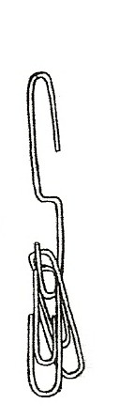
NOTE:

TESTING WEAK MAGNETS:
Weak magnets that cannot pick up one nail can be tested with paper clips. Hang several clips on a paper clip opened in an ‘S’ shape to make a hook. Test the magnet’s strength by picking up the ‘S’ clip.
Record on the chart as: 0 nails/ # of paper clips. (Also count the ‘S’ as 1 paperclip.)

MATERIALS:
nails in a plastic tray 1 cow magnet
1 box of paper clips 1 alnico magnet
1 ring magnet 1 ferrite magnet
copies of student worksheet 1 bar magnet (N-S marked)

DEMONSTRATE: [S, predict-justify] WHICH MAGNETS ARE STRONGER? [S, trials/conclusions]
- Record data on the student work sheet at the end of this section. Compare all the magnets first and have students predict which will be the strongest and why on the top of the worksheet.
Discuss the importance of trying each magnet at least 3 times.
- Each student tries his magnet 3 times in the tray of nails. Put the nails from each trial on a tray and have students count them at their desk.

MATH:

FINDING THE AVERAGE FOR 3 TRIALS:
Add the 3 answers and divide the sum by 3. Record averages on the worksheet. Graph the results, using the average for each magnet. (Use the graph worksheet at the end of this section.

VARIABLES AFFECT THE NUMBER OF NAILS THAT ARE PICKED UP.
Did all three trials of a magnet have the same number of nails? What are the variables? Discuss.
Variables: How long the magnet is near the nails, counting accurately, the way the magnet is placed on nails (both poles touching nails), etc.

- Was the strongest magnet also the biggest magnet? Compare the students’ predictions to their results. Discuss.

[S, justify/predictions]

DEMONSTRATE:
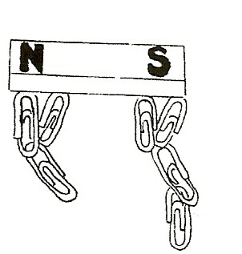
WHERE IS THE MAGNET STRONGEST?
What is the strongest part of a magnet.
Use the teacher’s N/S bar magnet to pick up paper clips. Where do most of the clips attach?
(at the poles where the magnetism is strongest) Why do paper clips hang on each other?
(Each clip is a temporary magnet because most domains are aligned.)

HOW MANY NAILS CAN EACH MAGNET ATTRACT?
Prediction: The magnet that will pick up the most nails is because .

Draw Magnet | 1st Trial | 2nd Trial | 3rd Trial | Average
1.
2.
3.
4.
5.
6.
7.

Did the largest magnet have the most strength? Was your prediction correct?

CONCLUSION:

Graphing Magnet Strength with a Bar Graph

How many nails did each magnet pick up. On the horizontal axis (across the bottom) of the graph draw pictures of the different magnets or write the magnet’s number (from the chart). On the vertical axis (up the side) write numbers to show how many nails were picked up. Record the average number of nails for each magnet. Label the vertical and horizontal axes.

