SOUND VIBRATIONS

ACTIVITY 4: THE BIG STRETCH
From Science in a Nutshell

OBJECTIVE:

Westminster College

To discover how the pitch and volume of a vibrating object can be changed.

MATERIALS:
journal page for Activity 4 box, cardboard
doorknob or drawer handle rubber band, any size tuning fork

BACKGROUND:
The pitch of the sound produced by a vibrating rubber band depends upon its length, thickness, and tautness (how tight it is stretched).

In this activity, you will discover how these properties influence the pitch of sounds. You will also discover how the sound changes when a vibrating object comes in contact with different materials.

EXPERIMENT:
- Stretch a rubber band between your index finger and thumb. Pluck the rubber band with a finger of your other hand. What do you observe?
- Stretch the rubber band and thumb father apart. Pluck the rubber band again. What differences did you observe?
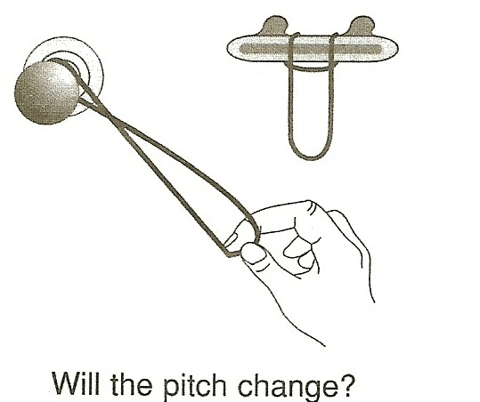
- To stretch the rubber band still more, secure it to a doorknob or drawer handle and pull gently. Now pluck the rubber band with your free hand. Do you hear a different sound?
- Stretch the rubber band a little bit farther and pluck it. How does the pitch of the sound change as you continue to stretch and pluck the rubber band/ Record your observations on your Journal page for Activity 4.
- Try attaching the rubber band to other doorknobs and handles. How does the sound change when you attach the rubber band to various objects?
- Experiment to find where you can attach the rubber band to get the best sound. List these places in your journal.
- Strike the tuning fork against the heel of your shoe and hold it 3-5 cm (1-2 in.) from your ear.

THE BIG STRETCH

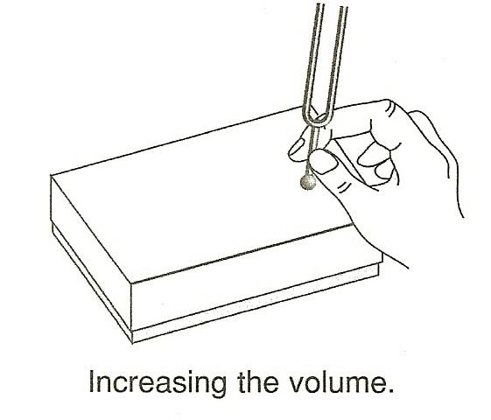
- Strike the tuning fork again and place the handle on top of the cardboard box. Do you hear a different sound? Did the box vibrate? Record your observations in your journal.
- Place the handle of the vibrating tuning fork on other surfaces. Try a desk, a drawer, the floor, and any other place you think of.
- Describe in your journal which surfaces produced the best (loudest and clearest) sounds. Are they the same surfaces that produced the best sounds with the rubber band?

IN A NUTSHELL:
  - The pitch of the rubber band gets higher as the rubber band is stretched.
  - The volume of sounds can be increased if the vibrating object comes in contact with another object that can also be made to vibrate.

CRACKING THE NUT:
Why do you think a great many musical instruments have hollow wood or metal sound boxes?

