SPACE

Section 4-THE REASONS FOR THE SEASONS
From Hands on Elementary School Science, Linda Poore 2003

Standards Addressed:

Westminster College

Students know the position of the Sun in the sky changes during the course of the day and from season to season.

Students know that the Earth is one of several planets that orbit the Sun, and that the Moon orbits Earth.

Students know energy comes from the Sun to Earth in the form of light.

Students will differentiate evidence from opinion, and know that scientists do not rely on claims or conclusions unless they are backed by observations that can be confirmed.

NOTE:
SEASONS: The tilt of the Earth on its axis causes the seasons as the Earth revolves around the Sun. In winter, the direction of the tilt is the same as in the summer (the axis points toward the North Star, Polaris), but since the Earth is now on the opposite side of the Sun, the Southern Hemisphere is tilted toward the Sun and the Northern Hemisphere is tilted away. Therefore, the Sun’s rays striking the United States are more slanted, causing less heating. The tilt also causes longer days in the summer, resulting in more heating of the Earth. The tilt of the Earth is 23.5 degrees from vertical.

IN ADVANCE:
Hang a star or dot from the ceiling to indicate the North Star. Attach the clamp lamp to a chair back or book and place the lamp in the middle of the room. Put a 1” red dot on the globe where you live and a 1” blue dot below the red dot and south of the equator. Make an overhead transparency of The Seasons.

MATERIALS:

For the Teacher:
clay, lamp with bulb, extension cord, globe, The Seasons transparency

EXPLORE: [S, sun-changes] [S, Earth-orbits] WHY DOES THE EARTH HAVE SEASONS?
THE EARTH REVOLVES AROUND THE SUN IN ITS ORBIT.
- Have students sit in a large circle around the lamp. Observe the tilt of the globe.
The axis of the globe always points to the North Star.
Show students the ‘North Star’ hanging in the room. (see above) Point the Earth’s axis towards this star.

Show students the Earth’s equator with the red dot indicating where they live and the blue dot below the equator (see In Advance above)

WINTER:
THE EARTH TILTS AWAY FROM THE SUN.
Take the globe on its long journey around the ‘sun’, (lamp) (Walk in a big circle behind the student circle.)
Keep the Earth the same height as the ‘sun’ lamp so it shines on the Earth’s equator. Start with the tilt away from the ‘sun’.
(The axis points to the North Star on the ceiling.)
Observe the red dot (where you live) tilting away from the ‘sun.’ It is not in the lighted area.
Is it winter or summer? (winter, cooler) The days are shorter.

SUMMER:
THE EARTH TILTS TOWARD THE SUN.
Continue taking the Earth around the ‘sun.’(lamp)
When the Earth reaches the other end of its orbit, it tilts toward the ‘sun’, causing more direct rays to heat North America.
(Show students that the axis still points to the North Star.)
The days are longer causing summer. Rotate the dots to the ‘day’ side of the globe so they can see that the red dot now is lighted as it tilts towards the ‘sun.’

[S, evidence-observations]
- Make a small 2” clay stick man and place him on the globe where you live. Repeat the activity, observing that he tilts away from the ‘sun’ in winter and towards the ‘sun’ in the summer.
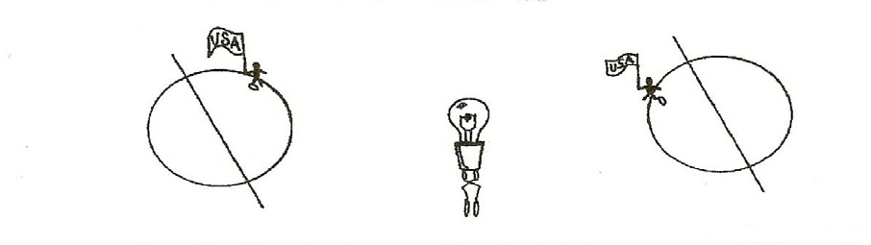

- Would we have seasons if the Earth did not tilt on its axis? [S, Earth-orbits]
Take the Earth around the lamp again, without tilting it. The United States never receives direct rays.
The weather and the length of the day would be the same all year.

- The Earth takes 365 ½ days to complete its journey around the Sun. Every fourth year, leap year, we have an extra day in February to use this extra time. (4 extra quarter days = 1 day)

KEY WORDS:
SUMMER SOLTICE: Longest day of the year. (June 21 or 22)
WINTER SOLTICE: Shortest day of the year. (December 21 or 22)

MATERIALS:
For the Teacher:
- flashlight with batteries
- pieces of white graph paper (Copy graph at the end of the section)

DEMONSTRATE:

HOW DOES THE EARTH’S TILT AFFECT THE AMOUNT OF HEAT RECEIVED FROM THE SUN?
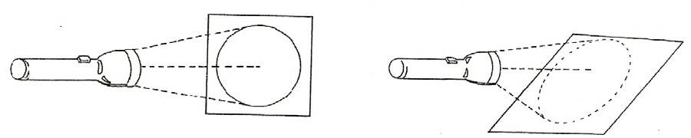
- Have 1 student hold a piece of white graph paper vertically. Darken the room.
Hold a flashlight 20 cm from the white graph paper and shine the light directly at the paper. Is the spot of light bright or dim? Outline the area where light falls with a pencil.
How many squares does the light cover? Count them.

- Repeat the experiment with the flashlight 20 cm from the paper, but angle a piece of graph paper at a 45° angle to the light.
Is the lighted area brighter or dimmer? (dimmer)
The same amount of light energy is spread over a greater area. Outline the area where the light falls.
How many squares did the light cover? Count them.[S, evidence-observations]

COMPARE THE RESULTS
Compare the 2 pieces of graph paper.
Compare the brightness and size of the lighted area of both experiments Which angle made the brightest light. (straight rays)
Which angle spread the light over a larger area? (slanted rays) How you can concentrate the light from the flashlight.
(Shine it straight toward the object and close to the object.)

THE SUN: DIRECT RAYS VS. SLANTED RAYS
Would the Sun be hotter when its rays strike the Earth straight or at an angle? (The light energy is concentrated in a smaller spot when hitting straight,

resulting in more heat. Thus, when we are titled toward the Sun in the Northern Hemisphere it is summer.) Also, the days are longer when the United States tilted toward the Sun.

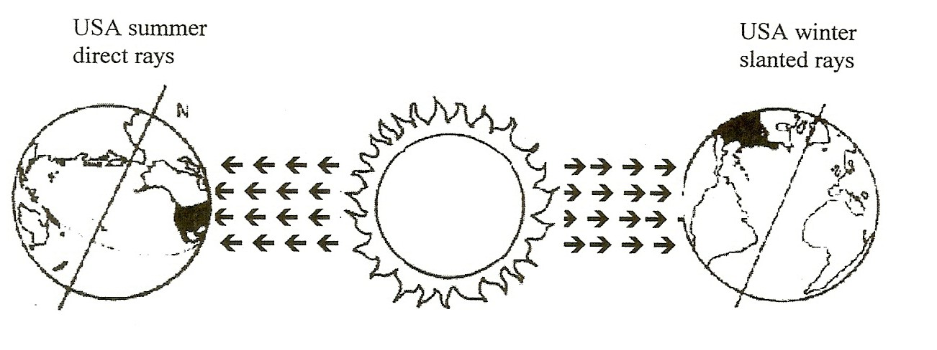
[S, evidence-observations] [S, sun’s energy]

- THE SUN’S POSITION CHANGES WITH THE SEASONS
The Sun appears in different locations relative to Earth during the year due to the Earth’s changing location in its orbit. The Earth revolves around the sun and is in a different area in Space, relative to the Sun. The Earth is moving through Space.

OBSERVING THE SUN’S POSITION DURING THE YEAR
If sunlight enters a window in your classroom, mark the place the rays hit the windowsill with a post-it and write the date and time. Mark where the Sun rays hit the sill at different dates during the year with additional dated ‘post- its’. (always check at the same time) Mark a spot the Sun’s rays hit the playground at 10am relative to a building or pole if the Sun does not shine in the classroom. Record the information and check each month.

[S, Sun’s-position]

ASSESSMENT: Complete the assessment work sheet, What causes the seasons.

