ROCKS, EROSION AND WEATHERING

SECTION 4-WEATHERING CHANGES ROCKS
From Hands on Elementary School Science by Linda Poore, 2003

Westminster College

STANDARD: Students know some changes in the earth are due to slow processes, such as erosion and some changes are due to rapid processes, such as landslides, volcanic eruptions, and earthquakes.

Students know natural processes, including freezing, thawing and growth of root, cause rocks to break down into smaller pieces.

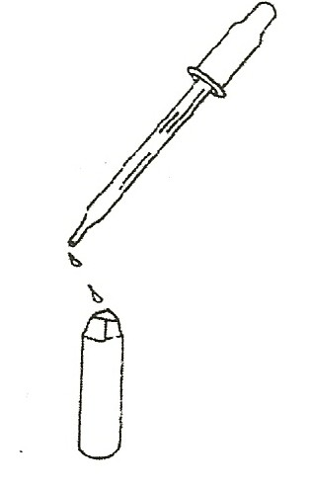
MATERIALS:
For the Teacher:
vinegar
1 dropper
18 limestone chips
18 pieces granite
18 marble rocks
1 piece sandpaper paper towels
hard candies chalk

EXPLORE: [S, break down] [S, changes]

OBSERVING CHEMICAL WEATHERING OF ROCKS
Have students: Place chalk, marble, the small limestone rock, and granite on a paper towel.
Write the names of the four rocks.
Observe as the teacher puts drops of vinegar on each rock.
Observe changes, comparing reactions on the 4 rocks and record observations.

WHICH ROCKS INTERACT WITH THE VINEGAR?
Chalk, limestone, and marble bubble in vinegar as carbon dioxide is released. (Vinegar dissolves the calcium carbonate in chalk.)
Wash the vinegar off the limestone chips and marble rocks.

- PHYSICAL WEATHERING [S, break down] Wind, rushing streams, or ocean waves destroy rocks by rubbing sand, rocks, and other materials they carry against the rocks.
Use the sandpaper to ‘weather’ a pencil. (rub off paint) Have students write their name with a pencil and erase it. The pencil mark disappears due to rubbing.
Rocks continuously weather in this way.

Weathering Changes Rocks

EDIBLE WEATHERING
Give each student a hard candy. (or M & M’s that dissolve fast) Describe its appearance and hardness.
Measure its size in millimeters.
Students are to weather the candy ‘rock’ with water and forces.
Allow one half of the students to use force (teeth) and the other half to use ‘water’ (saliva) only to weather candy.
Students put the candy ‘rock’ in their mouths at the same time.
They time how long it takes to completely destroy it and stand to show when their candy is totally ‘weathered.’
Why did some candy disappear first?
(Teeth break candy-there is more surface area and more force.)

WEATHERING WITH WATER AND FORCE
Put 1 hard candy in a jar of water.
Pass it around the room, shaking the jar.
How long does it take to destroy the hard candy ‘rock’?
Predict what would happen if the candy ‘rock’ was broken into smaller pieces first. Try it. [S, break down] [S, predict]

