MACHINES AND MOTION

SECTION 4: EXPERIMENTING WITH LEVERS

STANDARDS:

Westminster College

Students know objects fall to the ground unless something holds them up.

Students will measure length, weight, temperature, and liquid volume with appropriate tools and express those measurements in standard metric system units.

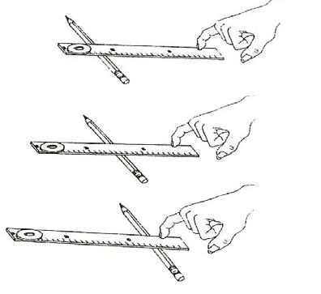
Students will construct bar graphs to record data using approximately labeled axes.

MATERIALS:
ruler
heavy washer pencil for fulcrum

EXPLORE:

CHANGING THE FULCRUM POSITION

- Show students how to make a lever by placing the ruler on a pencil (that acts as a fulcrum), and place the large washer at one end of the ruler (as a weight).

- Draw the 3 sample levers on the board or ‘Photocopy enlarge’ the picture above onto a transparency. Show students how to lift the washer using only the little finger to push down on the ruler. This makes it easy to feel the difference in force needed.

- Change the fulcrum (pencil) to different locations and see which fulcrum position makes lifting easier. (fulcrum near washer)

ASSESSMENT:
Have students set up a lever so it needs the least amount of force to lift the washer. Check each team’s lever. (fulcrum should be near weight)

MATERIALS:
brick board

EXPERIMENTING WITH LEVERS

EXPLORE:

CAN YOU LIFT THE TEACHER WITH YOUR THUMB?
- Challenge students to set up the materials using what they have learned about levers. (Answer: The teacher stands on one end of the board with the fulcrum/brick very close to the teacher.)

- Lift the teacher (or another student) with your thumb. Have the students line up and take turns.
Be careful to release the board slowly after each push.

- MEASURE the length of the board on each side of the fulcrum. The distance between the place you push and the fulcrum is much longer and gives you a mechanical advantage. The longer the board between you and the fulcrum, the less force needed to lift the weight.

WORK=FORCE TIMES DISTANCE
Look at the distance down you must push. Look at the distance up the weight is lifted. Which distance is greater? (where you push)
If you push down 40 cm and the weight lifts 10 cm, you will need only 1/4th of the force. If the weight is 1000 g, you can lift it with a force of 250 , but you push a greater distance. Have students draw a self-portrait showing them lifting the teacher with a lever. Title the paper, “ I lifted the teacher with my thumb and a lever.”

- Would a longer board make the work easier or harder? (Yes, as long as the fulcrum is close to the weight.)

NOTE:
Work=force x distance: A longer board allows you to be further from the weight and fulcrum, and less force is needed to do the same work. The fulcrum must be close to the weight. The teacher moves up a few centimeters, but the student pushes down 60 cm or more. ( more distance = less force)

HOMEWORK:
Have students:
Tell your parents you lifted the teacher with your thumb.
Ask them to guess how you did it. If you have a board and a rock, use it to lift an adult.

NOTE:

EXAMPLES OF SIMPLE MACHINES
- INCLINED PLANE (WEDGE): ax, electric razor, plow, zipper, screw, auger. (Two inclined planes together make a sharp edge called a wedge.)
- LEVER: hammer, pliers, wheelbarrow, bottle opener, nut cracker, hammer, fishing rod, tweezers, nail clippers, crowbar, piano hammers, typewriter key.

