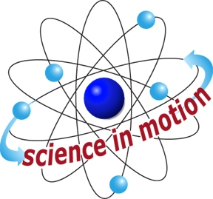
REFLECTION, DIFFRACTION, REFRACTION
Westminster College
SECTION 4: PARALELL MIRRORS PRODUCE MULTIPLE IMAGES

PROCEDURE:
- Place a sheet of loose leaf paper on the work surface. Keep the short edge of the paper parallel to the edge of your work area.

- Fasten each plane mirror to an L-shaped bracket. The long leg of the bracket should extend to the front of the mirror.

- Set the mirror on the paper so that the mirror edges are even with the paper’s edges.

- Lean down so that you are eye level with the mirrors. Look into the mirror furthest from you. How many images of your face can you count? If the mirrors were larger, do you think you would see more images?

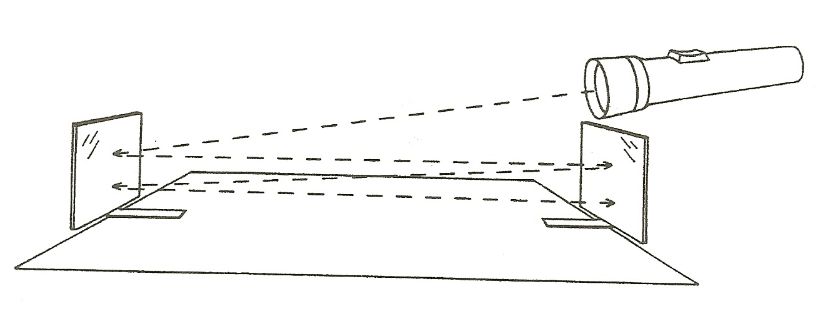
- Turn off the lights near the work area. Shine the flashlight into one of the mirrors. Do not use cap on the flashlight. How many reflections of the light can you count?

ADDITIONAL ACTIVITY:
Substitute either the concave or convex mirrors for one of the plane mirrors. What happens to the images?

