
SOUND VIBRATIONS
Westminster College
ACTIVITY 5: RUBBER BAND-JO
From Science in a Nutshell

OBJECTIVE:
To explore the relationship between vibrating rubber bands and the pitch of the sounds they produce.

MATERIALS:
journal page for Activity 5
box, cardboard
pencil
rubber band, assorted size

BACKGROUND:
You already know that a rubber band will produce a higher-pitched sound if the rubber band is stretched while it is plucked. But how can this information be useful? To what practical purpose can this knowledge be applied?

In this activity, you will use rubber bands to build a box banjo and learn how stringed instruments work.

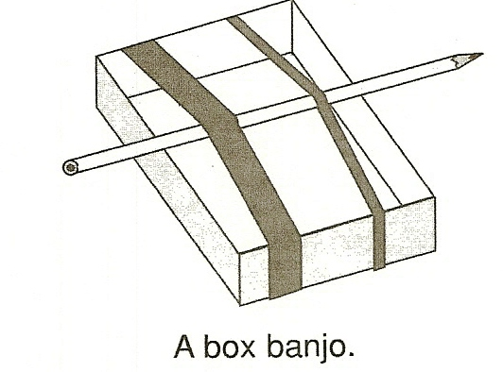
EXPERIMENT:
- Select a small, think rubber band and a small, thick rubber band that are about the same length. Stretch them around the cardboard box. Place a pencil under both rubber bands as shown below.
- Predict which rubber band will make the sound with the higher pitch when you pluck it. Test your prediction. Record the results on the Journal page for Activity 5.
- A guitar has two strings that produce the musical note E. One string is called high E and the other is called low E. One string is thicker than the other. From what you learned with the rubber bands which string is low E. Explain your answer in your journal.
- Shorten the vibrating portions of the rubber bands by sliding the pencil toward one end of the box. Pluck the short portion of each rubber band. What do you hear? How did the pitch of the sound change?
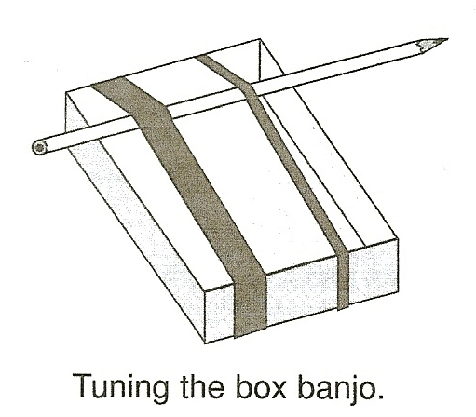

- Move the pencil near the other end of the box. Predict which part of each rubber band will produce the sound with a higher pitch. Then test your prediction.
- Experiment with other rubber bands of different lengths and thicknesses. Predict whether their pitch will be high or low. Do any of your results surprise you?
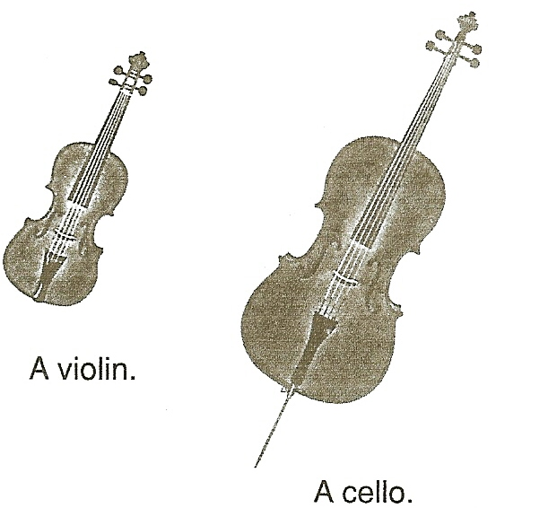
- The strings of a violin are shorter than those of a cello. Which instrument plays the lower notes? Explain your answer in the journal.

- To tune a guitar, you tighten or loosen the strings. If a vibrating string if producing a sound that is too low in pitch, does the guitarist tighten or loosen that string? Record your answer in your journal.

IN A NUTSHELL:
Thick, long, loose rubber bands and strings produce low-pitched sounds. Thin, short, and tight rubber bands and strings produce high-pitched sounds.

CRACKING THE NUT:
Why does a guitarist hold the strings down in different places along the neck of a guitar with one hand and pick or strum the strings with the other hand?

