AIR

SECTION 5: AIR CAN LIFT
From Hands on Science by Linda Poore 2003

STANDARDS:

Westminster College

Students know solids, liquids, and gases have different properties.

Students will record observations and data with pictures, numbers, or written statements.

Students will make new observations when discrepancies exist between two descriptions of the same object or phenomenon.

MATERIALS:
For the Students For the Teacher
1 straw 3 balloons
books 1 large thick garbage bag
1 large plastic bag duct tape
8 straws with a slightly larger
diameter than kits

IN ADVANCE:
For this activity: Can air lift a person?
Lay a heavy-duty garbage bag flat on a table.
Carefully poke 8 large straws (slightly larger in diameter than kit straw) along the 2 sides of a garbage bag, one every foot or so.
(This works best if straws are poked through from the inside.)
Tape duct tape around each straw on the inside and outside of the bag to seal the hole. Fold the end of the bag over twice and secure with duct tape.
This can be used for years, by fixing any tears with duct tape. Carefully deflate after the activity.

EXPLORE:

HOW STRONG IS AIR? AIR CAN LIFT
- HOW MANY BOOKS CAN YOU LIFT WITH AIR?
Give each student 1 straw and 1 large plastic bag.
Show the students how t put a straw in the bag opening and twist the bag opening around the straw to seal it.
Hold the twisted bag opening tightly over the straw.
Have students put a book on their large plastic bag and blow in the bag. What happens? (book goes up)
PREDICT how many books you can lift. Experiment.

CAN AIR LIFT A PERSON?
(Make garbage bag* - see IN ADVANCE)

Place the large garbage bag* with straws on a student’s desk. Place a Zerox box lid on top of the bag. Have 8 students insert their straws in the ‘bag straws’ and blow to lift the box. Carefully deflate the bag. Now lift a desk or a student. A student can sit in the box lid or put a desk upside-down on the bag. Have students blow together to lift the desk or person. Teach the students to blow 3 times and then put their tongue over the hole and rest for a second. Watch their faces! No fainting please! (You can have 8 older students come in to do this as a demonstration.)

DEMONSTRATE:

HOW DOES AIR HELP A PARACHUTE WORK?
  - Drop 2 pieces of identical paper to the ground. Observe. (float) Drop 2 pieces again, but hold one vertically and one horizontally. Discuss. (vertical falls faster)
Experiment again with one wadded into a ball and one flat.

  - Why did the ‘ball’ paper hit the floor first?
Students usually say it is heavier. (Weight is the same.) Unfold the paper, flatten it, and then crumple the other one.
Experiment again. If they are not convinced, have the students stand up and crouch down into a ball. Are you heavier now? (no)
Then, wrap a crayon inside the paper. Tell them that it is now heavier.

  - WHY? Gravity pulls down equally on both papers, but the air is also pushing up on the papers. Flat paper has more surface area for air to push on; so more air is holding it up and it falls more slowly. This is called air friction or air resistance.

MAKE A PARACHUTE

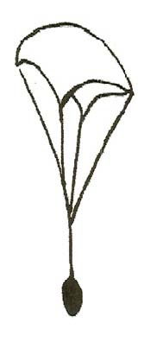
Parachutes are large pieces of silk or fabric that slow down a falling object or person. Photocopy the Make a Parachute worksheet. Parents will help them with this activity. This can also be done in class with student helpers from an upper grade. Have a race to see which parachute floats the slowest. Which parachute carries the heaviest load?

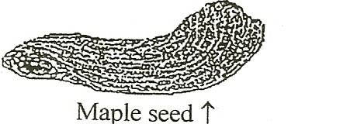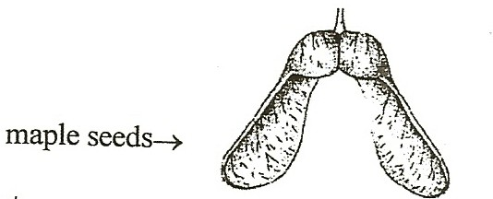

MATERIALS:
Scissors
3 paper clips per students real maple seeds, is possible worksheet

EXPLORE:

SEEDS USE AIR TO FLY TO A NEW PLACE TO GROW
- Tell students you need maple tree seeds or other seeds that float. Compare the real maple seeds to the paper ‘seeds’ on the worksheet.
The paper clip adds weight on one end, to make the paper seeds asymmetrical, like the maple seed.
Demonstrate how to hold the seed up high and drop it. The seeds rotate as they fall. Have the students stand in a location with more distance to drop. (e.g., on the picnic benches if it is safe)
Tell students they are to find the paper seed that falls the slowest.

EXPERIMENT:
Use the worksheet Seeds Float on Air. Discuss.
Have students: Cut out the seeds. Put a paper clip on each seed. Drop the seeds. Give them time to explore, play and discover.

- DISCUSS: Which seed turns the most?
What is the best way to drop a seed for the slowest fall and most turns, flat or up and down? (vertical or horizontal)

- Have a slow race. Have the students drop their seeds together and see who can drop it so it goes the slowest. This works best if only 2 students compete at one time.

- Discuss why wind is important to seeds.
The spiral motion makes it fall slowly so the wind can take it farther. What would happen if all the tree’s seeds fell straight down?
Could 500 trees grow there? (no)
Air helps the seeds find a place to grow.

- Complete the worksheet questions.

(worksheet answers: 1. Spins, 2. Slows, 3. Travel or move)

NOTE:

AIR HAS WEIGHT
We live at the bottom of an ‘ocean’ of air called our atmosphere. This atmosphere exerts a pressure of about 14.7 pounds, at sea level, on every square inch of the Earth. This means that if your head has a surface area of 20 square inches, then you have almost 300 pounds of air sitting on your head. However, air in your body pushes out with the same pressure, so you don’t feel the weight. This air pressure pushes equally in all directions, not just down. The air inside a balloon weighs less than a tenth of a gram.
14.7
POUNDS

MATERIALS:
1 cheap ruler
5 # bag of sugar
12” x 18” piece of construction paper

DEMONSTRATE:

AIR HAS WEIGHT
- Ask the students how far they think outer space, where the astronauts go, is above them. Tell them if you could drive a car straight up, you could be there in 20 minutes. (20 miles above us)

AIR PUSHES ON YOU
Think of all the air between you and space. Air is sitting on your head. Does it feel heavy? Give each student a paper with 14.7 pounds written in a square inch. (see above) Let them lift something that weighs 5 pounds, like a 5-pound bag of sugar. The weight of air is equal to 3 bags like this sitting on every square inch. What would it feel like to have 60 bags sitting on your head. That is the weight of

air pushing on you right now. Inside your body air is pushing back just as hard, so you don’t feel the push or weight.

SAFETY:
Move the students away from the ‘danger zone’ in case the ruler flies across the room.

DEMONSTRATE:

AIR PRESSURE
  - 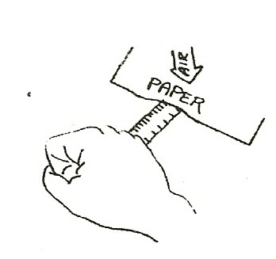Put a ruler on a desk with 4.5” hanging over the desk edge. Ask students what would happen if you gave it a quick ‘karate chop’ hit. Try it. Make sure no one can get hit. (flies across room)
2.

HOW HARD CAN AIR PUSH?
Place a piece of large paper ( 8.5 x 14 photocopy or 12 x 18 construction) over a cheap balsa wood ruler so that 4 ½ inches of the ruler extends over the edge of the table.
Flatten the paper carefully so almost no air is under the paper. Ask students to predict what will happen if you hit the ruler. Where will the ruler go? What is pushing down on the paper? (Air) The 12 x 18 paper would have 3175 pounds of air pushing on it (multiply 12 x 18 x 14.7 pounds) but some air is under the paper pushing up.
Predict what will happen. (If air is pushing hard, the ruler may break.)

3. Make a quick, hard ‘karate chop’ hit on the ruler. The ruler will break. This is very dramatic when the ruler has a metal edge! (Be sure no one is near where the ruler might fly.)
Why? The air pushed harder than the teacher, breaking the ruler.

