DETECTIVE LAB

SECTION 5: LASTING IMPRESSIONS
From Science in a Nutshell

OBJECTIVE:
To make and compare shoe prints

MATERIALS:
aluminum foil hand lens
Journal Page for Activity 5 tape measure
transparent tape pencil

Westminster College

BACKGROUND:
Although criminals may try to avoid leaving fingerprints, they may accidentally leave other kinds of useful prints at a crime scene. For example, shoe prints often serve as valuable clues that help to identify the suspects involved in a crime.

When new shoes leave the factory, the bottoms of any one style of shoe all look the same. After you wear the shoes for a while, the heels and soles begin to show signs of wear. Shoes show different signs of wear because no two people walk exactly alike.

The palms of a person’s hands, the feet, toes, and lips also have unique characteristics that can be used to identify crime suspects. Even tire impressions may be helpful in determining the vehicle that was used during a crime.

In this activity, you will explore shoe prints and learn how to match and identify several sets of shoe prints.

EXPERIMENT:

- Tear off 16 sheets of aluminum foil each about 30 cm long. Place two sheets next to each other on thick carpet. Stand with one foot on each piece of foil to make impressions of your shoe prints.

- Use tape to label this set (a right and a left foot) of shoe prints with your name. Make a second set of shoe prints, but do not label this set.

- Ask your partner to make two sets of shoe prints. Label one set with the name of your partner. Do not label the second set.

LASTING IMPRESSIONS

- Ask two other people to each make two sets of shoe prints. Label one set of shoe prints from each person and leave the second set of prints from each person unlabeled.

- Measure the height of your partner and the other two people who made shoe prints. Ask your partner to measure your height.

- In the chart on your Journal page for Activity 5, record your name and height and the names and heights of the three other people who made shoe prints.

- Mix up all the unlabeled sets of shoe prints. Then, try to match the labeled shoe prints with the unlabeled prints.

- What details do you examine to identify each unlabeled print? How can you tell whether the print was made by a right shoe or a left shoe? Can you always tell if a print is from the shoe of a man or a woman? Record your answers in your journal.
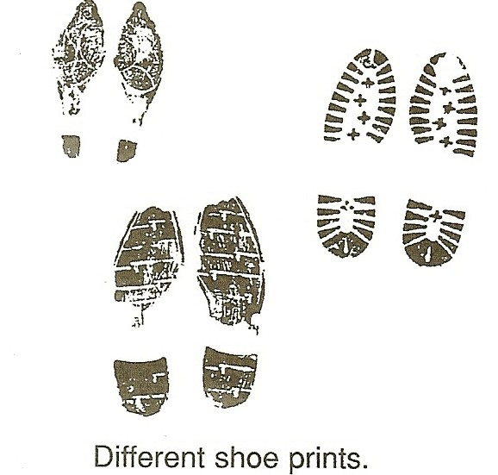

- Measure and record the length and width (at the widest point) of each shoe print. Record this information on the chart in your journal. Who has the longest shoe print? Answer this question in your journal.

- Examine the patterns of wear found on the heel and sole of each shoe print. Is a band name visible on the sole or heel? In the chart on your journal page, draw the shape and pattern of each heel and sole.

- Use the hand lens to examine each shoe print for special marks made by the shoe. Do you observe signs of tears or cuts, embedded nails or pebbles? On the chart in the journal, draw any special marks that you observe.

LASTING IMPRESSIONS

- Are toe prints as unique as fingerprints? Do you find arch, loop, and whorl patterns on toe prints? Are palm prints as unique as fingerprints? Are lip prints unique? How can you find out? Record your ideas on the journal page.

IN A NUTSHELL:
- Because no two shoes, even those of the same model and size, show identical signs of wear, shoe prints are often used to identify suspects.
- Many types of prints—shoe prints, lip prints, palm prints, footprints, toe prints and tire prints—can be used for identification.

CRACKING THE NUT:
After a rain or snow fall, examine tire tracks made by a bicycle. Can you identify which bicycle made each track? Try to match a tire track with the tread of the actual tire that made it.

