REFLECTION, DIFFRACTION, REFRACTION

SECTION 5: MIRRORS CAN CHANGE THE
DIRECTION OF A LIGHT RAY

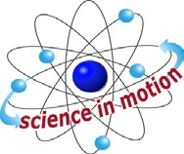
Westminster College

NOTE: This activity requires several students to work together in a darkened room.

PROCEDURE:
- Have one student hold a plane mirror at chest level, at a slight angle, while a second student stands a few feet away and shines the flashlight at the mirror.
- A third student a few steps away holds another mirror and tries to position it into the area of the beam reflected from the first mirror. This second student tries to project some of the light onto a light colored wall, ceiling or screen.
- Have another student try to reflect this already twice reflected beam with a third mirror.
- If other students have plane mirrors, see how many times you can bounce the light ray around the room before it gets too dim to see.
- Try this activity using the concave and the convex mirror in place of the first flat mirror. Record your observations.
- Using the concave mirror for the first mirror in the above activity, change the distance to the second mirror. Does the position of the second mirror make a difference?

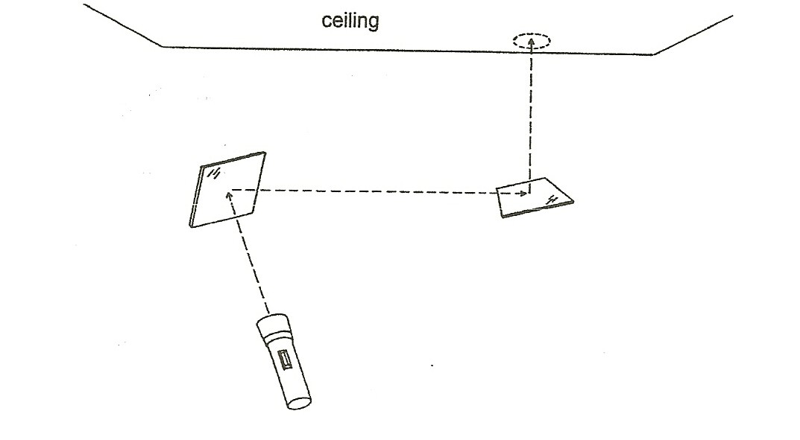

Note: Try not to shine the light in anyone’s eyes as it will make it harder for them to see in the dark and result in less accurate results.

Westminster College SIM Page 1

